

National Certificate: New Venture Creation (SMME)

SAQA ID 49648 Level 2

**FACILITATOR GUIDE**

**Module 2**

Communication Level 2

**Access and use information from texts**

Unit Standard 8963, Level 2 Credits 5

**Write for a defined context**

Unit Standard 8964, Level 2 Credits 5

**Maintain and adapt oral communication**

Unit Standard 8962, Level 2 Credits 5

**Use language and communication in occupational learning programmes**

Unit Standard 8967, Level 2 Credits 5

# TABLE OF CONTENTS

[TABLE OF CONTENTS i](#_Toc488675822)

[DOCUMENT CHECKLIST 1](#_Toc488675823)

[YOUR ROLE AS FACILITATOR 2](#_Toc488675824)

[Training Venue And Training Aid Compliance 3](#_Toc488675825)

[Structure And Strategy Of The Programme 4](#_Toc488675826)

[The Facilitator Guide 4](#_Toc488675827)

[Timelines and lesson plans 5](#_Toc488675828)

[Course content 6](#_Toc488675829)

[Class Activities 6](#_Toc488675830)

[Assessment 7](#_Toc488675831)

[Upon Completion Of The Programme 9](#_Toc488675832)

[UNIT STANDARDS 8963 & 8964 10](#_Toc488675833)

[Activity 1 (8963 SO1, AC1-7) 10](#_Toc488675834)

[Activity 2 (8963 SO2, AC1-4) 21](#_Toc488675835)

[Activity 3 (8963 SO3, AC1-6) 23](#_Toc488675836)

[Activity 4 (8963 SO4, AC1-2) 26](#_Toc488675837)

[Activity 5 (8964 SO1, AC1-2) 40](#_Toc488675838)

[Activity 6 (8964 SO 2, AC 1-7 40](#_Toc488675839)

[Activity 7 (8964 SO3, AC 1-2) 40](#_Toc488675840)

[Activity 8 (8964 SO4, AC 1-6) 43](#_Toc488675841)

[UNIT STANDARDS 8962 & 8967 44](#_Toc488675842)

[Activity 2 (8962 SO1, AC 1-7) 44](#_Toc488675843)

[Effective Communication Self Evaluation 45](#_Toc488675844)

[Activity 3 (8962 SO2, AC1-4) 49](#_Toc488675845)

[Activity 4 (8962 SO3, AC1-3) 49](#_Toc488675846)

[Activity 5 (8962 SO4, AC1-6) 51](#_Toc488675847)

[Activity 6 (8962 SO5, AC1-3) 52](#_Toc488675848)

[Activity 7 (8967 SO1, AC1-2) 55](#_Toc488675849)

[Activity 8 (8967 SO2, AC1-6) 55](#_Toc488675850)

[Activity 9 (8967 SO4, AC1-6) 56](#_Toc488675851)

[Activity 10 (8967 SO5, AC1-4) 57](#_Toc488675852)

[Activity 11 (8967 SO6, AC1-3) 59](#_Toc488675853)

[Activity 12 (8967 SO3, AC1-3) 62](#_Toc488675854)

[PERSONAL INFORMATION 63](#_Toc488675855)

[INTRODUCTION 64](#_Toc488675856)

[Structure 65](#_Toc488675857)

[Programme methodology 65](#_Toc488675858)

[What Learning Material you should have 66](#_Toc488675859)

[Different types of activities you can expect 67](#_Toc488675860)

[Assessments 68](#_Toc488675861)

[Learner Support 69](#_Toc488675862)

[Learner Administration 69](#_Toc488675863)

[Learner Expectations 70](#_Toc488675864)

[UNIT STANDARD 8963 72](#_Toc488675865)

[UNIT STANDARD 8964 76](#_Toc488675866)

[SECTION 1: READING AND VIEWING STRATEGIES 80](#_Toc488675867)

[Introduction 80](#_Toc488675868)

[Reading Skills 82](#_Toc488675869)

[Reading Strategies 82](#_Toc488675870)

[Skim 82](#_Toc488675871)

[Scan 82](#_Toc488675872)

[Sift 83](#_Toc488675873)

[Prediction 83](#_Toc488675874)

[Re-Reading 83](#_Toc488675875)

[Pre reading 83](#_Toc488675876)

[Highlighting 83](#_Toc488675877)

[Retell And Summarise 84](#_Toc488675878)

[Use Questions 84](#_Toc488675879)

[Research the information 84](#_Toc488675880)

[Record the information 85](#_Toc488675881)

[Sorting and categorizing 85](#_Toc488675882)

[Sifting for Relevance 85](#_Toc488675883)

[Validity and Reliability 85](#_Toc488675884)

[Aids for recording information 86](#_Toc488675885)

[Summaries 86](#_Toc488675886)

[Paraphrasing 87](#_Toc488675887)

[Point Form 87](#_Toc488675888)

[Mind-map 87](#_Toc488675889)

[Notes 90](#_Toc488675890)

[Annotations 90](#_Toc488675891)

[Diagram 90](#_Toc488675892)

[Tree Diagram 90](#_Toc488675893)

[Cause and effect diagrams 92](#_Toc488675894)

[Timelines 94](#_Toc488675895)

[Flow chart 95](#_Toc488675896)

[Venn diagram 96](#_Toc488675897)

[Pie chart 96](#_Toc488675898)

[Bar graph 97](#_Toc488675899)

[Structural features of text 98](#_Toc488675900)

[Reference Materials 99](#_Toc488675901)

[Dictionaries 99](#_Toc488675902)

[Textbooks 102](#_Toc488675903)

[Instruction Manuals 106](#_Toc488675904)

[Encyclopaedias 108](#_Toc488675905)

[Internet 110](#_Toc488675906)

[What Do We Read? 110](#_Toc488675907)

[Read Instructions 111](#_Toc488675908)

[Games 111](#_Toc488675909)

[Repairing objects 112](#_Toc488675910)

[Forms 112](#_Toc488675911)

[Maps 113](#_Toc488675912)

[Recipes 113](#_Toc488675913)

[Schedules 113](#_Toc488675914)

[Procedures 114](#_Toc488675915)

[Activity 1(8963 SO1, AC1-7) 115](#_Toc488675916)

[SECTION 2: IDENTIFY MAIN IDEAS 116](#_Toc488675917)

[Determine The Author’s Purpose 116](#_Toc488675918)

[Present ideas from the text 116](#_Toc488675919)

[Role play 116](#_Toc488675920)

[Simulation 116](#_Toc488675921)

[Identify socio-cultural issues 117](#_Toc488675922)

[Idioms and Proverbs 117](#_Toc488675923)

[Jargon 117](#_Toc488675924)

[Slang 118](#_Toc488675925)

[Activity 2 (8963 SO2, AC1-4) 118](#_Toc488675926)

[SECTION3: READ/VIEW AND RESPOND TO TEXT 119](#_Toc488675927)

[Reading and viewing resources 119](#_Toc488675928)

[Text Types 120](#_Toc488675929)

[Purpose and different points of view 120](#_Toc488675930)

[Own ideas 121](#_Toc488675931)

[Relevance of text 121](#_Toc488675932)

[Implicit and Explicit Text 121](#_Toc488675933)

[Activity 3 (8963 SO3, AC1-6) 121](#_Toc488675934)

[SECTION4: LANGUAGE STRUCTURES AND FEATURES 122](#_Toc488675935)

[Language Structures And Features 122](#_Toc488675936)

[Dealing With Bias 122](#_Toc488675937)

[Humour 123](#_Toc488675938)

[Irony and sSarcasm 123](#_Toc488675939)

[Hyperbole 124](#_Toc488675940)

[Generalisations 124](#_Toc488675941)

[Stereotyping 124](#_Toc488675942)

[Figurative Expressions 124](#_Toc488675943)

[Repetition 124](#_Toc488675944)

[Grammar 125](#_Toc488675945)

[Captions 126](#_Toc488675946)

[Pictures 126](#_Toc488675947)

[Typography 127](#_Toc488675948)

[Omissions and Silence 127](#_Toc488675949)

[Sentence structures 127](#_Toc488675950)

[Sentence Length 127](#_Toc488675951)

[Simple Sentences 128](#_Toc488675952)

[Compound Sentences 128](#_Toc488675953)

[Complex Sentences 128](#_Toc488675954)

[Activity 4 (8963 SO4, AC1-2) 128](#_Toc488675955)

[SECTION 5: AUDIENCE, PURPOSE & CONTEXT 130](#_Toc488675956)

[Styles Of Writing 130](#_Toc488675957)

[Narrative 130](#_Toc488675958)

[Discursive 130](#_Toc488675959)

[Reflective 130](#_Toc488675960)

[Argumentative 131](#_Toc488675961)

[Descriptive 131](#_Toc488675962)

[Expository 131](#_Toc488675963)

[Transactional 131](#_Toc488675964)

[Business correspondence 131](#_Toc488675965)

[Electronic texts 131](#_Toc488675966)

[Multi-Media Presentations 132](#_Toc488675967)

[Structure your writing 135](#_Toc488675968)

[There are many reasons why authors write texts 135](#_Toc488675969)

[Before you start writing/signing your text you have to plan what you are going to write 135](#_Toc488675970)

[Make your writing/signing interesting 136](#_Toc488675971)

[Diction 136](#_Toc488675972)

[Produce Writing/Signing That Is Appropriate 136](#_Toc488675973)

[A clear point of view 138](#_Toc488675974)

[The ten golden rules of meaningful written communication 138](#_Toc488675975)

[Pointers to think of before you write 138](#_Toc488675976)

[Use critical thinking skills 139](#_Toc488675977)

[Mind maps 139](#_Toc488675978)

[Highlights 139](#_Toc488675979)

[Brainstorming 139](#_Toc488675980)

[Activity 5 (8964 SO1, AC1-2) 140](#_Toc488675981)

[SECTION 6: GRAMMATICAL STRUCTURES 141](#_Toc488675982)

[Register 141](#_Toc488675983)

[Informal Register 141](#_Toc488675984)

[Formal Register 141](#_Toc488675985)

[Punctuation/NMF’s 142](#_Toc488675986)

[Period 142](#_Toc488675987)

[Comma 142](#_Toc488675988)

[Ellipses 143](#_Toc488675989)

[Semi-colons 143](#_Toc488675990)

[Dash 144](#_Toc488675991)

[Sentences 144](#_Toc488675992)

[Paragraphs 144](#_Toc488675993)

[Document 144](#_Toc488675994)

[Arranging The Paragraphs In A Logical Order 144](#_Toc488675995)

[Organise the material 146](#_Toc488675996)

[Activity 6 (8964 SO 2, AC 1-7 147](#_Toc488675997)

[SECTION 7: ADAPT LANGUAGE 148](#_Toc488675998)

[Activity 7 (8964 SO3, AC 1-2) 148](#_Toc488675999)

[SECTION 8: EDIT WRITING 149](#_Toc488676000)

[Redrafting 149](#_Toc488676001)

[Bibliography 150](#_Toc488676002)

[Activity 8 (8964 SO4, AC 1-6) 151](#_Toc488676003)

[UNIT STANDARD 8962 152](#_Toc488676004)

[UNIT STANDARD 8967 156](#_Toc488676005)

[SECTION 1: SPEAKING AND LISTENING STRATEGIES 161](#_Toc488676006)

[The Communication Process 161](#_Toc488676007)

[Activity 1 162](#_Toc488676008)

[Dos' And Don’ts On Listening/Viewing 164](#_Toc488676009)

[Active Listening 164](#_Toc488676010)

[Use questions 165](#_Toc488676011)

[Guidelines when asking questions: 166](#_Toc488676012)

[Sustain Interaction 166](#_Toc488676013)

[Speak in a way that conveys meaning 167](#_Toc488676014)

[Repetition 169](#_Toc488676015)

[Extract The Main Idea 169](#_Toc488676016)

[Recognise evidence and arguments 169](#_Toc488676017)

[Sustained interaction 169](#_Toc488676018)

[Adapt own speech 169](#_Toc488676019)

[Barriers To Effective Communication 170](#_Toc488676020)

[Poor interpersonal skills 170](#_Toc488676021)

[Failure to identify the needs of the receiver 170](#_Toc488676022)

[Different cultural backgrounds 170](#_Toc488676023)

[Lack of intercultural understanding 171](#_Toc488676024)

[Messages with too much/little information 171](#_Toc488676025)

[Use of insensitive or abusive language by the sender or receiver 171](#_Toc488676026)

[Effective verbal communication 171](#_Toc488676027)

[Activity 2 (8962 SO1, AC 1-7) 172](#_Toc488676028)

[SECTION 2: ADAPT SPEECH/SIGNING 173](#_Toc488676029)

[Facial Expression, Gesture And Inflection 173](#_Toc488676030)

[Non-Verbal Signs And Signals 174](#_Toc488676031)

[Movement 174](#_Toc488676032)

[Gesture 174](#_Toc488676033)

[Cultural Influence 174](#_Toc488676034)

[Response or feedback 174](#_Toc488676035)

[Eye Contact 175](#_Toc488676036)

[Body Language 175](#_Toc488676037)

[Empathy 175](#_Toc488676038)

[In Summary 176](#_Toc488676039)

[Nonverbal Messages 176](#_Toc488676040)

[Appropriate and inappropriate forms of politeness 177](#_Toc488676041)

[Express own ideas and opinions 177](#_Toc488676042)

[Activity 3 (8962 SO2, AC1-4) 177](#_Toc488676043)

[SECTION 3: LANGUAGE STRUCTURES 178](#_Toc488676044)

[Identify New Or Borrowed Words/Signs 178](#_Toc488676045)

[Borrowed words 178](#_Toc488676046)

[New words 178](#_Toc488676047)

[Idioms and Proverbs 179](#_Toc488676048)

[Jargon or Technical language 179](#_Toc488676049)

[Slang 180](#_Toc488676050)

[Acronym 180](#_Toc488676051)

[Construct meaning from contextual clues 181](#_Toc488676052)

[Contextual Clues 181](#_Toc488676053)

[Word-Attack Skills 181](#_Toc488676054)

[Homonyms and homophones 182](#_Toc488676055)

[Synonyms and antonyms 183](#_Toc488676056)

[Etymology and derivatives 183](#_Toc488676057)

[Compound words 183](#_Toc488676058)

[Roots 184](#_Toc488676059)

[Prefixes and suffixes 184](#_Toc488676060)

[Support meaning in speaking/signing 184](#_Toc488676061)

[Sentence Length 184](#_Toc488676062)

[Simple Sentences 184](#_Toc488676063)

[Compound Sentences 185](#_Toc488676064)

[Complex Sentences 185](#_Toc488676065)

[Activity 4 (8962 SO3, AC1-3) 185](#_Toc488676066)

[SECTION 4: ORGANISE AND PRESENT INFORMATION 186](#_Toc488676067)

[Organise Your Information 186](#_Toc488676068)

[Sorting and categorizing 186](#_Toc488676069)

[Sifting for relevance 186](#_Toc488676070)

[Validity and reliability 186](#_Toc488676071)

[Recording 187](#_Toc488676072)

[Identify and remove inappropriate or potentially offensive language. 187](#_Toc488676073)

[Arranging The Paragraphs In A Logical Order 187](#_Toc488676074)

[Register 188](#_Toc488676075)

[Informal Register 188](#_Toc488676076)

[Formal Register 188](#_Toc488676077)

[Sources of Information 189](#_Toc488676078)

[Dictionaries 189](#_Toc488676079)

[Textbooks 190](#_Toc488676080)

[Encyclopaedias 190](#_Toc488676081)

[Internet 191](#_Toc488676082)

[Atlas 191](#_Toc488676083)

[Videos 191](#_Toc488676084)

[Libraries 191](#_Toc488676085)

[Schedules 191](#_Toc488676086)

[Official documents 193](#_Toc488676087)

[Files 193](#_Toc488676088)

[Archive 193](#_Toc488676089)

[Journal 193](#_Toc488676090)

[Museum 193](#_Toc488676091)

[Directory 194](#_Toc488676092)

[Summaries 194](#_Toc488676093)

[Point Form 195](#_Toc488676094)

[Mind-map 195](#_Toc488676095)

[Visual Aids 195](#_Toc488676096)

[Handouts And Multimedia 196](#_Toc488676097)

[Prepared and unprepared talks 196](#_Toc488676098)

[Effective Speaking 196](#_Toc488676099)

[Preparation of Talks 197](#_Toc488676100)

[Activity 5 (8962 SO4, AC1-6) 201](#_Toc488676101)

[SECTION 5: HOW TO INFLUENCE THE AUDIENCE 202](#_Toc488676102)

[Impact On The Audience 202](#_Toc488676103)

[Dealing With Bias 202](#_Toc488676104)

[Humour 203](#_Toc488676105)

[Irony and sSarcasm 203](#_Toc488676106)

[Purpose Of Communicating 204](#_Toc488676107)

[Narrative 204](#_Toc488676108)

[Discursive 204](#_Toc488676109)

[Reflective 204](#_Toc488676110)

[Argumentative 204](#_Toc488676111)

[Descriptive 205](#_Toc488676112)

[Expository 205](#_Toc488676113)

[Transactional 206](#_Toc488676114)

[Business correspondence 206](#_Toc488676115)

[Electronic texts 206](#_Toc488676116)

[Multi-Media Presentations 206](#_Toc488676117)

[Techniques of communication 206](#_Toc488676118)

[Repetition 206](#_Toc488676119)

[Rhetorical questions 206](#_Toc488676120)

[Use of first person for inclusion 206](#_Toc488676121)

[Omissions Or Inclusion 207](#_Toc488676122)

[Activity 6 (8962 SO5, AC1-3) 207](#_Toc488676123)

[SECTION 6: LEARNING RESOURCES 208](#_Toc488676124)

[Learning Resources 208](#_Toc488676125)

[Text Books 208](#_Toc488676126)

[Using Textbooks To Collect Information 208](#_Toc488676127)

[Internet 212](#_Toc488676128)

[Magazines and Newspapers 212](#_Toc488676129)

[Resource centres 212](#_Toc488676130)

[Other People 213](#_Toc488676131)

[Videos 213](#_Toc488676132)

[Dictionaries 213](#_Toc488676133)

[Use learning resources effectively 216](#_Toc488676134)

[Sorting and categorizing 216](#_Toc488676135)

[Sifting for relevance 216](#_Toc488676136)

[Validity and reliability 216](#_Toc488676137)

[Acknowledgement Of Resource 216](#_Toc488676138)

[Activity 7 (8967 SO1, AC1-2) 217](#_Toc488676139)

[SECTION 7: LEARNING STRATEGIES 218](#_Toc488676140)

[How You Remember 218](#_Toc488676141)

[Association 218](#_Toc488676142)

[The Three Stages Of Memory 218](#_Toc488676143)

[The Three Kinds Of Memory 218](#_Toc488676144)

[The Three Stages Of Remembering 219](#_Toc488676145)

[Memorising Techniques 220](#_Toc488676146)

[Structures To Remember 220](#_Toc488676147)

[Exercise 220](#_Toc488676148)

[Exercise 221](#_Toc488676149)

[Exercise 221](#_Toc488676150)

[Associations 221](#_Toc488676151)

[Exercise 222](#_Toc488676152)

[Exercise 222](#_Toc488676153)

[Do You Know The Following Study Method? 222](#_Toc488676154)

[The Process Of Learning 223](#_Toc488676155)

[Skimming 223](#_Toc488676156)

[Scanning 224](#_Toc488676157)

[Summaries 224](#_Toc488676158)

[Highlighting And Underlining 225](#_Toc488676159)

[Taking Notes 225](#_Toc488676160)

[Ask And Answer Questions 225](#_Toc488676161)

[Mind-map 226](#_Toc488676162)

[Key words 226](#_Toc488676163)

[Ask relevant questions 227](#_Toc488676164)

[What Do We Read? 228](#_Toc488676165)

[Listen for detail 228](#_Toc488676166)

[Peer And Self-Assessment 229](#_Toc488676167)

[Communicating With Others 229](#_Toc488676168)

[Activity 8 (8967 SO2, AC1-6) 229](#_Toc488676169)

[SECTION 8: PLAN AND GATHER INFORMATION 230](#_Toc488676170)

[Sources of Information 230](#_Toc488676171)

[Interviews (asking people questions) 230](#_Toc488676172)

[Observation 231](#_Toc488676173)

[Organise The Material 231](#_Toc488676174)

[Sorting and categorizing 231](#_Toc488676175)

[Sifting for relevance 231](#_Toc488676176)

[Validity and reliability 232](#_Toc488676177)

[Recording 232](#_Toc488676178)

[Activity 9 (8967 SO4, AC1-6) 234](#_Toc488676179)

[SECTION 9: TEAMWORK 235](#_Toc488676180)

[Team Members 235](#_Toc488676181)

[The Role Of The Team Leader 236](#_Toc488676182)

[Purpose Of A Team 236](#_Toc488676183)

[Negotiation 237](#_Toc488676184)

[Preparation 237](#_Toc488676185)

[Building Understanding 239](#_Toc488676186)

[Bargaining 239](#_Toc488676187)

[Closing 240](#_Toc488676188)

[SECTION 10: WORKPLACE CHARACTERISTICS 241](#_Toc488676189)

[Activity 11 (8967 SO6, AC1-3) 241](#_Toc488676190)

[SECTION 11: OCCUPATIONAL LEARNING MATERIALS 243](#_Toc488676191)

[Occupational Learning Materials 243](#_Toc488676192)

[Layout of learning material 243](#_Toc488676193)

[Glossary 243](#_Toc488676194)

[Technical language and terminology (Jargon) 244](#_Toc488676195)

[A Filing System 244](#_Toc488676196)

[Methods Of Classification 245](#_Toc488676197)

[Alphabetical Order 245](#_Toc488676198)

[Numerical Order 245](#_Toc488676199)

[Alpha-numeric filing 246](#_Toc488676200)

[Selecting a classification system 246](#_Toc488676201)

[Lending of Learning Materials 246](#_Toc488676202)

[Activity 12 (8967 SO3, AC1-3) 246](#_Toc488676203)



# DOCUMENT CHECKLIST

|  |  |  |
| --- | --- | --- |
| **Document** | | **✓/🗶** |
| Strategy and alignment Matrix | |  |
| Learner Guides | |  |
| Learner Formative Assessment Workbooks | |  |
| Summative assessment guide | |  |
| Facilitator Guide | |  |
| Attendance Register | |  |
| Name Tags | |  |
| Hand-outs | |  |
| Course Evaluation Forms for learners | |  |
| Course/Venue Evaluation Forms for facilitator | |  |
| Additional Material | |  |
| Other: | |  |
| **Acknowledgement of receipt and preparations** | | |
| Facilitators Name and Surname |  | |
| Facilitators Signature |  | |
| Date |  | |

# YOUR ROLE AS FACILITATOR



You, as facilitator, need to ensure that learners have a thorough understanding of the topic presented. Learners must be able to further learning independently and apply their knowledge and skill in the workplace once they have completed the program.

In order to achieve this, you need to have:

1. **Knowledge of the subject/topic**

* Understand the requirements of the unit standard
* Be a Subject Matter Expert (SME) or know more than just the basics about the topic
* Be able to give examples of how to apply the content in the workplace

1. **Knowledge of the workplace**

* Be able to indicate how learners can/should apply their knowledge and skill in the workplace

1. **Knowledge of the course content**

* Be familiar with the material, layout and content of the course.
* Understand the linkage between the different guides and how they should be used.

1. **Knowledge and understanding of the methodology**

* Familiarise yourself with the content of the assessment guides and documents for this unit standard.
* Follow the assessment procedure correctly.
* Familiarise yourself with the preferred methodology that should be used.
* Prepare yourself accordingly.

## Training Venue And Training Aid Compliance



Ensure that the following is in place:

#### Facilitator is in possession of:

* Facilitator Guide,
* Learner Guide,
* Assessment Guide
* Attendance Register for each training day
* Handouts, if applicable

#### Learners are in possession of:

* Learner Guides
* Assessment Guides

#### Training Venue contains:

* Dictionaries, if available
* A chair for each learner
* A desk with sufficient seating space for each learner
* Paper, pens and pencils for all learners
* A flip chart stand with flip chart sheets
* A PC for the slide shows
* Prestik
* Whiteboard and permanent markers (3 different colours each)
* Sufficient ventilation or air-conditioning
* Schedule of training and relaxation times
* Name tags for each learner
* List of classroom conduct, including:
* Smoke breaks
* Body breaks
* Cell phone etiquette
* General classroom etiquette

## Structure And Strategy Of The Programme

### The Facilitator Guide



It guides you through the duration of the Learning Programme;

As a training aid it contains activities that will assist you in transferring the knowledge and skills as stipulated in the SAQA required specific outcomes and assessment criteria

#### How to use your facilitator guide

The Facilitator Guide contains the essential information to cover the outcomes as stipulated for this Unit Standard. As such, the content of the Learner Guide has to be covered completely. .

This learning programme is divided into sections. Each section is preceded by a description of the required outcomes and assessment criteria as contained in the unit standards specified by the South African Qualifications Authority.

These descriptions will define what the learners have to know and be able to do in order to be awarded the credits attached to this learning programme. These credits are regarded as building blocks towards achieving a National Qualification upon successful assessment.

#### Programme introduction

The following introductory actions are to be taken upon commencement of the programme:

* Facilitator him/herself to the learners
* Let the delegates introduce themselves individually.
* Give a brief comment after each introduction and welcome the delegate before moving to then next delegate. Give full attention to each delegate as they introduce themselves.
* Let the participants know what time the breaks are, and for how long. Don’t forget lunch time. Tell them where the toilets are and what time you intend to finish.
* Ensure all administrative tasks such as completion of attendance registers, learner detail forms and the like are completed before the programme commences.

#### Transition

* Begin with an appropriate activity, such as an icebreaker, a story or a statement.
* Ask learners to state their expectations of the course and write them down on a flipchart/whiteboard and put up where visible for duration of course.

#### State Course Outcomes

* Go through the objectives and the content before you proceed with your programme.
* This learning programme introduces a holistic approach to the subject matter presented in this manual, as an introduction to applying acquired knowledge and skills in the workplace.

#### Group and individual activities

A certain level of collective general knowledge can be assumed in any group. Encourage lively discussion in class during group activities. Discussions can take the form of brainstorming if necessary.

Ensure that shy and quiet learners are also drawn into the discussion, as learners will have to learn to start thinking for themselves and taking control of the learning process in order to achieve all the outcomes.

All the conclusions made during group activities have to be noted down by learners in order to achieve all the outcomes. Their notes will form part of formative and summative assessments

Teamwork is important in all the unit standards. Divide the learners into groups and make it clear to them that they have to stay in these groups for the duration of the qualification. They have to learn to cope with conflict and with each other even if they do not get along together, since they will not have any say as to who they will be working with when they find themselves in a working environment.

### Timelines and lesson plans



|  |  |  |  |  |  |
| --- | --- | --- | --- | --- | --- |
| **SAQA US ID** | **UNIT STANDARD TITLE** | | | | |
| 8963 | Access and use information from texts | | | | |
| **Institutional Learning Duration** | **Structured Workplace Learning Duration** | **NQF LEVEL** | | | **CREDITS** |
| 15 Hours | 35 Hours | Level 2 | | | 5 |
| **SAQA US ID** | **UNIT STANDARD TITLE** | | | | |
| 8964 | Write/present for a defined context | | | | |
| **Institutional Learning Duration** | **Structured Workplace Learning Duration** | **NQF LEVEL** | | | **CREDITS** |
| 15 Hours | 35 Hours | Level 2 | | | 5 |
| **SAQA US ID** | **UNIT STANDARD TITLE** | | | | |
| 8962 | Maintain and adapt oral/signed communication | | | | |
| **Institutional Learning Duration** | **Structured Workplace Learning Duration** | | **NQF LEVEL** | | **CREDITS** |
| 15 Hours | 35 Hours | | Level 2 | | 5 |
| **SAQA US ID** | **UNIT STANDARD TITLE** | | | | |
| 8967 | Use language and communication in occupational learning programmes | | | | |
| **Institutional Learning Duration** | **Structured Workplace Learning Duration** | | **NQF LEVEL** | **CREDITS** | |
| 15 Hours | 35 Hours | | Level 2 | 5 | |

#### Summative Activities

Learners who want to gain credits for the unit standard/s completed, must complete all the summative activities. These include:

* Summative Test/Knowledge questions (completed during the facilitation session)
* Workplace assessments (completed and submitted after the facilitation session): discuss the completion of workplace assessments with the learners
* Workplace Logbook (completed and submitted after the facilitation session)

In order to submit the required evidence for the Portfolio-of-Evidence, learners need to complete all summative activities and attach it to the relevant records.

### Course content

The course content covers all the basics required for learners to achieve the outcomes, however, at times there is information that learners will have to obtain by themselves.

To this end, a glossary is also not included in the course material. It is expected of learners to compile their own glossaries, which will form part of outcomes for communication unit standards. Please encourage them to start compiling glossaries as soon as possible. The glossaries can be simple: they need only quote the word and the meaning, as long as they understand what it means.

Learners are required to start thinking for themselves and take control of the learning process as soon as possible. To this end, research projects will form part of some assessments.

### Class Activities



During and after the initial training the learner will be required to complete a number of class activities. These activities will be both individual and group activities. The activities are numbered and are to be included in the learner’s portfolio of evidence. These activities will measure the progress of the learner through the programme. For authenticity reasons these activities must be handwritten, unless indicated otherwise.

### Assessment



The process of assessment of competency should be explained in detail to learners upon commencement of course. The following statements should be made:

Attending the training is not sufficient evidence of competence to award a certificate and the credits attached to this programme. Learners are required to undergo assessment in order to prove competence in order to be awarded the credits attached to this programme, eventually leading to a national qualification.

#### Explain the concept ‘Competence’

Competence is the ability to perform whole work roles, to the standards expected in employment, in a real working environment.

There are three levels of competence:

* **Foundational competence**: an understanding of what you do and why
* **Practical competence**: the ability to perform a set of tasks in an authentic context
* **Reflexive competence**: the ability to adapt to changed circumstances appropriately and responsibly, and to explain the reason behind the action

Generally speaking, in the past, education and training institutions became accustomed to awarding certificates based on the amount of time spent in a classroom or training room. In addition, learners were assessed by means of an examination that tested memory as opposed to actual competence. This meant that many learners were awarded certificates and even whole qualifications without ever having to demonstrate that they were able to practically apply their knowledge and skills.

Now, based on the principles of the National Qualifications Framework, in order for the learners to receive a certificate of competence and be awarded credits, they are required to provide evidence of their competence by compiling a portfolio of evidence, which will be assessed by a Service Provider assessor.

#### Explain the concept ‘Portfolio of Evidence’

A portfolio of evidence is a structured collection of evidence that proves the learner’s efforts, progress and achievement in a specific learning area, and demonstrates competence.

#### Explain the assessment process

Assessment of competence is a process of making judgments about an individual's competence through matching evidence collected to the appropriate national standards. That is why the evidence in the learner’s portfolio should be closely linked to the outcomes and assessment criteria of the unit standards against which the learners are being assessed.

Ideally, formative assessments should minimise the need for re-assessment as the assessor and the candidate will agree to a summative assessment only when they both feel the candidate is ready.

However, candidates who are deemed not yet competent on a summative assessment will be allowed to be re-assessed no more than two times.

When learners have to undergo re-assessment, the following conditions will apply:

* Specific feedback will be given so that candidates can concentrate on only those areas in which they were assessed as not yet competent
* Re-assessment will take place in the same situation or context and under the same conditions as the original assessment
* Only the specific outcomes that were not achieved will be re-assessed

Candidates who are repeatedly unsuccessful will be given guidance on other possible and more suitable learning avenues.

In order for the assessor to assess competence, the portfolio should provide evidence of both knowledge and skills, and of how knowledge and skills were applied in a variety of contexts.

This Candidate’s Assessment Portfolio directs the learner in the activities that need to be completed so that competence can be assessed and the credits attached to the programme be awarded.

* The assessment requirements for this programme are stated at the beginning of each section.

The right of the candidate to appeal against assessment decisions or practices they regard as unfair. An Appeals and Disputes procedure is in place and communicated to all assessment candidates prior to assessment in order for them to appeal on the basis of:

* Unfair assessment
* Invalid assessment
* Unreliable assessment
* Unethical practices
* Inadequate expertise and experience of the assessor

Appeals have to be lodged in writing (Candidate Appeal Form) & submitted to the internal moderator within 48 hours, following the assessment in question. The moderator will consider the appeal & make a decision regarding the granting of a re-assessment. The learner will be informed about the appeal-outcome within 3 days of lodging the appeal. Should the learner not be satisfied with the internal appeal outcome, the learner will be advised of the rights to refer the matter to the SETA ETQA.

All the required forms and explanations are included in the assessment guide.

## Upon Completion Of The Programme



The facilitator should:

* Ensure that all learners have completed all Learner Administration documentation, including the Learner Evaluation (of the Facilitator) forms
* All attendance registers have been completed correctly
* All Learners are in possession of a:
* Learner Guide
* Assessment Guide
* Clear Instructions as to the subsequent activities leading to assessment, moderation and certification



# UNIT STANDARDS 8963 & 8964

### Activity 1 (8963 SO1, AC1-7)

This is an individual activity

Explain scanning

|  |
| --- |
| A type of reading/viewing used to locate a particular piece of information without necessarily attending to other parts of a text |
|  |

explain skimming

|  |
| --- |
| A type of reading/viewing used to identify only the main idea or ideas or to pick out any words in capitals/ in italics/underlined, as well as any visuals or font indicators that would help a reader/viewer to understand a passage |
|  |

Explain pre-reading

|  |
| --- |
| This is when you look at the title of the book or text, the Index or, in the case of magazine and newspaper articles, and you guess what the book or article is about |
|  |

Explain re-reading

|  |
| --- |
| When you read something more than once in order to ensure that you understand the meaning and can answer questions about the piece or even quote from the written piece in some writing of your own |
|  |

Explain predicting

|  |
| --- |
| When you anticipate what the writer is going to say next, or further on in the article or other piece, you are predicting |
|  |

Explaing sifting

|  |
| --- |
| Selecting the most important ideas, words, facts or finding only those details relevant to a task or purpose |
|  |

This is a group activity

Following is an extract from an article about slavery in Africa. Read the extract and then answer the following questions.

*“At the first cracks of gunfire, the villagers of Nyamlell in southern Sudan dropped their hoes and scattered into the bush. Abuk Marou Keer also heard the guns. But the blind Dinka woman could only pull her seven-year-old son and twelve-year-old daughter close. Shaking with fear, they hid in their windowless hut and prayed.*

*Minutes later 300 men on foot, horseback and camels crashed through the fields of maize. Clad in turbans and the long, white robes of the desert, they brandished rifles, pangas and spears. Soon 80 village men lay dead.”*

*The invaders were Muslim Arabs from northern Sudan; the victims darker-skinned Dinka tribes people who are Christians or practice native religions*

*“Once the Arabs seized the cattle, they moved from hut to hut gathering grain, blankets, salt – and human booty. Deep in the shadows of one hut, they discovered Abuk. Grabbing the terrified woman by her bead necklace, a militiaman growled, “Now you belong to me!” in all, 282 Dinka, including Abuk’s mother, sister and niece were herded up and forced to march north.*

*Two days later Abuk and the rest of the prisoners reached a compound, which she was told would be her “home.” Like the other Dinka women and children, she was ordered to carry water, wash clothes and collect firewood for her Arab masters. Abuk had become a slave.”*

What happened to the villagers of Nyamlell?

|  |
| --- |
| 80 village men were killed |

Who did that to them?

|  |
| --- |
| 300 Arab men |

Where were they forced to go?

|  |
| --- |
| They were marched north, to a compound |

Where did the invaders come from?

|  |
| --- |
| Northern Sudan |

Why did the invaders take the villagers with them?

|  |
| --- |
| So that the villagers would work for them as slaves |

How did the invaders overpower the villagers?

|  |
| --- |
| There were 300 of them and they were armed |

When did it happen – during the day or the night?

|  |
| --- |
| During the day |

How do you know this?

|  |
| --- |
| The villagers were working in the maize fields |

What were the invaders wearing?

|  |
| --- |
| Turbans and the long, white robes of the desert |

Which weapons did they use?

|  |
| --- |
| Rifles, pangas and spears |

Why couldn’t Abuk run away with her children?

|  |
| --- |
| She was blind |

How many invaders were there?

|  |
| --- |
| 300 |

What did the invaders take with them when they left the village?

|  |
| --- |
| Cattle, grain, blankets, salt and humans |

this is an individual activity

Refer back to the article about slavery and write a summary of the article in your own words. Remember to use headings, sub-headings and paragraphs. Highlight keywords in your summary. Compare your summary with that of the rest of the class.

|  |
| --- |
| As long as the summary is shorter than the text, it is fine. check that learners used headings, sub-headings and paragraphs and that keyword were highlighted |
|  |
|  |
|  |
|  |
|  |
|  |
|  |
|  |
|  |
|  |

Write the summary in points form.

|  |  |
| --- | --- |
|  |  |
|  |  |
|  |  |
|  |  |
|  |  |

Now, paraphrase the following paragraph in your own words. You are welcome to use slang, or to write exactly as you speak.

*“Once the Arabs seized the cattle, they moved from hut to hut gathering grain, blankets, salt – and human booty. Deep in the shadows of one hut, they discovered Abuk. Grabbing the terrified woman by her bead necklace, a militiaman growled, “Now you belong to me!” in all, 282 Dinka, including Abuk’s mother, sister and niece were herded up and forced to march north.”*

|  |
| --- |
|  |
|  |
|  |
|  |
|  |
|  |
|  |
|  |
|  |
|  |
|  |
|  |
|  |
|  |
|  |
|  |
|  |
|  |
|  |

Explain annotations

|  |
| --- |
| When you add annotations to your text, it means that you add explanatory notes to the text |
|  |
|  |

Explain what a flow chart is

|  |
| --- |
| A diagram showing a sequence of stages making up a complex process |
|  |
|  |

Explain what a pie chart is used for

|  |
| --- |
| A pie chart is used to show how a total breaks down |
|  |
|  |

Explain a bar graph

|  |
| --- |
| Is used to compare values at intervals, the bars run horizontally. For example, you can compare your marks for your matric subjects per school term |
|  |
|  |

Explain what a Venn diagram is used for

|  |
| --- |
| It is used when the common elements influence each other or have an effect upon each other. |
|  |
|  |

This is a group activity.

Develop a time line for the events in the article.

|  |
| --- |
| Check that the timeline makes sense |

Do a cause and effect exercise using a tree diagram as shown in the learner guide.

Check the efforts of the teams to make sure they understand the concept

This is an individual activity

What is the purpose of a bilingual dictionary? (1)

|  |
| --- |
| A bilingual dictionary, dictionary will give the word in one language with the equivalent in the other language, and vice versa |
|  |

What is the purpose of an explanatory dictionary? (3)

|  |
| --- |
| An explanatory dictionary gives the word, (1) its meaning (1) as well as advice on how to use it in practice (1) |
|  |

What is the purpose of a thesaurus? (1)

|  |
| --- |
| A thesaurus is a dictionary that contains lists of words that have the same, similar or related meaning |
|  |

What is the purpose of an instruction manual? (1)

|  |
| --- |
| to help you install and use the equipment. |
|  |

What is the purpose of an encyclopaedia? (1)

|  |
| --- |
| An encyclopaedia is a book or a set of books giving information about many subjects. |
|  |

Is the Internet a source of information? (1)

|  |
| --- |
| Yes |
|  |

This is a group activity

In a group, discuss how you would go about preparing the following dish:

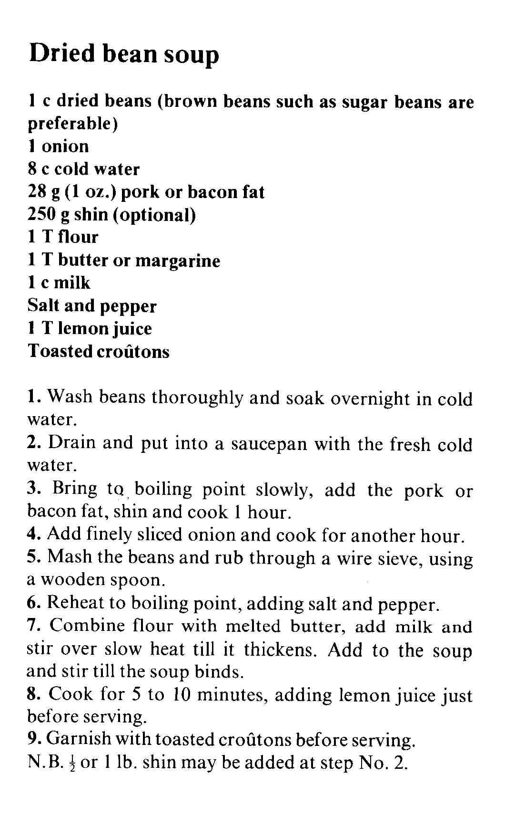

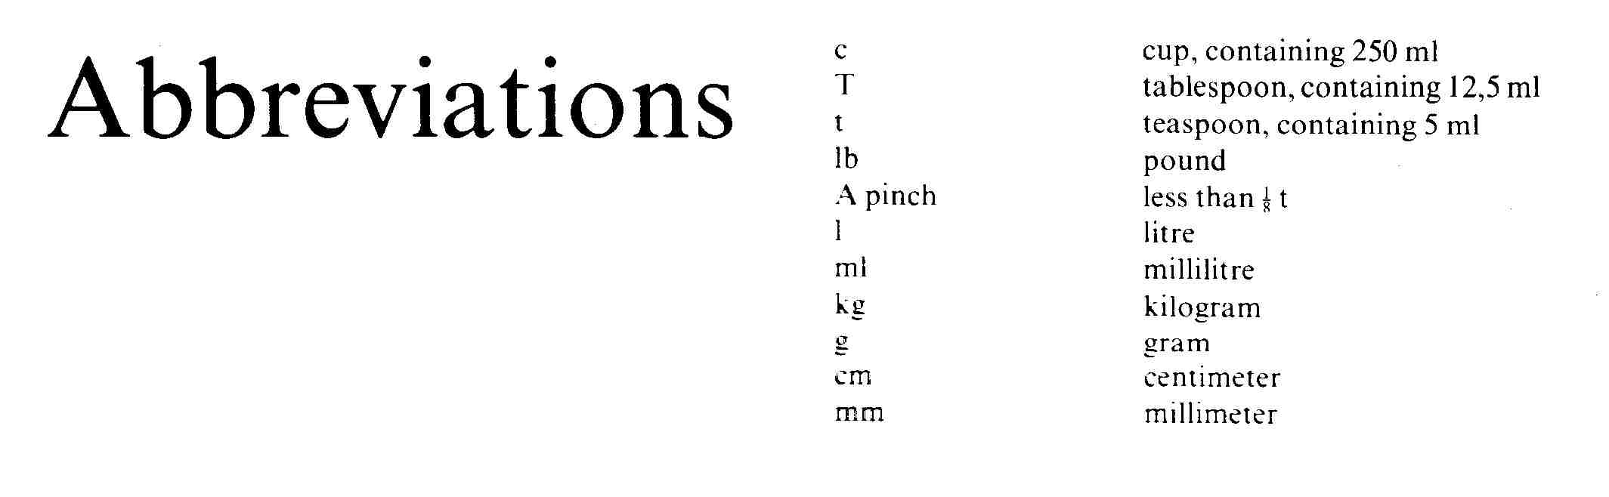

On the map, find the corner of Harrison and Commissioner Streets

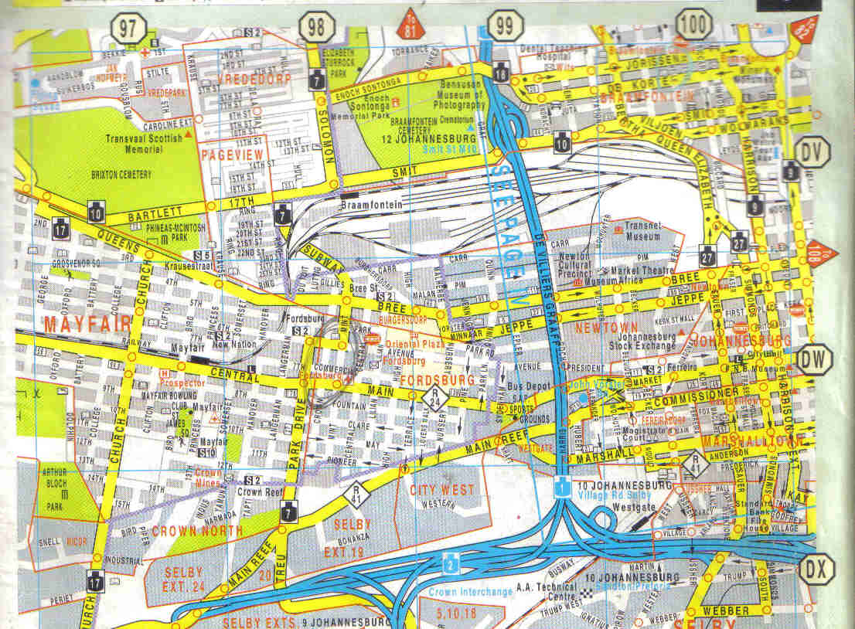

Following is an example of a form to apply for a banking account. In groups, discuss the form to identify which part of the forms have to be completed for an individual account. Then complete the form

Check that forms are completed correctly

Your Bank

Your Bank Limited, Reg No 1999/00789/09

|  |  |
| --- | --- |
| 1. INDIVIDUAL/SOLE TRADER CLIENT RECORD |  |

|  |  |  |  |  |  |  |  |  |  |  |  |  |  |  |  |  |  |  |  |  |  |  |  |  |  |  |  |  |  |  |  |  |  |  |  |  |  |  |  |  |  |  |  |  |  |
| --- | --- | --- | --- | --- | --- | --- | --- | --- | --- | --- | --- | --- | --- | --- | --- | --- | --- | --- | --- | --- | --- | --- | --- | --- | --- | --- | --- | --- | --- | --- | --- | --- | --- | --- | --- | --- | --- | --- | --- | --- | --- | --- | --- | --- | --- |
| * 1. **INDIVIDUAL/SOLE TRADER CLIENT RECORD** | | | | | | | | | | | | | | | | | | | | | | | | | | | | | | | | | | | | | | | | | | | | | |
| **1.1 PERSONAL DETAILS OF APPLICANT** | | | | | | | | | | | | | | | | | | | | | | | | | | | | | | | | | | | | | | | | | | | | | |
| Surname |  | | | | | | | | | | | | | | | | | | | | | | | | | | | | | | | | | | | | | | | | | | | | |
| Full first names |  | | | | | | | | | | | | | | | | | | | | | | | | | | | | | | | Initials | | | | | | | |  | |  | |  | |
| Title (specify) |  | | | | | | | | | | | | | | | | | | | | | | | | | | | | | | | | | | | | | | | | | | | | |
| Date of birth |  | | | | | | | | | | | | | | | Gender | | | | | | | | | | | Male | | | | | | | | | | | | Female | | | | | | |
| ID type | 01 ID Book | | | | | 02 Passport | | | ID/Passport No | | | | | |  | |  | | |  | |  | |  | | | |  | |  | | | |  | |  | |  | | |  | |  | |  |
| Marital Status | 1. Married | | | | | | 2. Single | | | | 3. Other | | | | | | | | 4. Divorced | | | | | | | | | | 5. Separated | | | | | | | | | | | 6. Widowed | | | | | |
| If married, state whether | | | 1 Antenuptial Contract (with accrual) | | | | | | | | | 2 Antenuptial Contract (without accrual) | | | | | | | | | | | | | | | | | | | | | 3 Community of Property | | | | | | | | | | | | |
| 5 Other (specify) | | | | | | | | | | | | | | | | | | | | | | | | | | | | | | | | | | | | | | | | | | |
| In which language do you require correspondence? | | | | | | | | | | English | | | | | | | | | | | | |  | | | Afrikaans | | | | | | | | | | | | | | | | | |  | |
| Home language (specify) | | |  | | | | | | | | | | | | | | | | | | | | | | | | | | | | | | | | | | | | | | | | | | |
| Type of business (for sole trader only) | | | | | | |  | | | | | | | | | | | OFFICE  USE | | | | | | | Client type | | | | | | | | | |  | |  | | |  | |  | |  | |
|  | | | | | | | | | | | SIC Code | | | | | | | | | | | | | | |  | |  | |  | |
| Financial year end (sole trader only) | | | | | |  | | | | | | |  | |  | | | Occupation code | | | | | | | | | | | | | | | | |  | |  | |
| **1.2 ADDRESS DETAILS** | | | | | | | | | | | | | | | | | | | | | | | | | | | | | | | | | | | | | | | | | | | | | |
| Business address | |  | | | | | | | | | | | | | | | | | | | | | | | | | | | | | | | | | | | | | | | | | | | |
| Suburb | | |  | | | | | | City/Town | | |  | | | | | | | | | | | | | | | | | Postcode | | | | | |  | | |  | |  | |  | |
| Residential address | |  | | | | | | | | | | | | | | | | | | | | | | | | | | | | | | | | | | | | | | | | | | | |
| Suburb | | |  | | | | | | City/Town | | |  | | | | | | | | | | | | | | | | | Postcode | | | | | |  | | |  | |  | |  | |
| **1.3 TELEPHONE DETAILS** | | | | | | | | | | | | | | | | | | | | | | | | | | | | | | | | | | | | | | | | | | | | | |
| Telephone | | (W) | | Dialling code | | | |  | | | | | | Number | | | | | | |  | | | | | | | | | | | | | | | | | | | | | | | | |
| (H) | | Dialling code | | | |  | | | | | | Number | | | | | | |  | | | | | | | | | | | | | | | | | | | | | | | | |
| Fax | | (W) | | Dialling code | | | |  | | | | | | Number | | | | | | |  | | | | | | | | | | | | | | | | | | | | | | | | |
| (H) | | Dialling code | | | |  | | | | | | Number | | | | | | |  | | | | | | | | | | | | | | | | | | | | | | | | |
| Cell phone | |  | | | | | | | | | | | | | | | | | | | | | | | | | | | | | | | | | | | | | | | | | | | |
| Email address | |  | | | | | | | | | | | | | | | | | | | | | | | | | | | | | | | | | | | | | | | | | | | |
| Internet website | |  | | | | | | | | | | | | | | | | | | | | | | | | | | | | | | | | | | | | | | | | | | | |

|  |  |  |  |  |  |  |  |  |  |  |  |  |  |  |  |  |  |  |  |  |  |  |  |  |  |  |  |  |  |  |  |  |  |  |  |  |  |  |  |  |
| --- | --- | --- | --- | --- | --- | --- | --- | --- | --- | --- | --- | --- | --- | --- | --- | --- | --- | --- | --- | --- | --- | --- | --- | --- | --- | --- | --- | --- | --- | --- | --- | --- | --- | --- | --- | --- | --- | --- | --- | --- |
| **1.4 EMPLOYMENT DETAILS** | | | | | | | | | | | | | | | | | | | | | | | | | | | | | | | | | | | | | | | | |
| Occupation (individual) |  | | | | | | | | | | | | | | | | | | | | | | | | | | | | | | | | | | | | | | | |
| Occupational status | 1 Full time employed | | | | | | | | 2 Professional self-employed | | | | | | | | | | | | 3 Non-professional self-employed | | | | | | | | | | | | | | | 4 Housewife | | | | |
| 5 Student | | | | 6 Unemployed | | | | | | 7 Part time employed | | | | | | | | 8 Temporarily employed | | | | | | | | | | 9 Scholar | | | | | | | | 10 Pension | | | |
| Employment sector | Agriculture | | | | | Catering & entertainment | | | | | | | | Civil service | | | | | | | | Construction | | | | | | Education | | | | | Finance | | | | | | Health | |
| Security | | | | | | Selling | | | | | Transportation | | | | | | | | Welfare | | | | | | | Armed forces | | | | | | | | Media | | | | | |
| Industry | | | | | | | Legal profession | | | | | | | Nature Resources | | | | | | | | | | Science/Computing | | | | | | | | Other | | | | | | | |
| Occupation level | Senior management | | | | | | | | | Management | | | | | | Supervisor | | | | | | | | Skilled worker | | | | | | | | Semi-skilled worker | | | | | | | | |
| Unskilled worker | | | | | | | | | | | Junior position | | | | | | | | | | | | | | |  | | | | | | | | | | | | | |
| **1.5 ADDITIONAL CLIENT INFORMATION** | | | | | | | | | | | | | | | | | | | | | | | | | | | | | | | | | | | | | | | | |
| Monthly income (specify) | | |  | | | | | | | | | | | | | | Number of dependants | | | | | | | | | | | | | |  | | | | | | | | | |
| Residential status | Owner | | | | Tenant | | | | Boarder | | | | Rented flat | | | | | | Caravan/informal settlement | | | | | | | | | | | | | Living with parents | | | | | | | | |
| Ever declared insolvent | | Yes | | No | | Tax number | | | | | | |  | | |  | |  | | | | |  | | |  | |  | |  | | | |  | | | |  | |  |

Explain the procedures that are followed in the classroom on the first day of training.

|  |
| --- |
| Check that procedures are correct |
|  |
|  |
|  |
|  |
|  |

In groups, discuss the rules of the game Boggle regarding forming of words.

|  |
| --- |
| Check that procedures are correct |
|  |
|  |
|  |
|  |
|  |

This is an individual activity.

Find out how to change a plug for an electrical appliance such as a kettle and demonstrate the procedure to the group.

|  |
| --- |
| Check that procedures are correct |
|  |
|  |
|  |
|  |
|  |

Read the following text and then follow the instructions below.

**CHECK YOUR ATTITUDE**

A positive, enthusiastic attitude makes all the difference. If you allow yourself to get down-hearted you will convey this frame of mind to your colleagues and employees. One of the problems with a negative attitude is that it destroys action. People who have failed spend so much time negatively analysing their business, that they take no action. Winners do not have time for this. They simply carry on with the tasks that have to be done.

Associate with successful people. Meet with other business people who feel excited about what they are doing. Enthusiasm is a wonderful thing. It is contagious. Just think of how quickly a crowd at a soccer match or other sport gathering can become enthusiastic. As a leader, you have to set an example for everyone in your business. If you are confident, have a positive attitude and act as though you are a winner, you will find that you are surrounded by other high performers.

**Checklist: how do you match up?**

Do you:

1. Project an attitude of success
2. Have confidence in what you do
3. Encourage yourself all the time that you are doing the right thing
4. Associate with other successful and positive people – the winners of this world
5. Know what you are doing
6. Work at building up relationships and providing your customers with complete satisfaction.

Which reading strategy did you use when you read the above text? (1)

|  |
| --- |
| Any of the following is worth one point: skim, scan, pre-reading, re-reading, predict, sift |

Did the author make use of headings, sub-headings and numbers or bullets? Give an example of each one you can identify. (3)

|  |
| --- |
| Heading: CHECK YOUR ATTITUDE (1) |
| Sub heading: Checklist: how do you match up? (1) |
| bullets |

### Activity 2 (8963 SO2, AC1-4)

Identify at least two examples of explicitly stated facts in the article about slavery.

|  |
| --- |
| Make sure that the examples are correct |
|  |
|  |
|  |

Identify at least three examples of implicitly stated points in the article about slavery.

|  |
| --- |
| Make sure that the examples are correct |
|  |
|  |
|  |
|  |
|  |

In a group, find the equivalent in your mother tongue of at least three of the expressions named in the learner guide. State them in English.

|  |
| --- |
| Check the expressions |
|  |
|  |

In a group, quote at least three other expressions from your mother tongue. State them in English and also explain what they mean.

|  |
| --- |
| Check the expressions |
|  |
|  |

Summarise the article about slavery as a mind map

|  |
| --- |
|  |

Explain role play

|  |
| --- |
| Role-plays: participants are presented with a situation, often a problem or an incident, to which they have to respond, by assuming a specific role. |
|  |

Explain simulation

|  |
| --- |
| Simulations: mirror actual activities or conditions. This is used by airline pilots and astronauts, where the flying conditions are simulated in a flying chamber so that the pilots can get used to flying conditions without actually flying an aeroplane. |
|  |

Identify jargon or technical words used in a specific industry, such as the transport or retail industry. Identify at least 3 words.

|  |
| --- |
| Check that the words are jargon |
|  |
|  |

### Activity 3 (8963 SO3, AC1-6)

**Look at the cover page of a novel that tells you at a glance what the story is about. The novel is called “THEY’RE ALL MY CHILDREN”. Answer the following questions**:

Who wrote the book?

|  |
| --- |
| Louanne Johnson |

What do you think the book is about? A mother writing about her children, a grandmother writing about her children and grandchildren, a teacher writing about the schoolchildren she taught or someone saving war orphans?

|  |
| --- |
| teacher writing about the schoolchildren she taught |
|  |

Why do you think so?

|  |
| --- |
| Check the motivation |
|  |

There are two clues in this cover page that helps you identify what the story is about. What are they?

|  |
| --- |
| The word in the title: children |
| the black board and chalk |

What do you think of the page layout?

|  |
| --- |
| Check the motivation |
|  |

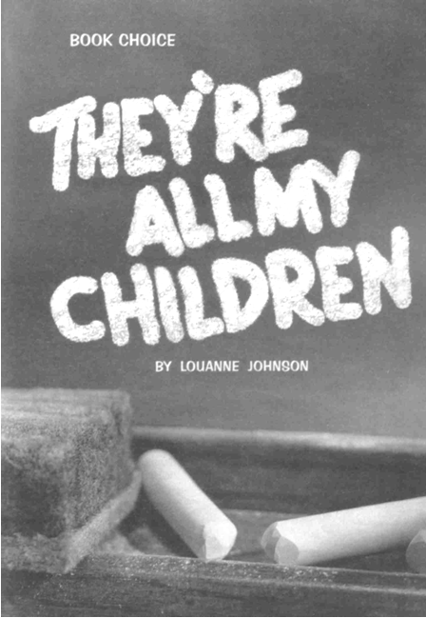

**The next piece of writing is called: “Notes from all over”.**

Note how titles, subtitles and visual aids are used to highlight main points and helps you to decide whether to read the article or simply skim until you get to something that interests you.

Which part of the written piece would you read first?

|  |
| --- |
| Check the motivation |
|  |

Why?

|  |
| --- |
| Check the motivation |
|  |

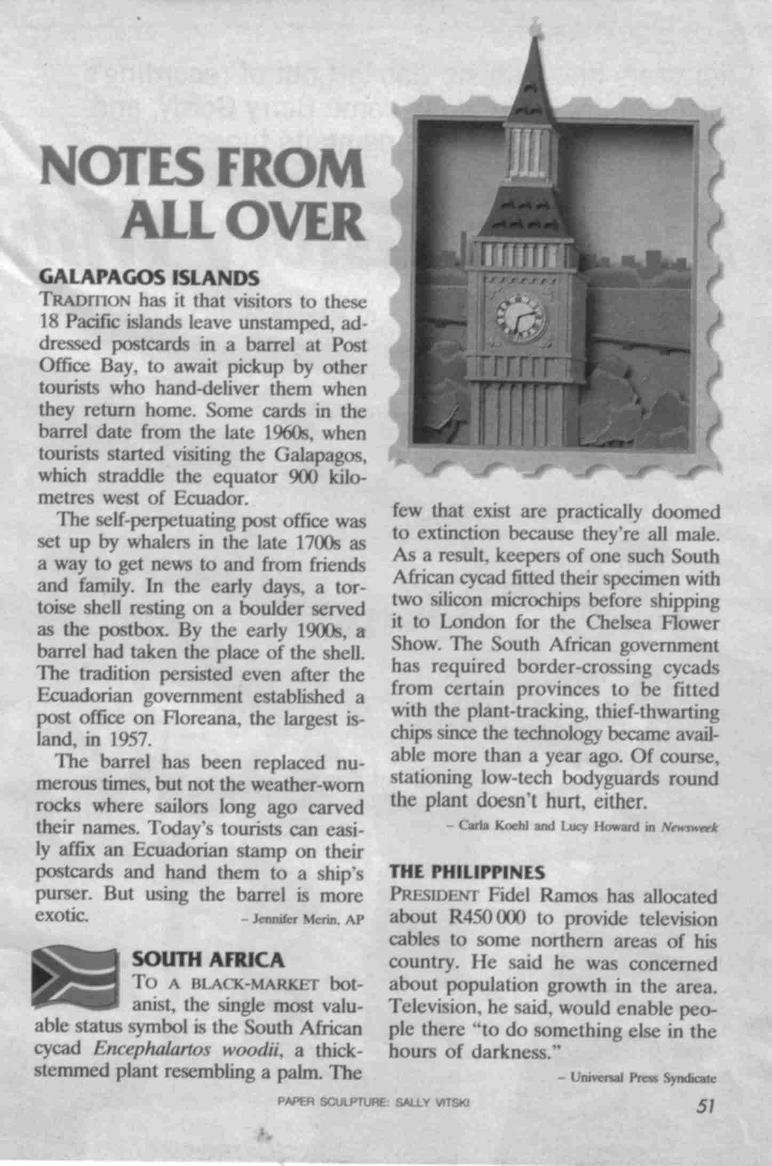

Below is the first page of a magazine article about slavery. Answer the following questions about this page:

* Who wrote the article?
* Which techniques are used to catch your attention and encourage your to read further?
* To which continent did slavery return, according to the author?
* Why do you think so?
* Who is being taken prisoner?



### Activity 4 (8963 SO4, AC1-2)

In a group, find the equivalent in your mother tongue (home language) of at least three of the expressions mentioned in the learner guide.

|  |  |
| --- | --- |
|  |  |
|  |  |
|  |  |
|  |  |
|  |  |
|  |  |

In a group, quote at least three other expressions from your mother tongue. Explain what they mean in English.

|  |  |
| --- | --- |
|  |  |
|  |  |
|  |  |
|  |  |
|  |  |
|  |  |

In a group, give three examples of generalisations.

|  |
| --- |
| Any three generalisations, such as all blondes are stupid |
|  |
|  |
|  |
|  |
|  |

What do you think of when you look at the following pictures? Write down your observations. Also write down why you think so.











In a group, discuss the following scene and answer the questions:

* What do you think is happening in the scene below?
* Why do you think so?
* I put three pictures of the previous exercise together. How does your feeling about what is happening differ from the previous pictures.





In a group, discuss the following scene and answer the questions:

* What do you think of when you look at the scene below?
* Why do you think so?
* I put two pictures of the previous exercise together. How does your feeling about the picture differ from the previous pictures?



In a group, discuss the following scene and answer the questions:

* What do you think is happening in the scene below?
* Why do you think so?



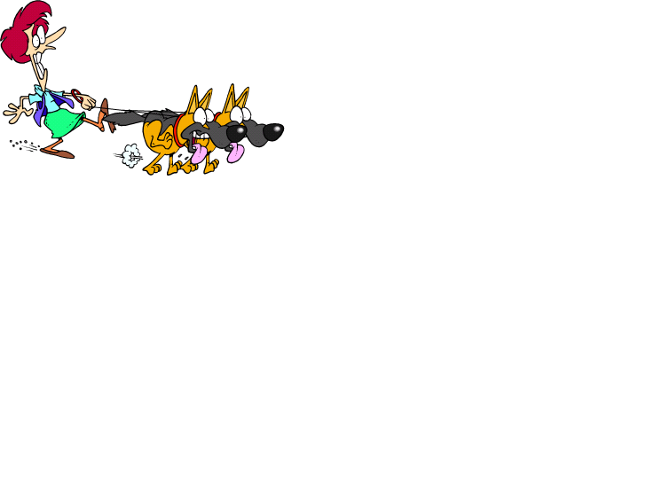

**Look at the advertisements on the following pages and answer the following questions about them:**

* What is being advertised?
* What was the first thing you noticed?
* How did they make use of font types and sizes to make key points stand out?
* Is the layout of the page done in a way that is interesting and gets your attention?
* Was it easy to understand the message?

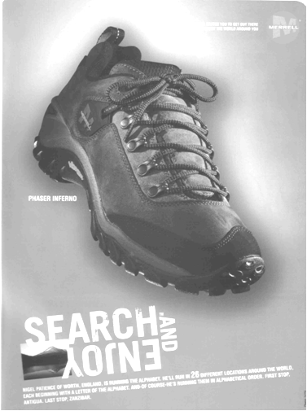

|  |
| --- |
|  |
|  |
|  |
|  |
|  |
|  |
|  |
|  |

In a group, give three examples of stereotyping.

|  |
| --- |
|  |
|  |
|  |
|  |
|  |

In a group, give at least three examples of figurative expressions.

|  |
| --- |
|  |
|  |
|  |
|  |
|  |

In a group, think of more examples of repetition.

|  |
| --- |
|  |
|  |
|  |
|  |
|  |

In a group, add some captions to the following picture:

|  |  |  |  |
| --- | --- | --- | --- |
| |  | | --- | |  | |  | |  |   Gof |

What was your most painful experience as a result of bias? You must also state whether the bias was due to cultural differences, religious beliefs, racist or sexist beliefs, due to discrimination or due to peer pressure.

|  |
| --- |
|  |
|  |
|  |
|  |
|  |

Give one example of each of the following biases: Cultural

|  |
| --- |
| Check the answer |
|  |

Religious

|  |
| --- |
| Check the answer |
|  |

Peer pressure

|  |
| --- |
| Check the answer |
|  |

Racial discrimination

|  |
| --- |
| Check the answer |
|  |

Discrimination due to your gender

|  |
| --- |
| Check the answer |
|  |

Discrimination due to age

|  |
| --- |
| Check the answer |
|  |

In the article about slavery, the slave traders discriminate against the Dinka tribe. At least two forms of discrimination are mentioned. Identify them.

|  |
| --- |
| Check the answer |
|  |
|  |
|  |

Following is a quote from a book called *My Family and Other Animals*, by Gerald Durrell. The book contains short stories about his family’s move from England to Greece, in the time before the second world war. They took their dog, called Roger, with them. Gerald had two older brothers, Larry and Leslie.

*“That dog’s been a nuisance all the way from England,” said Larry. “I had hoped to give an impression of gracious majesty, and this is what happens … we arrive in town like a troupe of medieval tumblers.”*

*“Don’t keep on, dear,” Mother said soothingly, straightening her hat: “we’ll soon be at the hotel.”*

*So our cab clopped and jingled its way into the town, while we sat on the horsehair seats and tried to muster the appearance of gracious majesty Larry required. Roger, wrapped in Leslie’s powerful grasp, lolled his head over the side of the vehicle and rolled his eyes as though at his last gasp. Then we rattled past an alley-way in which four scruffy mongrels were lying in the sun. Roger stiffened, glared at them and let forth a torrent of deep barks. The mongrels were immediately galvanized into activity, and they sped after the cab, yapping vociferously. Our pose was irretrievable shattered, for it took two people to restrain the raving Roger, while the rest of us leaned out of the cab and made wild gestures with magazines and books at the pursuing horde. This only had the effect of exciting them still further, and at each alley-way we passed their numbers increased, until by the time we were rolling down the main thoroughfare of the town there were some twenty-four dogs swirling about our wheels, almost hysterical with anger.*

This is an example of humour. Did you find the piece funny? Motivate your answer.

|  |
| --- |
|  |
|  |
|  |
|  |
|  |
|  |
|  |
|  |
|  |
|  |
|  |

In a group, analyse the written piece about Jacob Zuma’s supporters.

How many short sentences are used in the article?

|  |
| --- |
| 3 |
|  |

How many long sentences?

|  |
| --- |
| 9 |
|  |

Give one example of a complex sentence

|  |
| --- |
| It is a sad reflection on South African society … |
| It is even sadder that this Neanderthal … |
| Equally shocking is that only about 5% … |

Give one example of a compound sentence.

|  |
| --- |
| Last year about 55 000 rapes ….. |
|  |

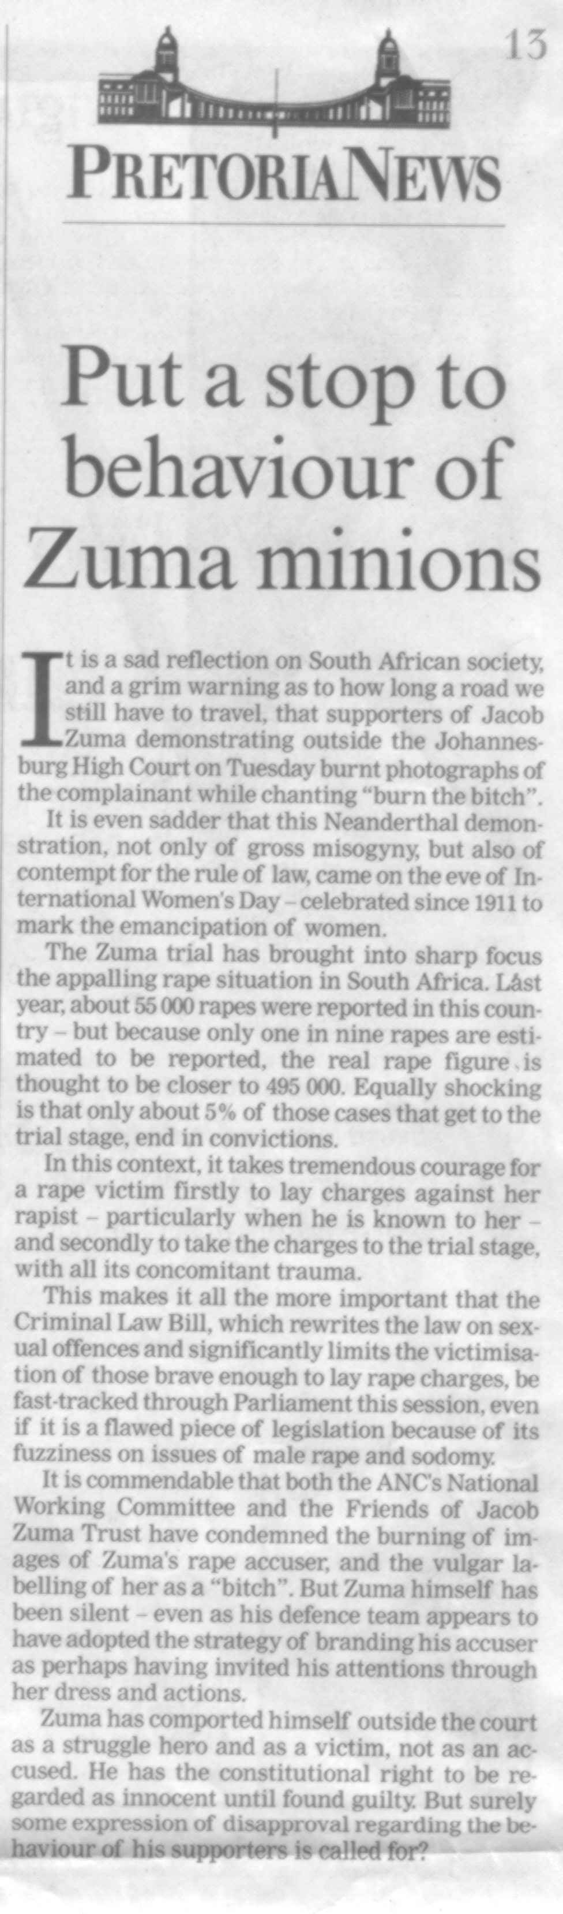

Extract from the Pretoria News of 9 March 2006.

Analyse the article called: Spectre of AIDS at Mandela Nuptials.

How many short sentences are used in the article?

|  |
| --- |
| 3 |
|  |

How many long sentences?

|  |
| --- |
| 12 |

Give one example of a complex sentence

|  |
| --- |
| Mandla Mandela and his wife … |
| Speaking at his reception … |
| My parents, Makgatho and Joyce … |
|  |

Give one example of a compound sentence.

|  |
| --- |
| Mandla was flanked by his close friend … |
| Beef stroganoff and a spitbraai … |

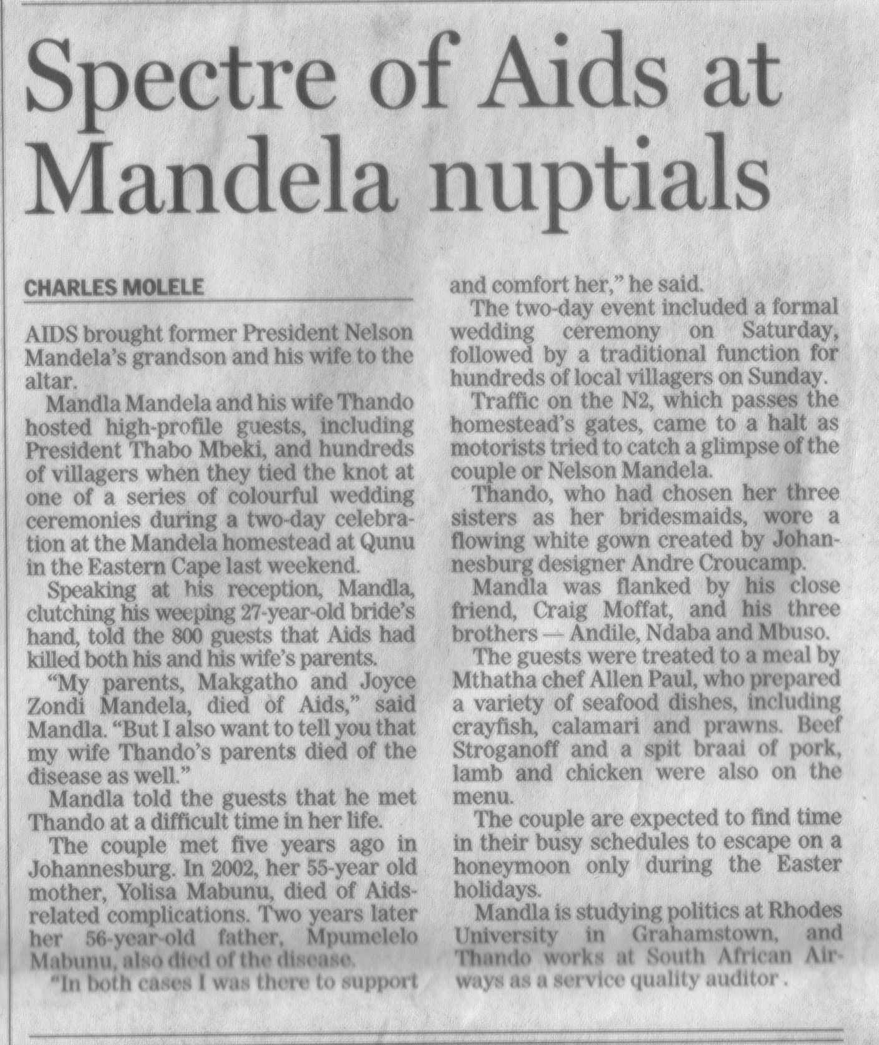

### Activity 5 (8964 SO1, AC1-2)

On the following pages you will find copies of an article called Good Neighbours? From the Clicks ClubCard magazine of October 2005.

Do the following:

1. Identify the style of writing.
2. Identify the structures and features of text that was used.
3. Do the visual aids add to your understanding of the article?
4. How are sentence lengths varied to capture and hold your attention? Use any paragraph as an example.
5. Does the author’s paragraphs flow logically?
6. How does the author link paragraphs? Use the first and second paragraphs as an example.
7. Do the paragraphs vary in length? Motivate your answer.
8. Where do you think the author collected information and data from?
9. Summarise the text, using headings, sub headings, numbers and/or bullets. Make sure that you simplify the text (write/sign in plain. Clear language)

### Activity 6 (8964 SO 2, AC 1-7

Refer back to the article called Good Neighbours? From the Clicks ClubCard magazine of October 2005. Paraphrase this article. Ensure that you use language structures and features as well as text structures and features. Vary the sentence length, vary the length of the paragraphs, pay attention to your first and last paragraph and make sure that your paragraphs follow each other logically. Pay attention to signing, NMF’s and handshapes when you to this assessment.

Also make sure that you do not use offensive or discriminatory language.

### Activity 7 (8964 SO3, AC 1-2)

Check your summary for the following:

* Excessive use of jargon, insensitive choice of words/signs, (gender; rank; hierarchies in familiar settings or organisations; family; sports; wealth) offensive or incorrect register – remove if present
* Complex wording/signing of ideas – simplify if present



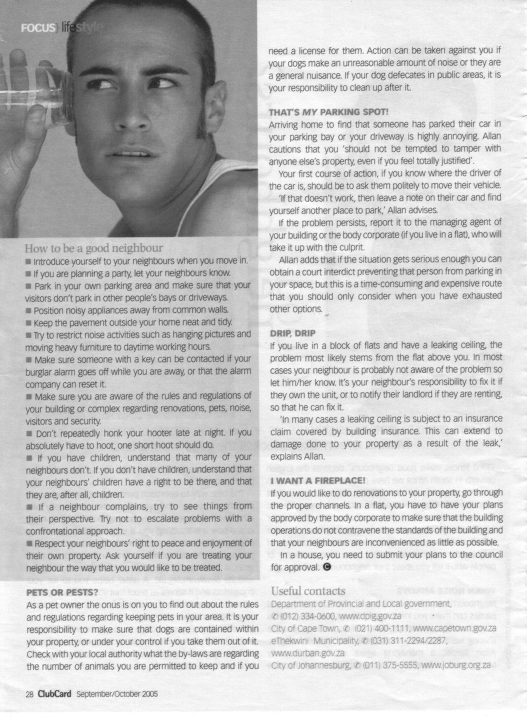

### Activity 8 (8964 SO4, AC 1-6)

Paraphrase this article. Ensure that you use language structures and features as well as text structures and features. Vary the sentence length, vary the length of the paragraphs, pay attention to your first and last paragraph and make sure that your paragraphs follow each other logically. Pay attention to signing, NMF’s and handshapes when you to this assessment.

Also make sure that you do not use offensive or discriminatory language.

# UNIT STANDARDS 8962 & 8967

### Activity 2 (8962 SO1, AC 1-7)

The facilitator will read/sign a piece of text. In a group, use the who, what, when, where, why and how questions to extract the main idea from the communication.

|  |
| --- |
|  |
|  |
|  |
|  |
|  |
|  |
|  |
|  |
|  |
|  |
|  |
|  |
|  |
|  |
|  |
|  |
|  |
|  |
|  |
|  |

### Effective Communication Self Evaluation

To help you become more aware of your communication habits, complete the following communication self-evaluation by checking either ‘Strongly Disagree,’ ‘Disagree,’ ‘Neutral,’ ‘Agree,’ or ‘Strongly Agree’ for each statement. After the quiz, follow the scoring and interpretation grid.

|  |  |  |  |  |  |  |  |  |  |  |
| --- | --- | --- | --- | --- | --- | --- | --- | --- | --- | --- |
|  |  | **Strongly Disagree** |  | **Disagree** |  | **Neutral** |  | **Agree** |  | **Strongly Agree** |
| 1 | I tend not to listen to people with whom I disagree. | □ |  | □ |  | □ |  | □ |  | □ |
| 2 | I find it difficult to fully participate in conversations where the subject is not of interest to me. | □ |  | □ |  | □ |  | □ |  | □ |
| 3 | When I feel I know the message the communicator is trying to get across, I stop listening | □ |  | □ |  | □ |  | □ |  | □ |
| 4 | I find it easy to listen to others’ views even if they are different from my own | □ |  | □ |  | □ |  | □ |  | □ |
| 5 | I ask people to clarify things I don’t understand. | □ |  | □ |  | □ |  | □ |  | □ |
| 6 | I usually form a rebuttal in my head while the other person is talking. | □ |  | □ |  | □ |  | □ |  | □ |
| 7 | I often look as if I am listening when, in fact, I’m not. | □ |  | □ |  | □ |  | □ |  | □ |
| 8 | I sometimes daydream when I should be listening. | □ |  | □ |  | □ |  | □ |  | □ |

|  |  |  |  |  |  |  |  |  |  |  |
| --- | --- | --- | --- | --- | --- | --- | --- | --- | --- | --- |
|  |  | **Strongly Disagree** |  | **Disagree** |  | **Neutral** |  | **Agree** |  | **Strongly Agree** |
| 9 | If I’m not listening, I will tell the person | □ |  | □ |  | □ |  | □ |  | □ |
| 10 | I listen for the main ideas, not the details. | □ |  | □ |  | □ |  | □ |  | □ |
| 11 | I recognize that words mean different things to different people. | □ |  | □ |  | □ |  | □ |  | □ |
| 12 | If I don’t like or believe the other person, I block out what is being said. | □ |  | □ |  | □ |  | □ |  | □ |
| 13 | I look at the person who is talking. | □ |  | □ |  | □ |  | □ |  | □ |
| 14 | I concentrate on the other person’s message rather than on physical appearance. | □ |  | □ |  | □ |  | □ |  | □ |
| 15 | I know which words and phrases cause me to react emotionally | □ |  | □ |  | □ |  | □ |  | □ |
| 16 | I preplan my communications with others to accomplish my goals. | □ |  | □ |  | □ |  | □ |  | □ |
| 17 | I anticipate other’s reactions to my communications | □ |  | □ |  | □ |  | □ |  | □ |
| 18 | I take into consideration how others want to receive my information. | □ |  | □ |  | □ |  | □ |  | □ |

|  |  |  |  |  |  |  |  |  |  |  |
| --- | --- | --- | --- | --- | --- | --- | --- | --- | --- | --- |
|  |  | **Strongly Disagree** |  | **Disagree** |  | **Neutral** |  | **Agree** |  | **Strongly Agree** |
| 19 | I try to determine the mood of the other person (angry, frustrated, worried, etc.)when communicating with them. | □ |  | □ |  | □ |  | □ |  | □ |
| 20 | I feel that I’m able to communicate my ideas to others so that they understand my meaning. | □ |  | □ |  | □ |  | □ |  | □ |
| 21 | I often feel others should have known my meaning. | □ |  | □ |  | □ |  | □ |  | □ |
| 22 | I am able to receive negative feedback without getting defensive | □ |  | □ |  | □ |  | □ |  | □ |
| 23 | I practice my listening skills on a regular basis | □ |  | □ |  | □ |  | □ |  | □ |
| 24 | I find it hard to concentrate on what someone is saying when there are noise distractions | □ |  | □ |  | □ |  | □ |  | □ |
| 25 | I often judge the content of other’s messages when they’re communicating with me | □ |  | □ |  | □ |  | □ |  | □ |
| 26 | I restate information given to me to make sure that I understand it correctly | □ |  | □ |  | □ |  | □ |  | □ |
| 27 | I let others know that I recognize the emotional level they are at when speaking to them. | □ |  | □ |  | □ |  | □ |  | □ |

#### Scoring:

Circle the number that corresponds to your checkmarks for each question. Then add up these numbers to reach a total score.

Strongly Strongly

Disagree Disagree Neutral Agree Agree

1 5 4 3 2 1

2 5 4 3 2 1

3 5 4 3 2 1

4 1 2 3 4 5

5 1 2 3 4 5

6 5 4 3 2 1

7 5 4 3 2 1

8 5 4 3 2 1

9 1 2 3 4 5

10 1 2 3 4 5

11 1 2 3 4 5

12 5 4 3 2 1

13 1 2 3 4 5

14 1 2 3 4 5

15 1 2 3 4 5

16 1 2 3 4 5

17 1 2 3 4 5

18 1 2 3 4 5

19 1 2 3 4 5

20 1 2 3 4 5

21 5 4 3 2 1

22 1 2 3 4 5

23 1 2 3 4 5

24 5 4 3 2 1

25 5 4 3 2 1

26 1 2 3 4 5

27 1 2 3 4 5

Total = \_\_\_\_\_ \_\_\_\_\_\_ \_\_\_\_\_\_ \_\_\_\_\_\_ \_\_\_\_\_\_

Grand Total = \_\_\_\_\_\_\_\_\_\_\_\_\_\_\_\_\_\_\_\_\_\_

#### Analysis

*See where your grand total fits in the categories below and then read your analysis.*

***Total Score:***

* 109 – 125 You have an excellent understanding of the communication process. Keep up the good work.
* 83 – 108 You have a strong understanding of the communication process and often use it effectively. You have a few areas that could use some extra work. Try to work on your weaknesses.
* 54 – 81 You have a general understanding of the communication process and may occasionally use it effectively. You frequently get into trouble when communicating with others and you have a number of areas that could use some improvement.
* 27 – 53 You have many opportunities to improve your communication effectiveness. Your skills are not what they should be in order to consistently get your message across clearly to others. Other people may frequently misunderstand your meaning.

### Activity 3 (8962 SO2, AC1-4)

Prepare a short presentation about a subject that interests you. It could be a hobby, sport, politics, etc. The presentation should not last longer than five minutes, with two or three minutes for questions. Present your speech to the group. The other group members will evaluate you about the following:

* Did you combine the spoken/signed word with visual features and body language and did this enhance the presentation?
* Did you use intonation/NMFs appropriately?
* Did you express your own ideas and opinions in ways that reflect respect for others and sensitivity to socio- cultural differences?
* Did the others in the group understand your speech?
* How did your form of politeness impact on the interaction during the question session?

### Activity 4 (8962 SO3, AC1-3)

The members of the group will take turns to read/sign the article about Jacob Zuma out loud. Each member can read a paragraph until the entire article has been read/signed. In a group,

Identify unfamiliar words

|  |
| --- |
| Lead the discussion |
|  |
|  |
|  |

Discuss how you can use contextual clues to find out the meaning of unfamiliar words.

|  |
| --- |
| Give the learners advice on how to do this |
|  |
|  |
|  |
|  |
|  |
|  |
|  |
|  |
|  |
|  |
|  |

### Activity 5 (8962 SO4, AC1-6)

Refer back to the article about Mr Zuma. Sort the relevant facts into chronological order. Compare your notes to those of the other groups. Prepare a short presentation in the formal register about these facts. One member of the group to give the presentation to the other groups

|  |
| --- |
| Check that the presentation is in chronological order |
|  |
|  |
|  |
|  |
|  |
|  |
|  |
| Presentation |
|  |
|  |
|  |
|  |
|  |
|  |
|  |
|  |
|  |
|  |
|  |
|  |
|  |
|  |
|  |
|  |
|  |

### Activity 6 (8962 SO5, AC1-3)

As part of your pre training assessment, you had to watch an actuality show or documentary on TV, or listen to such a program on the radio.. Identify the facts and opinions. Motivate your answer. Include the details of the program in your assessment: date, subject, interviewer and interviewee.

Discuss your findings with your fellow group members.

What information do you think has been omitted by the interviewer? List at least two instances. Motivate your answer.

|  |
| --- |
| Check the motivation |
|  |
|  |
|  |

How does the tone of the interviewee (the person being interviewed) affect the audience’s point of view? Motivate your answer.

|  |
| --- |
| Check the motivation |
|  |
|  |
|  |

How does the point of view of the interviewer affect the audience’s point of view? Motivate your answer.

|  |
| --- |
| Check the motivation |
|  |
|  |
|  |

What information do you think has been selected by the interviewer? List at least two instances. Motivate your answer.

|  |
| --- |
| Check the motivation |
|  |
|  |
|  |

What information do you think has been left out by the interviewer?

|  |
| --- |
| Check the motivation |
|  |
|  |
|  |

How do your findings compare to those of the other group members?

|  |
| --- |
| Check the motivation |
|  |
|  |
|  |

Refer back to the article about Mr Zuma in handout 1. Do you think any facts or information has been left out? Motivate your answer.

|  |
| --- |
| Check the motivation |
|  |
|  |
|  |

Think of political speakers and how they use rhetorical questions. In a group, list at least three examples.

|  |
| --- |
| Check the answers |
|  |
|  |
|  |

On the second page in handout 1 there is an article about the marriage of Nelson Mandela’s grandson. In this article there is an example where the first person is quoted. Find the example and quote it below.

|  |
| --- |
| Check the answer |
|  |
|  |
|  |

Think of political speakers who use the first person to include you in their speech, thereby influencing the audience. List at least two examples.

|  |
| --- |
| Check the answers |
|  |
|  |
|  |

Do you think using rhetorical questions and first person is a good way of influencing the audience?

|  |
| --- |
| Check the motivation |
|  |
|  |
|  |

### Activity 7 (8967 SO1, AC1-2)

During your pre training assessment you were required to do research about future career prospects. List the sources you used.

|  |
| --- |
| Check answer |
|  |
|  |
|  |

Can you think of any other sources you can consult? Name them.

|  |
| --- |
| Check answer |
|  |
|  |
|  |

Where can you find information about HIV/AIDS? List two sources of information.

|  |
| --- |
| Check answer |
|  |
|  |
|  |

### Activity 8 (8967 SO2, AC1-6)

Have a group discussion about the advantages and disadvantages of studying in a group.

|  |
| --- |
|  |
|  |
|  |
|  |
|  |
|  |
|  |
|  |
|  |

### Activity 9 (8967 SO4, AC1-6)

In your groups, discuss the process of gathering information, classifying and recording the information. Refer to the activities you undertook during your pre-training assignments. What would you do differently?

|  |
| --- |
| Check the group presentations for understanding about the research process. |
|  |
|  |
|  |
|  |
|  |
|  |
|  |
|  |
|  |
|  |
|  |
|  |
|  |

### Activity 10 (8967 SO5, AC1-4)

Have a group discussion about ways to improve the behaviour of bus and taxi drivers. Use the steps in the negotiation process to prepare for negotiations with taxi drivers. Break into separate groups, where one group represents taxi drivers and the other group represents passengers. Negotiate for better service from the taxi drivers

|  |
| --- |
| Monitor the negotiation process |
|  |
|  |
|  |
|  |
|  |
|  |
|  |
|  |
|  |
|  |
|  |
|  |
|  |
|  |
|  |
|  |
|  |
|  |
|  |
|  |

Break up into your groups. Take five minutes to list three examples of conflicts and disputes of importance to you in your work and in your life where negotiation could be used effectively. After the discussion, each person in the group, in turn, tells the group, very briefly, about one idea and then discussions, questions and suggestions are discussed within the group.

|  |
| --- |
| One member of the group to present two examples to the class |
|  |
|  |
|  |
|  |
|  |
|  |
|  |
|  |
|  |
|  |
|  |
|  |
|  |
|  |

This is an individual activity that has to be discussed in the groups afterwards

Have you ever been involved in a team or group: at schools, work or sport? What was the purpose of the team?

|  |
| --- |
| Check the answers |
|  |
|  |
|  |

Were the team goals achieved? Do you think teamwork or lack thereof affected the achieving of the team goals?

|  |
| --- |
| Check the answers |
|  |
|  |
|  |

What would you do differently if you were the team leader?

|  |
| --- |
| Check the answers |
|  |
|  |
|  |

### Activity 11 (8967 SO6, AC1-3)

When the group presents to the classroom, check that the answers are relevant to the questions that were asked

Select one organisation from the services industry that is also a small business, such as a hair dresser. In a group, discuss the following:

|  |
| --- |
| Communication channels in the organisation |
|  |
|  |
| Communication resources such as telephone, fax, computers |
|  |
|  |
| Technological resources used by the organisation, such as computers |
|  |
|  |
| What multilingual needs exist in the organisation |
|  |
|  |

In a group, discuss your research from the pre training assessment about a manufacturing business.:

|  |
| --- |
| Communication channels in the organisation |
|  |
|  |
| Communication resources such as telephone, fax, computers |
|  |
|  |
| Technological resources used by the organisation, such as computers |
|  |
|  |
| What multilingual needs exist in the organisation |
|  |
|  |

Discuss your own organisation:

|  |
| --- |
| Communication channels in the organisation |
|  |
|  |
| Communication resources such as telephone, fax, computers |
|  |
|  |
| Technological resources used by the organisation, such as computers |
|  |
|  |
| What multilingual needs exist in the organisation |
|  |
|  |

List the similarities and differences between the organisations and how the differences impact on the occupational learning of the employees.

|  |
| --- |
|  |
|  |
|  |
|  |
|  |
|  |
|  |
|  |
|  |
|  |
|  |
|  |
|  |
|  |
|  |
|  |

### Activity 12 (8967 SO3, AC1-3)

In a group, develop a lending sheet for the video list in handout 2

|  |
| --- |
|  |

# PERSONAL INFORMATION

|  |  |
| --- | --- |
| **NAME** |  |
| **CONTACT ADDRESS** |  |
|  |
| **Code** |  |
| **Telephone (H)** |  |
| **Telephone (W)** |  |
| **Cellular** |  |
| **Learner Number** |  |
| **Identity Number** |  |
| **EMPLOYER** |  |
| **EMPLOYER CONTACT ADDRESS** |  |
|  |
| **Code** |  |
| **Supervisor Name** |  |
| **Supervisor Contact Address** |  |
|  |
| **Code** |  |
| **Telephone (H)** |  |
| **Telephone (W)** |  |
| **Cellular** |  |

# **INTRODUCTION**

#### Welcome to the learning programme

Follow along in the guide as the training practitioner takes you through the material. Make notes and sketches that will help you to understand and remember what you have learnt. Take notes and share information with your colleagues. Important and relevant information and skills are transferred by sharing!



This learning programme is divided into sections. Each section is preceded by a description of the required outcomes and assessment criteria as contained in the unit standards specified by the South African Qualifications Authority. These descriptions will define what you have to know and be able to do in order to be awarded the credits attached to this learning programme. These credits are regarded as building blocks towards achieving a National Qualification upon successful assessment and can never be taken away from you!

## Structure

### Programme methodology



The programme methodology includes facilitator presentations, readings, individual activities, group discussions and skill application exercises.

Know what you want to get out of the programme from the beginning and start applying your new skills immediately. Participate as much as possible so that the learning will be interactive and stimulating.

The following principles were applied in designing the course:

* Because the course is designed to maximise interactive learning, you are encouraged and required to participate fully during the group exercises
* As a learner you will be presented with numerous problems and will be required to fully apply your mind to finding solutions to problems before being presented with the course presenter’s solutions to the problems
* Through participation and interaction the learners can learn as much from each other as they do from the course presenter
* Although learners attending the course may have varied degrees of experience in the subject matter, the course is designed to ensure that all delegates complete the course with the same level of understanding
* Because reflection forms an important component of adult learning, some learning resources will be followed by a self-assessment which is designed so that the learner will reflect on the material just completed.

This approach to course construction will ensure that learners first apply their minds to finding solutions to problems before the answers are provided, which will then maximise the learning process which is further strengthened by reflecting on the material covered by means of the self-assessments.

#### Different role players in delivery process

* Learner
* Facilitator
* Assessor
* Moderator

### What Learning Material you should have

This learning material has also been designed to provide the learner with a comprehensive reference guide. It is important that you take responsibility for your own learning process; this includes taking care of your learner material. You should at all times have the following material with you:

|  |  |
| --- | --- |
| **Learner Guide** | **This learner guide is your valuable possession:**  This is your textbook and reference material, which provides you with all the information you will require to meet the exit level outcomes. During contact sessions, your facilitator will use this guide and will facilitate the learning process. During contact sessions a variety of activities will assist you to gain knowledge and skills.  Follow along in the guide as the training practitioner takes you through the material. Make notes and sketches that will help you to understand and remember what you have learnt. Take and share information with your colleagues. Important and relevant information and skills are transferred by sharing!  This learning programme is divided into sections. Each section is preceded by a description of the required outcomes and assessment criteria as contained in the unit standards specified by the South African Qualifications Authority. These descriptions will define what you have to know and be able to do in order to be awarded the credits attached to this learning programme. These credits are regarded as building blocks towards achieving a National Qualification upon successful assessment and can never be taken away from you! |
| **Formative Assessment Workbook** | The Formative Assessment Workbook supports the Learner Guide and assists you in applying what you have learnt.  The formative assessment workbook contains classroom activities that you have to complete in the classroom, during contact sessions either in groups or individually.  You are required to complete all activities in the Formative Assessment Workbook. The facilitator will assist, lead and coach you through the process. These activities ensure that you understand the content of the material and that you get an opportunity to test your understanding. |

### Different types of activities you can expect

To accommodate your learning preferences, a variety of different types of activities are included in the formative and summative assessments. They will assist you to achieve the outcomes (correct results) and should guide you through the learning process, making learning a positive and pleasant experience.



The table below provides you with more information related to the types of activities.

| **Types of Activities** | **Description** | **Purpose** |
| --- | --- | --- |
| **Knowledge Activities** | You are required to complete these activities on your own. | These activities normally test your understanding and ability to apply the information. |
| **Skills Application Activities** | You need to complete these activities in the workplace | These activities require you to apply the knowledge and skills gained in the workplace |
| **Natural Occurring Evidence** | You need to collect information and samples of documents from the workplace. | These activities ensure you get the opportunity to learn from experts in the industry.  Collecting examples demonstrates how to implement knowledge and skills in a practical way |

### Assessments

The only way to establish whether a learner is competent and has accomplished the specific outcomes is through the assessment process. Assessment involves collecting and interpreting evidence about the learners’ ability to perform a task.

To qualify and receive credits towards your qualification, a registered Assessor will conduct an evaluation and assessment of your portfolio of evidence and competency.

This programme has been aligned to registered unit standards. You will be assessed against the outcomes as stipulated in the unit standard by completing assessments and by compiling a portfolio of evidence that provides proof of your ability to apply the learning to your work situation.



**How will Assessments commence?**

#### Formative Assessments

The assessment process is easy to follow. You will be guided by the Facilitator. Your responsibility is to complete all the activities in the Formative Assessment Workbook and submit it to your facilitator.

#### Summative Assessments

You will be required to complete a series of summative assessments. The Summative Assessment Guide will assist you in identifying the evidence required for final assessment purposes. You will be required to complete these activities on your own time, using real life projects in your workplace or business environment in preparing evidence for your Portfolio of Evidence. Your Facilitator will provide more details in this regard.

To qualify and receive credits towards your qualification, a registered Assessor will conduct an evaluation and assessment of your portfolio of evidence and competency.

### Learner Support

The responsibility of learning rests with you, so be proactive and ask questions and seek assistance and help from your facilitator, if required.



Please remember that this Skills Programme is based on outcomes based education principles which implies the following:

* You are responsible for your own learning – make sure you manage your study, research and workplace time effectively.
* Learning activities are learner driven – make sure you use the Learner Guide and Formative Assessment Workbook in the manner intended, and are familiar with the workplace requirements.
* The Facilitator is there to reasonably assist you during contact, practical and workplace time for this programme – make sure that you have his/her contact details.
* You are responsible for the safekeeping of your completed Formative Assessment Workbook and Workplace Guide
* If you need assistance please contact your facilitator who will gladly assist you.
* If you have any special needs please inform the facilitator

## Learner Administration



#### Attendance Register

You are required to sign the Attendance Register every day you attend training sessions facilitated by a facilitator.

#### Programme Evaluation Form

On completion you will be supplied with a “Learning programme Evaluation Form”. You are required to evaluate your experience in attending the programme.

Please complete the form at the end of the programme, as this will assist us in improving our service and programme material. Your assistance is highly appreciated.

### Learner Expectations

Please prepare the following information. You will then be asked to introduce yourself to the instructor as well as your fellow learners



|  |
| --- |
| Your name: |
|  |
|  |
| The organisation you represent: |
|  |
|  |
| Your position in organisation: |
|  |
|  |
| What do you hope to achieve by attending this course / what are your course expectations? |
|  |
|  |
|  |
|  |
|  |
|  |
|  |
|  |

# UNIT STANDARD 8963

#### Unit Standard Title

Access and use information from texts

#### NQF Level

2

#### Credits

5

#### Purpose Of The Unit Standard

Learners at this level are able to read or view, understand and respond to texts on a range of topics.

Learners credited with this unit standard are able to:

* identify the main ideas in different text types
* read and respond to texts for a variety of purposes
* use a range of reading and viewing strategies to make meaning of texts
* identify and discuss how language structures and features may influence a reader.

#### Learning Assumed To Be In Place And Recognition Of Prior Learning

The credit calculation is based on the assumption that learners are already competent in terms of the full spectrum of language knowledge laid down in the national curriculum statements up to and including GETC or NQF level 1.

Learners can:

* read and view for information and enjoyment, and respond critically to the aesthetic, cultural and emotional values in texts.

#### Unit Standard Range

Written and visual texts appropriate to the needs and interests of learners.

Specific range statements are provided in the body of the unit standard where they apply to particular specific outcomes or assessment criteria.

#### Specific Outcomes and Assessment Criteria:

**Specific Outcome 1**

Identify the main ideas in different text types.

**Assessment Criteria**

* The main ideas are identified and distinguished from supporting information.
* The author's purpose is identified and the identification is justified by reference to the text.
* Information or ideas from the text are presented in a form appropriate to a learning task or activity.
* **RANGE** Summary (e.g. mind-map, point-form, sub-headings, paragraph form), paraphrase, illustrations, role-play, dramatised key scenes.
* Socio-cultural beliefs in texts are identified and explained with reference to relevant passages or extracts from the text.
* **RANGE** Idioms, jargon (language specific to a trade, business or industry), proverbs.

**Specific Outcome 2**

Read and respond to texts for a variety of purposes.

**Outcome Range**

Textbooks, magazines, newspapers, brochures, policies, questionnaires, notices, memoranda, agendas, application forms, documentaries, novels, photographs, diagrams, blueprints, films, and any other appropriate types.

**Assessment Criteria**

* Different text types categorised in terms of their intended target audience.
* The purpose of the text is identified and the identification is justified by reference to the text and context.
* Different points of view in texts are identified and observations are justified by reference to the text and context.
* One's ideas and/or arguments are supported with a simple range of reasons and facts relevant to the topic of discussion.
* The relevance of texts is evaluated and justified in terms of meaning to self and others in peer, community or work group.
* Implicit and explicit messages in texts are identified and explained with reference to the purpose of the text.

**Specific Outcome 3**

Use a range of reading and viewing strategies to make meaning of texts.

**Assessment Criteria**

* Reading and viewing strategies employed in searching for meaning in texts are flexible and appropriate to the particular text and nature of the search.
* **RANGE** Skimming, scanning, pre-reading, re-reading, predicting and sifting.
* Simple questions used are appropriate to the context; the type of information required and/or attempts to clarify meaning.
* **RANGE** Who; what; when; where; why and how questions.
* Information from texts is recorded logically and coherently according to the purpose of the task or learning activity.
* **RANGE** Use and effect patterns; summaries; notes; annotations; time-lines; tree diagrams; highlighting; paraphrasing; flow charts; pie charts; bar graphs; Venn diagrams.
* Simple instructions and directions are read and interpreted and subsequent explanations are consistent with the intention of the text.
* **RANGE** Games; repairing objects; classroom, workplace or laboratory procedures; recipes; schedules; forms; maps; and warranties.
* The structural features of texts are identified and their uses in accessing meaning are explored.
* **RANGE** Title, sub-title, font, size of font, index page, layout, resume, summary, use of visuals/ bold/ italics/underlining, captions.
* Reference materials are used to clarify meanings of words, concepts, language structures and conventions.
* **RANGE** Dictionaries; instruction manuals; textbooks; thesaurus; encyclopaedia; the internet.

**Specific Outcome 4**

Identify and discuss how language structures and features may influence a reader.

**Assessment Criteria**

* The choice of words, language usage, symbols, pictures and tone is described in terms of how a point of view is shaped or supported.
* **RANGE** Bias (cultural, religious or peer preferences, misrepresentation, discrimination, racist, sexist, ageist); humour; irony; sarcasm, use of omission and silence, figurative expressions, repetition; hyperbole; generalisations; stereotyping; pictures and captions; typography and grammar

#### Unit Standard Accreditation And Moderation Options

* Providers of learning towards this unit standard will need to meet the accreditation requirements of the GENFETQA.
* Moderation Option: The moderation requirements of the GENFETQA must be met in order to award credit to learners for this unit standard.

#### Unit Standard Essential Embedded Knowledge

The following essential embedded knowledge will be assessed through assessment of the specific outcomes in terms of the stipulated assessment criteria:

* Learners can understand and explain that language have certain features and conventions which can be manipulated. Learners can apply this knowledge and adapt language to suit different contexts, audiences and purposes.
* Candidates are unlikely to achieve all the specific outcomes, to the standards described in the assessment criteria, without knowledge of the stated embedded knowledge. This means that for the most part, the possession or lack of the knowledge can be directly inferred from the quality of the candidate`s performance. Where direct assessment of knowledge is required, assessment criteria have been included in the body of the unit standard.

#### Critical Cross-field Outcomes (CCFO):

**Identifying**

Identify and solve problems: using context to decode and make meaning individually and in groups in oral, reading and written activities.

**Working**

Work effectively with others and in teams: using interactive speech in activities, discussion and research projects.

**Organising**

Organise and manage oneself and one`s activities responsibly and effectively through using language.

**Collecting**

Collect, analyse, organise and critically evaluate information: fundamental to the process of developing language capability across language applications and fields of study.

**Communicating**

Communicate effectively using visual, mathematical and/or language skills: in formal and informal communications.

**Science**

Use science and technology effectively and critically: using technology to access and present texts.

**Demonstrating**

Understand the world as a set of inter-related parts of a system: through using language to explore and express links, and exploring a global range of contexts and texts.

**Contributing**

Contribute to the full development of self by engaging with texts that stimulate awareness and development

# UNIT STANDARD 8964

#### Unit Standard Title

Write for a defined context

#### NQF Level

2

#### Credits

5

#### Purpose Of The Unit Standard

Learners credited with this unit standard are able to write to suit a range of contexts. They use complex sentence structures and show some control of style and register. Writers can match the choice of text type, structure, tone and word selection in their writing to the needs of specific audiences. They express themselves reasonably clearly and precisely when writing, and they are willing to explore new forms of writing in thoughtful and organised ways.

Learners at this level also use appropriate language in familiar and unfamiliar situations in their writings and in their written observations and responses based on texts they encounter. They use language appropriate to the socio-cultural, learning or workplace/technical environment as required.

Learners credited with this unit standard are able to:

* write for a specific purpose and audience
* use grammatical structures and writing conventions to produce coherent and cohesive texts for specific contexts
* adapt language to suit context
* draft and edit own writing.

#### Learning Assumed To Be In Place And Recognition Of Prior Learning

The credit calculation is based on the assumption that learners are already competent in terms of the following outcomes or areas of learning when starting to learn towards this unit standard: NQF level 1 or GETC language standards.

Learners can:

* write different kinds of texts for a wide range of purposes.

#### Unit Standard Range

* Appropriate language patterns and structures, which take account of aspects of context, purpose and audience, are used.
* Specific range statements are provided in the body of the unit standard where they apply to particular specific outcomes or assessment criteria.

#### Specific Outcomes and Assessment Criteria:

**Specific Outcome 1**

Write for a specific audience and purpose.

**Outcome Range**

Narrative, discursive, reflective, argumentative, descriptive, expository, transactional, business correspondence, electronic texts, multi-media presentations.

**Assessment Criteria**

* A range of appropriate texts is selected and produced in response to tasks or learning activities.
* Form and content are appropriate to the conventions of the text type, and to the nature and level of the target audience, as well as to the task.
* **RANGE** Format, visual presentation (headings, sub-headings, bullets, numbering, font, etc.)

**Specific Outcome 2**

Use grammatical structures and writing conventions.

**Outcome Notes**

Use grammatical structures and writing conventions to produce coherent and cohesive texts for specific contexts.

**Assessment Criteria**

Clear, simple sentences are used.

* A variety of sentence lengths and types are employed where appropriate.
* Paragraphs showing awareness of topic sentence are constructed.
* Punctuation conventions are used appropriately.
* Register is chosen to suit audience and purpose.
* Link devices are used correctly to write sustained pieces.
* Different sentence beginnings and clause structure options are correctly employed.
* Texts are organised and structured so that they have a clearly defined beginning, middle and end.

**Specific Outcome 3**

Adapt language to suit context.

**Outcome Range**

Socio-cultural, technical/workplace.

**Assessment Criteria**

* Inappropriate language is identified and adapted.
* **RANGE** Excessive use of jargon, insensitive choice of words, (gender; rank; hierarchies in familiar settings or organisations; family; sports; wealth), offensive or incorrect register.
* Complex ideas are reworded more simply.

**Specific Outcome 4**

Draft and edit own writing.

**Assessment Criteria**

* The planning, drafting, editing and redrafting of texts improves its suitability for the intended purpose and audience.
* Cohesive devices to link parts of texts with other parts and to link ideas are checked and adapted to promote overall coherence of the text.
* Major grammatical errors are identified and changes improve structure and readability of text.
* Spelling, punctuation, register, sentence and paragraph structure are checked and corrected where necessary, and the selection of vocabulary is appropriate to content.
* Points of view, where expressed, are supported with a simple range of reasons and facts.
* Sources used in writing are acknowledged and accurately recorded in format appropriate to the task or learning activity.

#### Unit Standard Accreditation And Moderation Options

* Providers of learning towards this unit standard will need to meet the accreditation requirements of the GENFETQA.
* Moderation Option: The moderation requirements of the GENFETQA must be met in order to award credit to learners for this unit standard.

#### Unit Standard Essential Embedded Knowledge

The following essential embedded knowledge will be assessed through assessment of the specific outcomes in terms of the stipulated assessment criteria:

* Learners can understand and explain that language have certain features and conventions which can be manipulated. Learners can apply this knowledge and adapt language to suit different contexts, audiences and purposes.
* Candidates are unlikely to achieve all the specific outcomes, to the standards described in the assessment criteria, without knowledge of the stated embedded knowledge. This means that for the most part, the possession or lack of the knowledge can be directly inferred from the quality of the candidate`s performance. Where direct assessment of knowledge is required, assessment criteria have been included in the body of the unit standard.

#### Critical Cross-field Outcomes (CCFO):

**Identifying**

Identify and solve problems: using context to decode and make meaning individually and in groups in oral, reading and written activities.

**Working**

Work effectively with others and in teams: using interactive speech in activities, discussion and research projects.

**Organising**

Organise and manage oneself and one`s activities responsibly and effectively through using language.

**Collecting**

Collect, analyse, organise and critically evaluate information: fundamental to the process of developing language capability across language applications and fields of study.

**Communicating**

Communicate effectively using visual, mathematical and/or language skills: in formal and informal communications.

**Science**

Use science and technology effectively and critically: using technology to access and present texts.

**Demonstrating**

Understand the world as a set of inter-related parts of a system: through using language to explore and express links, and exploring a global range of contexts and texts.

**Contributing**

Contribute to the full development of self by engaging with texts that stimulate awareness and development of life skills and the learning process.

SECTION 1: READING AND VIEWING STRATEGIES

#### Outcome

Use a range of reading and/or viewing strategies make meaning of texts

#### Assessment criteria

On completion of this section you will be able to ensure that:

* Reading and/or viewing strategies employed in searching for meaning in texts are flexible and appropriate to the particular text and nature of the search: Skimming, scanning, pre-reading, re-reading, predicting and sifting
* Questions used are appropriate to the context, the type of information required and/or attempts to clarify meaning: Who, what, when, where, why and how questions
* Information from texts researched is recorded logically and coherently according to the purpose of the task or learning activity: Cause and effect patterns, summaries, notes, annotations, time-lines, tree diagrams, highlighting, paraphrasing, flow charts, pie charts, bar graphs, Venn diagrams
* Instructions and directions are read/viewed and interpreted and subsequent explanations are consistent with the intention of the text: Classroom/workplace/laboratory procedures, games, repairing objects, recipes, schedules, forms, maps
* The structural features of texts are identified and their use in accessing meaning are explored: Title, sub-title, font, size of font, index page, layout, resume summary, use of visuals/ bold/ italics/underlining, captions
* Reference materials are used to clarify meanings of words/signs, concepts, language structures and conventions: Dictionaries, instruction manuals, textbooks, thesauruses, encyclopaedias, the internet
* The research process is focused, logical and effective

## Introduction

BOOK064**Reading is an essential part of communication.** When a writer (the communicator) wants to communicate with a recipient (the reader) and they are not in direct contact with each other, the writer will communicate his message in writing.

We see this every day in the form of advertisements, newspapers, magazines, CD covers, comic books, etc.

When you are reading something it is important to remember that the **writer wants to give a specific message**: when Game sends out flyers about special offers, they want you, the reader, to consider buying one or more of their products.

This is true of all forms of advertisement: the advertiser wants to introduce himself and his products to you in such a way that you are persuaded to buy from him, rather than from his competition.

A newspaper, on the other hand, contains articles that have at least two purposes: to inform you, the reader, and also to convince you, the reader, of the writer’s point of view. They use various methods to persuade you to buy the newspaper, so that you can read it: they have big advertisements about the headlines or main stories in the paper, they also print their headlines in big, bold letters in order to grab your attention.

You must always be aware that the writer’s purpose is to persuade you that their point of view is the right one. This is true of advertisements, magazines, newspapers, anything you read, even company policy.

What needs to be remembered is that in the case of company policy, you have to follow the rules as laid down.

With almost everything you read, that is not directly work related, especially in newspapers and magazines, you have to remember that the writer wants to persuade you to believe his point of view.

Some writers are very good at this, so you must always analyse what you are reading in order to come to your own conclusions about the matter. One way of doing this is, of course, to read more than one writer’s point of view. You can do this by reading more than one newspaper or magazine that has articles of the same subject and you will be surprised by the differing points of view that are put forward.

An excellent example could be a newspaper headline that reads:

**ALL WHITE RUGBY TEAM**

This could mean that the Springbok rugby team was chosen with only white players. It could also mean that the coach, Jake White, has the right to put together the team without interference from the rugby administrators. It could also be a humorous play with words in order to grab your attention.

This means that whenever you read something, you have to be able to analyse what you are reading. You also have to be able to “read between the lines” – when things are not stated directly, but only hinted at.

If we look at the newspaper headline that was quoted as an example, we could take the headline to be a speculation that, if Jake White was able to choose players for the team, he would only choose white players.

So, how would you know what the headline means? By reading the article and then analysing it, taking into consideration

* What the writer states in the article,
* Who would probably read the article
* And very importantly, what the writer’s normal point of view is about the choice of rugby players for the Springbok rugby team.

Only then can you really determine what the writer is trying to tell you.

## Reading Skills

Taking into account the various reading strategies that we employ, as well as the strategies that are used to capture our attention, how do we analyse written material to ensure that we understand what the writer is trying to say?

To start off, you would use more than one strategy when reading an article in a newspaper, for example.

You could **skim or scan**, in order to determine the main points, **read and then reread** in order to ensure that you are reading correctly and then you would **summarise** the main points:

* BOOK033Who
* What
* When
* Where
* Why
* How

## Reading Strategies

Whenever we read something, we employ a certain strategy:

* When you are in a hurry, you might **skim** over the reading material
* Sometimes we also **predict** what the writer is going to say, before we get to the section where he actually says it
* Scanning
* Sifting

Skim

A type of reading/viewing used to identify only the main idea or ideas or to pick out any words in capitals/ in italics/underlined, as well as any visuals or font indicators that would help a reader/viewer to understand a passage.

When you read through something very quickly, noting only the main points, you are skimming. We tend to do this when we are in a hurry, or when we are not interested enough in the writing to read the whole article. We skim, looking only for the main points, and do not take notice of the body of the writing.

Skimming allows you to go through a lot of reading material, that might not be relevant to your need for information, in a very short time.

### Scan

SCHMS029A type of reading/viewing used to locate a particular piece of information without necessarily attending to other parts of a text.

This is different from skimming: when you skim, you look for the main points of the reading material, when you scan you look for information that is important to you. This information may not be included in the main points.

As an example let’s take a newspaper article about a crime that took place. Very often, I only read the basic details of the crime: what happened, where and when did it happen, were the criminals caught. I do not read what witnesses and bystanders or even the victims of the crime had to say about it. I am only interested in certain aspects of the article and I therefore skim through it.

This morning I skimmed the newspaper article about the crime, now it’s evening and I want to know what one specific eye witness said. I’m not going to read the entire article, instead I scan only for the witness’s name in order to get to the part that I am interested in.

### Sift

Selecting the most important ideas, words, facts or finding only those details relevant to a task or purpose. This is similar to scanning, but you sift out facts or details that are not relevant to your purpose or task.

### Prediction

When you anticipate what the writer is going to say next, or further on in the article or other piece, you are predicting. We often do this when we have read items from the same author a number of times and we more or less know what his views on the subject are.

This can happen often with sports writers and writers of political text, especially when they tend to put across their own points of view. If you read this person’s work often enough, you can predict what he is going to say about the match over the weekend or the political rally that took place.

Re-Reading

When you read something more than once in order to ensure that you understand the meaning and can answer questions about the piece or even quote from the written piece in some writing of your own.

Sifting and re-reading are often used together, especially when you want to quote from the written piece: you would read it more than once and then extract the important points or facts.

Pre reading

This is when you look at the title of the book or text, the Index or, in the case of magazine and newspaper articles, and you guess what the book or article is about. For example, if the title of a newspaper article says:”Bafana Tops”, you will guess that the article is about a win for our national soccer team.

Or, it the title of the article says:”Fresh vs canned vs frozen” and the sub title reads:”Does fresh food pack more punch?” you can guess that the article is about the benefits of fresh food as opposed to canned or frozen.

Then you can decide if you want to read the article or if the aricle is relevant to your work, etc.

Highlighting

While you are reading text you are always looking for the main points. You can make notes of the main points while reading, or you can highlight them. Highlighting can be done by making a note in the margin of the book, by underlining the relevant passages or you can use a highlighting pen.

If the book is your property or belongs to your organisation, feel free to highlight important points. When the book belongs to someone else or a library, please don’t use the highlighting technique – make photo copies of the pages you require and highlight important points on these.

You can also use various coloured highlighters to distinguish between different main points or headings and sub headings. How you use the different colours is up to you, as long as there is method and order in the way you use colour.

You can, for example, highlight all the points relating to one topic in blue, all the points relating to another topic in yellow and so on. Or you can highlight all the main points, irrespective of topic, in blue, all the supporting information in yellow.

Feel free to experiment but make sure that you have your system worked out before you start using your highlighter.

Retell And Summarise

Retelling the text in your own words clears up language issues; it challenges you to aim for complete retention. Summarising allows you to discriminate between main ideas and supplementary information.

* While reading, make a note of the main ideas or events. Put a check mark in the book or write a note to point out a main idea.
* At the ends of chapters or sections, review the information or story. Note main ideas or events and the details that support them.
* After reading, retell or summarise the text. Focus on the important points and support them with relevant details.
* Refer to the book to check the retelling or summary.

## Use Questions

You should also use questions to identify the type of information you need and/or to clarify meaning. The typical questions to ask are:

* Who: who is involved, who must do something, who is affected?
* What: what happened, what is the procedure to follow, what should be done to connect an appliance, etc.
* When: When did it happen, when should the procedure be followed, when should the appliance be connected?
* Where: where did it happen, where should the procedure be followed, where should the appliance be connected?
* Why: why did it happen, why should the procedure be followed, why should the appliance be connected?
* How: how do we know that it happened, how should the procedure be followed, how should the appliance be connected?

## Research the information

To research a topic, follow these steps:

1. Decide what information you need
2. Collect the material
3. Sort it into groups

In order to decide what information you need, it is often useful to brainstorm or mind map

Before you start writing your document, you have to plan what you are going to write. First, you are going to define the topic and then you have to gather information about the topic.

|  |  |
| --- | --- |
| **Information can be gathered from:** | **In the case of business correspondence, you will find information in:** |
| Libraries | Minutes of meetings. |
| Encyclopaedias | Correspondence with clients and suppliers. |
| Manuals | Operations and procedures manuals |
| Magazines | Internal correspondence between departments, branches and regions. |
| Newspapers | Correspondence between management and their departments. |
| Interviews with experts |  |
| Internet |  |

When doing research about a topic it is important that you gather as much information about a subject as possible. The more information you have, the better. Of course, the information and data must be relevant to the topic that you are going to write about.

## Record the information

To record your information logically, follow these steps:

1. Organise information into groups (chronological; in order of importance; by geographical location)
2. Organise these groups into a logical sequence
3. Organise the information within each group into a logical sequence

### Sorting and categorizing

Arrange or organise the information with common features or characteristics systematically in groups.

All the information with similar content is grouped together. Your classification will depend on the order in which you are going to write the document: you can sort the information chronologically, using contrast or cause and effect.

You can use cause and effect, and contrast to help you arrange your paragraphs in a logical way.

* **Contrast** is when you contrast one theme, thought, opinion or product with another. Refer back to the introduction of the article about the gorillas: you can contrast the concern of conservationists who were worried about the gorillas, with the views of humanists who were more concerned about the people being killed.
* **Cause and effect**: referring back to the same text, you can progress from the causes of the war to the consequences(effect) of the civil war on ordinary people.

If you are writing about something that happens over a period of time, you can arrange your paragraphs chronologically: start with the earliest date and end with the latest date. When writing about droughts in South Africa you can start with the big drought in the 1930s and end with the current drought.

Sifting for Relevance

Once you have classified the information and data, you have to sift through it for relevance. You should keep only the information that is relevant to your topic, everything else can be discarded. In other words, if you are writing about plants that flower in summer, all information about plants that flower in autumn is not relevant, you cannot use it to enhance your writing and you should discard it.

Validity and Reliability

Now you have to check your information for validity and reliability. The obvious way of doing this is to check your facts with more than one source: check more than one manual, talk to more than one person, visit more than one website, to ensure that your facts are correct. Preferably, you should use more than one manual, more than one website and the knowledge of more than one expert for each aspect that has to be checked. If most or all you sources state the same basic fact, you can be reasonably sure that the fact is correct.

## Aids for recording information

The reason for reading is often to do research or for the purposes of study. This means that you want a record of the information when you have done your research or read the text. There are many aids to use when you are recording (writing down) the information you have gathered. These aids will help you to record your notes logically (in the correct order) and coherently (so that you and others can understand it).

Some of these aids will be discussed now.

Summaries

A summary is a **brief statement** of the **main points** of something.

The purpose of using reading strategies and then rereading a piece of written word is to separate the main ideas from supporting information and also to identify the author’s purpose.

“At the first cracks of gunfire, the villagers of Nyamlell in southern Sudan dropped their hoes and scattered into the bush. Abuk Marou Keer also heard the guns. But the blind Dinka woman could only pull her seven-year-old son and twelve-year-old daughter close. Shaking with fear, they hid in their windowless hut and prayed.”

If we take the first paragraph of the article about slavery, we can summarise as follows, using the who what where when how and why questions:

What happened? Where did it happen? Who fled? Why did Abuk not flee with her children?

“During the day, the villagers heard gunfire and fled. A blind Dinka woman could not flee, so she and her children hid in their hut.”

I have now summarised a 54-word paragraph into a 24-word paragraph, quoting only the main ideas of the paragraph.

Everything else is supporting information:

* The villagers dropping their hoes indicate that they were working in the fields, so it must be daytime. The blind woman’s name is supporting information, as well as the ages of her children.
* The last sentence is also supporting information.

The **purpose** of a summary is to take a big piece of text and break it into smaller parts that are easy to understand and, when you are learning something, memorise it easily, separating main ideas from supporting information.

**In everyday life we break big things into smaller parts all the time**: when you have a big piece of steak in your plate, you don’t put the whole steak into your mouth, you cut it into smaller pieces so that you can eat it.

We also do this with big tasks: doing the weekly washing, we break it into smaller pieces by sorting clothes into colours and materials and then we wash them, using more than one load. When we mow the lawn, we start with one piece, once that is finished we do the next piece, and so on.

It therefore makes sense to do this with reading material as well.

A **summary** can take many forms:

* As per the example above, which is called paraphrasing. Paraphrasing is when you rewrite something using different words.
* You can summarise in point form
* When you are summarising a big piece of text, you will make use of headings and sub-headings. This manual is an example of using headings and sub-headings to break a big piece of text into smaller pieces

### Paraphrasing

As mentioned, paraphrasing is rewriting something using different words.

You can also rewrite the entire text in your own words, without summarising it: in other words quoting main ideas as well as supporting information. Then you rewrite the entire text, using your own words. A paraphrase of a document is usually longer than the original document.

“One day, while the villagers of Nyamlell, a village in southern Sudan, were busy tilling their fields, they heard gunfire. Everybody dropped their hose and fled helter-skelter into the surrounding bush. Unfortunately, one blind woman named Abuk Marou Keer could not flee. She and her children, a seven-year-old son and a twelve-year-old daughter, took shelter in their hut, where they sat in the dark, praying that they would not be found. You could smell their fear in the windowless hut.”

Now I have rewritten the entire paragraph, using my own words. Can you see that the paragraph still means the same thing, the message is still the same. This is paraphrasing.

### Point Form

This is when you summarise, using points. If we use the same example, it would look like this:

1. The villagers heard gunfire and fled.
2. A blind woman could not flee, so she and her children hid in their hut.

### Mind-map

A mind-map is a summary that looks like a diagram. When you are learning and trying to memorise facts, a mind-map is your easiest and best method of summarising.

A mind-map is more effective for studying than summarising facts in points, underneath each other, since the human brain is capable of absorbing facts in all directions, not only from top to bottom, but also from left to right.

With a mind-map, you follow ;the same procedures as for any other summary. You take a big piece of writing, break it into smaller parts by using headings and sub-headings, and then you summarise in point form or paragraph form.

A mind-map looks different, since it resembles a diagram. The one main point of the summary is quoted in the middle. This would be a heading in your summary.

The sub-headings are written on lines that flow out of the main point. Any further points would branch out from the lines that contain sub-headings.

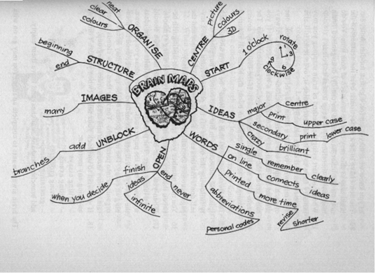

If we were to summarise our example in a mind-map, it would look like this:

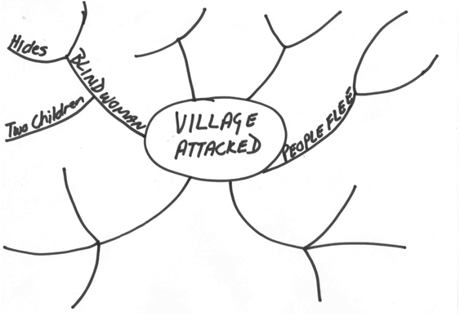

Notes

A note is a brief written record that is used as an aid to memory. You would make notes when you are doing your research, but you can also add notes to a page, this is called footnotes. See the bottom of a page for an example. footnotes are used to indicate which resource was used, or to indicate where a full explanation of the term can be found. Footnotes are usually numbered.

You can also add notes to the page by placing the notes in a box.

A note is a brief written record

Annotations

When you add annotations to your text, it means that you add explanatory notes to the text. As an example, in the section about questions, I stated the type of question and then added explanations:

**Who: who is involved, who must do something, who is affected**?

Diagram

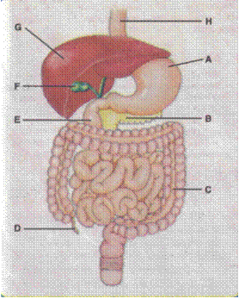A simplified drawing showing the appearance or structure of something.

This is a diagram of a human’s insides.

Tree Diagram

A tree diagram is a tree-shaped drawing showing a structure of something. The best examples are to be found in family trees, where you list you grandparents from your mother’s side and your father’s side, then your parents and then yourself, your brothers and sisters. Of course, the diagram can be bigger than this – you could start with your great-grandparents or even further back, and you can also include aunts, uncles, nephews and nieces.

It is called a tree diagram, because it starts big at the top and then becomes smaller with the next lines. On the next page is an example of a family tree starting with your grandparents.

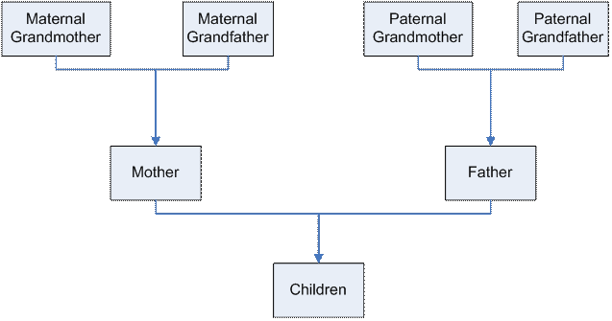

You can also use a tree diagram to make decisions or to solve problems. A **problem tree analysis** is a quick and effective way of analysing a problem. This analysis identifies the causes and symptoms of a problem and presents them in a logical cause-effect sequence. The question *why* is asked several times consecutively, in order to discover the root causes of the problem. These causes are then arranged into a cause-effect relationship.

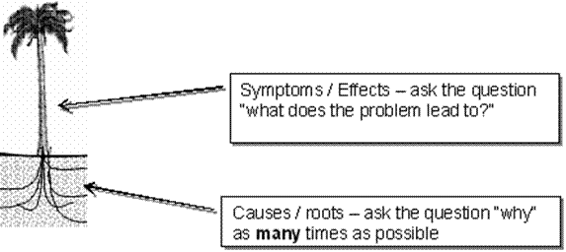

Example of a Problem Analysis Tree

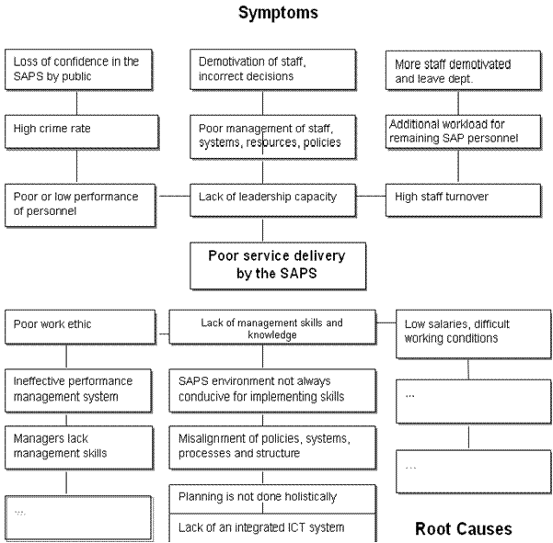

Cause and effect diagrams

A cause and effect diagram demonstrates the relationship between the effects of a problem and the categories of the causes of the problem. As the arrangement of the diagram lets it look like a fishbone, it is also known as a fish-bone diagram. The technique allows one to determine the Effect or Problem you would like to examine, categorize the possible causes thereof and find subcategories of these causes in order to arrive at the root causes of a problem or effect

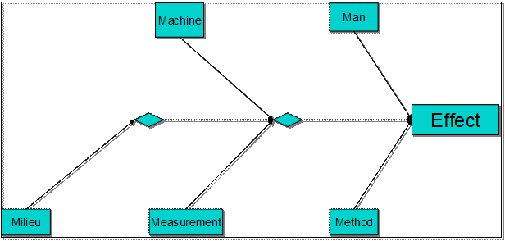

Above is an example of a fishbone diagram also called an Ishikawa diagram, showing factors of men, machines, milieu (workplace), materiel, methods, measurement, all affecting the overall problem.

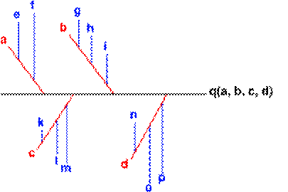

You can use smaller arrows to connect the sub-causes to major causes

Source: Quality Tools (2005)

When constructing a fishbone diagram, you must start with stating the problem in the form of a question, such as:

**‘Why is the Water Point not being used successfully by the village**

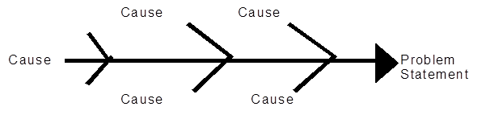By stating the problem in the form of a question, you will be able to brainstorm the causes.

The team must agree on the problem statement and once this is done it must then be placed in the ‘fish head box’.

The rest of the fish bone consists of a spine leading to the head and ‘bones’ leading from the spine. Each bone represents a contributing cause or category. Agree with the rest of the team the labels for these categories.

Once you have labelled each bone/cause, then you are able to ask ‘why does that happen’ or ‘ what has contributed to this cause’. Place your insight or observation onto a smaller bone leading from the category bone.

Once you have completed your fishbone, you will have a good understanding of what is the real cause of the problem. You will now be able to start brainstorming solutions to the problem.

Timelines

The time allowed for or taken by a process or sequence of events

A timeline displays a sequence of events from left to right in relation to time, on a timescale. Your examination schedule looks as follows:

* Study for maths exam 2 days, 1 to 2 August
* Write maths exam 1 day 3 August
* Study for history exam 2 days, 4 to5 August
* Write history exam, 1 day 8 August
* Study for English exam 1 day 9 August
* Write English exam 1 day 10 August

You can scribble all over your calendar, or you can do a timeline:

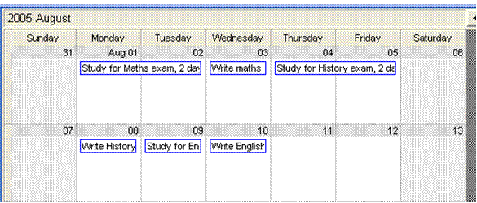

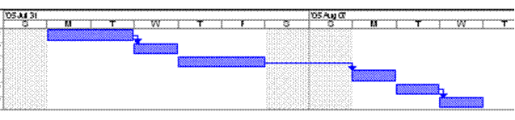

Flow chart

**A diagram showing a sequence of stages making up a complex process**

A soccer team’s preparation for a match, could look like this: Practice attack – practice defence – practice skills – rest – travel to destination – prepare for the match – match – celebrate victory – discuss match.

The flow chart could look like this:

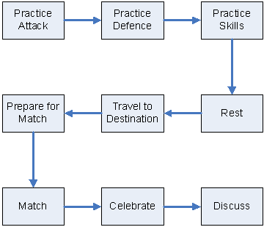

Venn diagram

A diagram representing mathematical sets as circles, common elements of the sets being represented by overlapping sections of the circles.

It is used when the common elements influence each other or have an effect upon each other.

The example below illustrates the management of resources of an organisation. and how the resources overlap and influence each other.

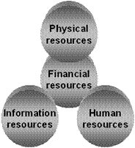

Source: Management principles, Smit and Cronje

Pie chart

A pie chart is used to show how a total breaks down. For example, you have R3000 per month to spend on rent, transport, food, etc. You can use a pie chart to give a visual demonstration of how you spend your R3000.

|  |  |
| --- | --- |
| Rent | 900 |
| Transport | 300 |
| Food | 800 |
| Clothes | 500 |
| Spending | 500 |
| **Total** | **3000** |

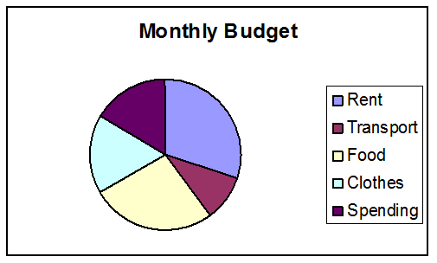

Bar graph

Is used to compare values at intervals, the bars run horizontally. For example, you can compare your marks for your matric subjects per school term.

This example shows only your mathematics results.

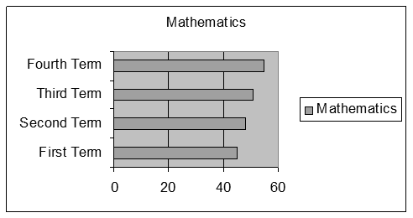

This example shows all your subjects

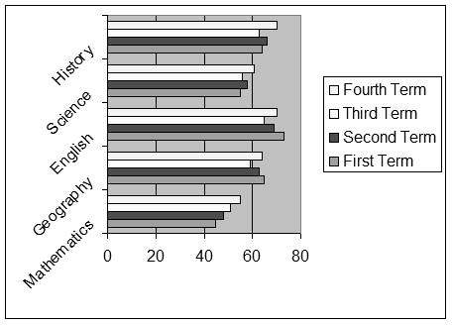

## Structural features of text

In the printed media, newspapers, magazines, brochures, text books, use is made of different techniques in order to

* get your attention,
* help the writer to get the message across,
* indicate a change of topic, a main point or sometimes both
* encourage you to read the written piece

They use:

* Different font Types and sizes
* **Bold**, *italics* and underline
* Visual aids, such as cartoons, diagrams, and so on
* Titles and subtitles
* Captions: a title or brief explanation printed with a visual aid, which can be a photo, an illustration, a diagram or a cartoon
* Photos
* The layout of the page
* A summary of a piece of the article is quoted

Advertisements are very good examples of using text and visuals to get a message across, using as little words as possible.

## Reference Materials

You will use reference materials to clarify the meanings of words/signs, concepts, language structures and conventions, and also for information about the topic you are researching.

Dictionaries

If reading is a form of communication then you, as the reader, have certain responsibilities in order to ensure that the communication process is successful. One of the actions that you will have to take is to ensure that you understand what the writer is trying to say to you.

One of the most common problems in communication is that the recipient of the communication – in this instance you as the reader – does not understand the message. If this is due to words being used that you don’t understand, it is your responsibility to find out what the words mean.

There are various resources that you could use to find out what words mean. You could use a dictionary or a thesaurus.

There are various kinds of dictionaries available:

#### Bilingual Dictionary

A bilingual dictionary, e.g. and Afrikaans/English dictionary will give the word, in Afrikaans with the English equivalent, and vice versa. A word like “walk” would, in an English/Afrikaans diary give the following information:

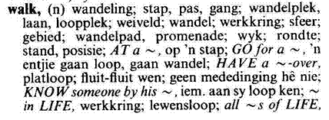

If we now look at the second word quoted, stap, the dictionary would give the following information:

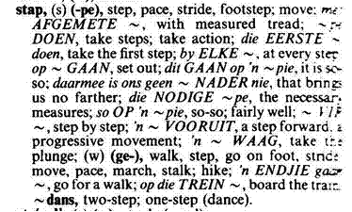

#### Explanatory Dictionary

An explanatory dictionary gives the word, its meaning as well as advice on how to use it in practice. This dictionary would be in one language only, English or Afrikaans or Sotho, etc. There is only one language involved, so there will not be references to the Afrikaans or Sotho equivalent.

If we look up the word walk in an explanatory dictionary, we will get the following information:

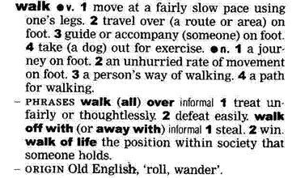

In the front of the dictionary you will find a guide on how to use the dictionary.

Many of these descriptions will sound like gobbledygook to you. What is important for now is that you can refer to the beginning of the dictionary in order to understand what the descriptions in the dictionary mean.

As you can see, the main word is quoted in bold, with variations of the same word quoted afterwards and then follow explanations of what the word means as well as how to use the word in a sentence.

Dictionaries usually also tell you how to pronounce the word correctly.

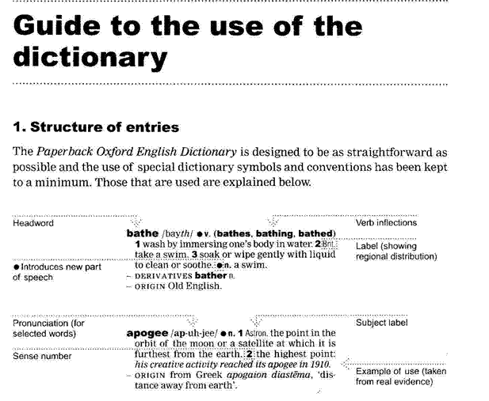

#### Thesaurus

A thesaurus is a dictionary that contains lists of words that have the same, similar or related meaning. If you look up the word walk in a thesaurus, you will find the following lists, usually with explanations of the words included:

|  |  |
| --- | --- |
| Saunter | Stroll |
| Amble | March |
| Stride | Pace |
| Hike | Toddle |
| Totter |  |

This will enable you to choose the exact word to use, or to determine the exact meaning of the word that was used in the piece of writing.

The sooner you get into the habit of looking up words that you don’t understand, the sooner you will improve your language and communication skills in general. If you don’t own a dictionary, you will probably find one at your place of employment and your local library will also have dictionaries.

This is an outcome, so you will be requested to look up words and their meanings as part of your assessment. Start using a dictionary now, so that you can get used to it.

Textbooks

A textbook is a book that is used as a standard work for the study of a subject. We all used textbooks in school in order to study the grammar, spelling and language rules for English, Afrikaans, Sotho or Zulu, we also used textbooks to study economics, history, geography and so on.

Having a textbook for a language is a valuable reference resource, because you can refer to the textbook to solve issues such as language structure. If you are unsure how to structure a sentence in English, a textbook will help you with this.

As an example, if you say: “ My husband and I have been nearly married for two years.” it literally means that for two years you and your husband have been almost married, but have not gotten married yet. You probably mean that for two years you have been thinking about getting married, but cannot make up your minds to actually do it.

If you say: “My husband and I have been married for nearly two years” it means that you got married almost two years ago.

This is a silly example, used to show you how important it is to state words in a sentence in the correct order. If you don’t, the recipient of the message can easily get the wrong message.

Of course, you get more kinds of textbooks than language textbooks. As stated, you get textbooks about geography, history, architecture, interior decorating, garden landscaping, computer software and hardware. There are textbooks about arts and crafts, woodworking, driving, just about anything that you want to learn about.

If you look up the word textbook in a thesaurus, you will find the following list:

* Schoolbook
* Manual
* Workbook

In other words, a textbook, or manual, contains information about a subject. This means that you can use a textbook to look up information about a subject. This learner guide is an example of a textbook or manual.

#### How would you look up information in a textbook?

You could read the entire book and hope you get the specific information you are looking for, but there are easier ways. Textbooks are divided into chapters. Each chapter will contain information about a specific subject. The chapters can be subdivided into sections and, if the manual is comprehensive, even sub-sections.

#### Contents Page

The writers who compile text books always try to make it easy for us to find specific information about a certain subject. Every textbook will have a contents page, which will give the main headings of the different chapters of the textbook. You can then go to that page and look at the contents from that page on. Following is a contents page of a textbook about General Management.

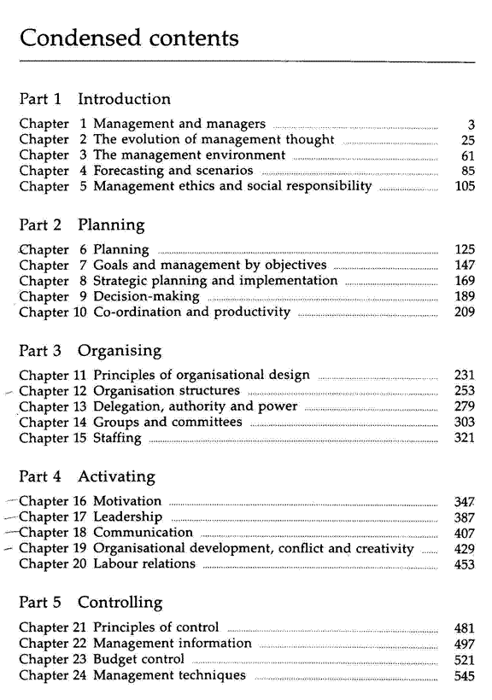

Can you see that subjects are grouped together in a sensible manner? Can you see that it is easy to obtain information about a specific subject?

If I need information about motivation, I will go to page 347, as indicated in the contents page. Here I will see that the chapter is further divided into sections, which are indicated by text typed in bold.

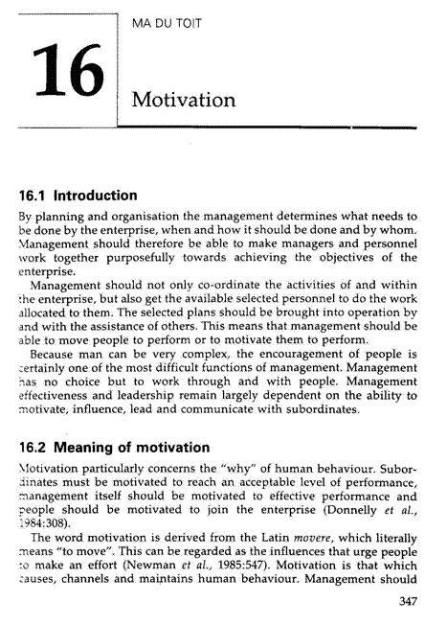

Now I can page through the chapter, looking only at the headings of sections until I find the information I am looking for.

Did you notice that the headings in this textbook are also numbered? All this is done to make it easy for you to find the information again. I would make a note of the page number, as well as the heading number: p347, 16.2 Meaning of motivation. All this makes it easy for me to find the information the first time and also to refer back to the information afterwards.

#### Index

Most textbooks also contain an Index, situated at the back of the book. Using the Index, you can look up information by looking for a specific word. The Index is always sorted alphabetically, so if I want to look up the word motivation, I will have to go to M in the Index.

From the Index, under M, (shown on the next page) I can see that there are references to motivation on pages 10 as well as 347. I can therefore find information about motivation on page 10 and 347.

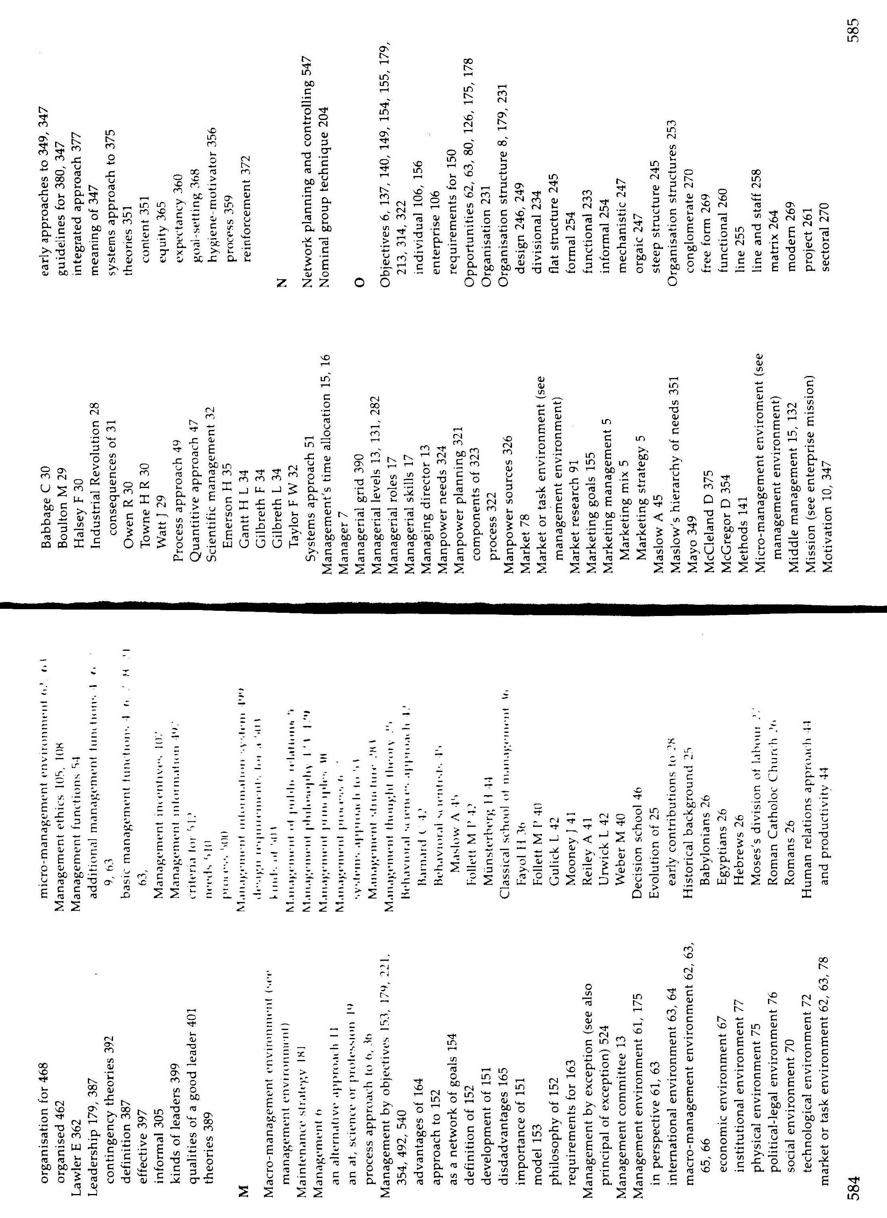

Instruction Manuals

When you buy a new appliance, such as a cell phone, a music centre or a washing machine, you will find an instruction manual included with the product. It can also be called a user’s manual. Whatever it is called, it has a specific purpose: to help you install and use the equipment.

It is very important to read the instruction manual thoroughly. If you don’t install and use the appliance properly, you can void the guarantee and your appliance will not work properly.

You are the user and you have to make sure that you understand the instruction manual. The manufacturer cannot be held responsible if you install and use the equipment incorrectly.

This also applies to medicine that has to be taken. If you go to the doctor and you get medicine that has to be taken three times a day, this means that you have to take the medicine every eight hours. If you take less than the prescribed dosage, for example you take your medicine every twelve hours, you will not feel better. If you take more, say every six or four hours, you will overdose yourself. Both situations can have serious consequences.

Going back to the instruction manual, if the manual says you must not put the electric kettle near water, you must not do this. If you place in near water, the electrical connections can get wet. At the least, the kettle will sustain damage, at the worst you can be electrocuted.

As an example, let us take a look at the instruction manual for a sandwich press.

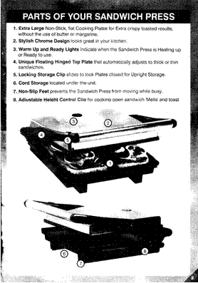

From this example you can see that an instruction manual is also divided into sections. The sections are indicated by means of headings and the contents tell you how to install and operate your appliance.

In the example, we showed you three sections and the cover page of the manual. The three sections are:

* User instructions,
* Parts of your sandwich press and
* Operating your sandwich press.

In the user instructions section, you will find information about the installation of the appliance and how to install the appliance. Safety procedures will also be included here.



Operating your sandwich press: here you will find the guidelines for using the sandwich press.

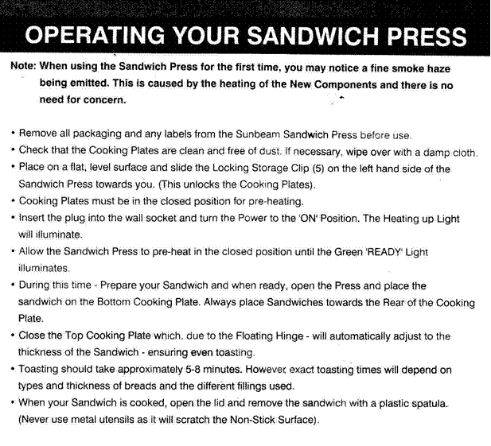All instruction manuals will be divided into sections or chapters. A big instruction manual will also have a contents page and an Index.

Encyclopaedias

An encyclopaedia is a book or a set of books giving information about many subjects.

Encyclopaedias are organised alphabetically, according to subject, from A to Z. When you are looking for information in an encyclopaedia, you have to refer to the Index Book first.

The Index Book is organised like an index in a text book. It is a lot bigger, since an encyclopaedia contains information about every known subject.

You will use the Index Book in an encyclopaedia the same way as the Index section in a textbook. First, you will identify the subject you are looking for: helicopters. Then you go to the Index Book and look under H for helicopters.

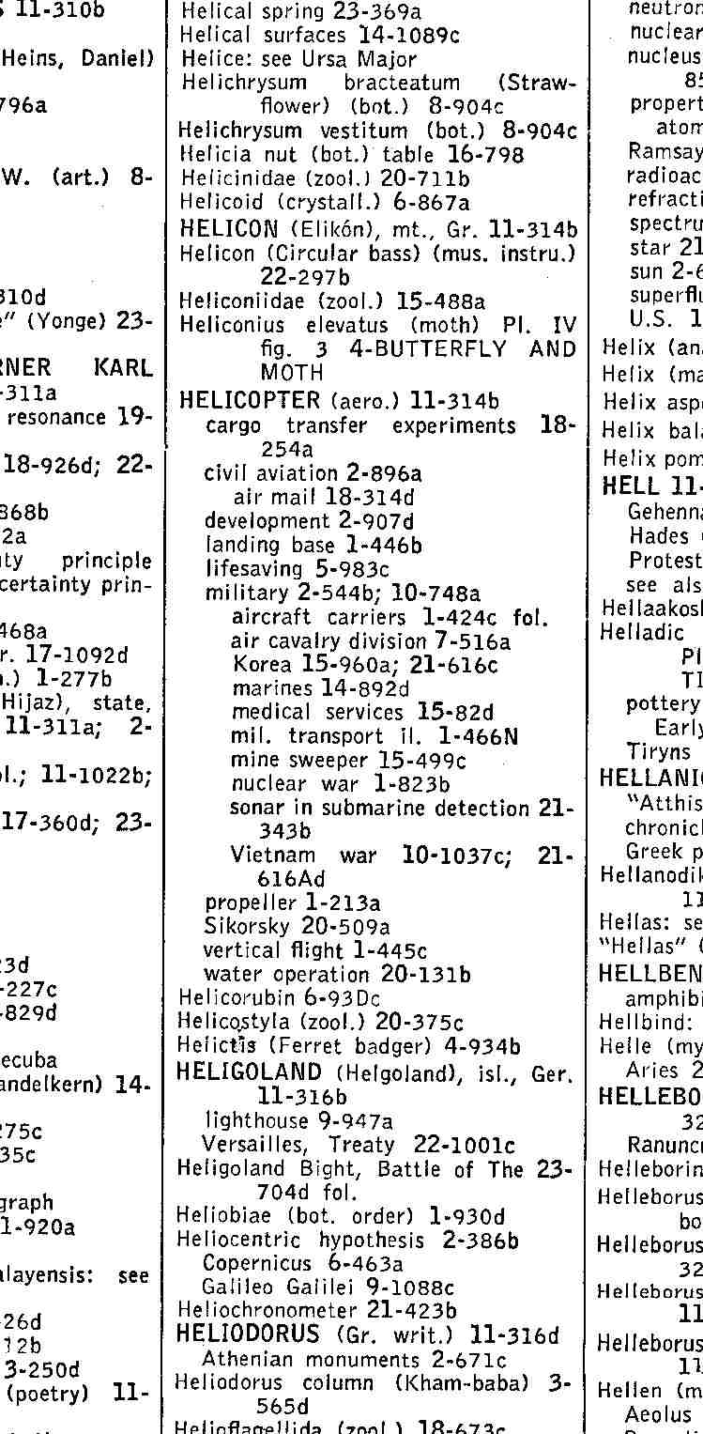The Index Book will then tell you in which book, on which page and where on the page you will find the information you require on the subject, in this case helicopters.

From this example of an Index book, you can see what information you can find about helicopters.

If you want information about military helicopters, you will go to book 2 of the encyclopaedia, then page 544, section b of the page.

This particular encyclopaedia is called Encyclopaedia Britannica and it consists of 27 books filled with information, plus the Index book.

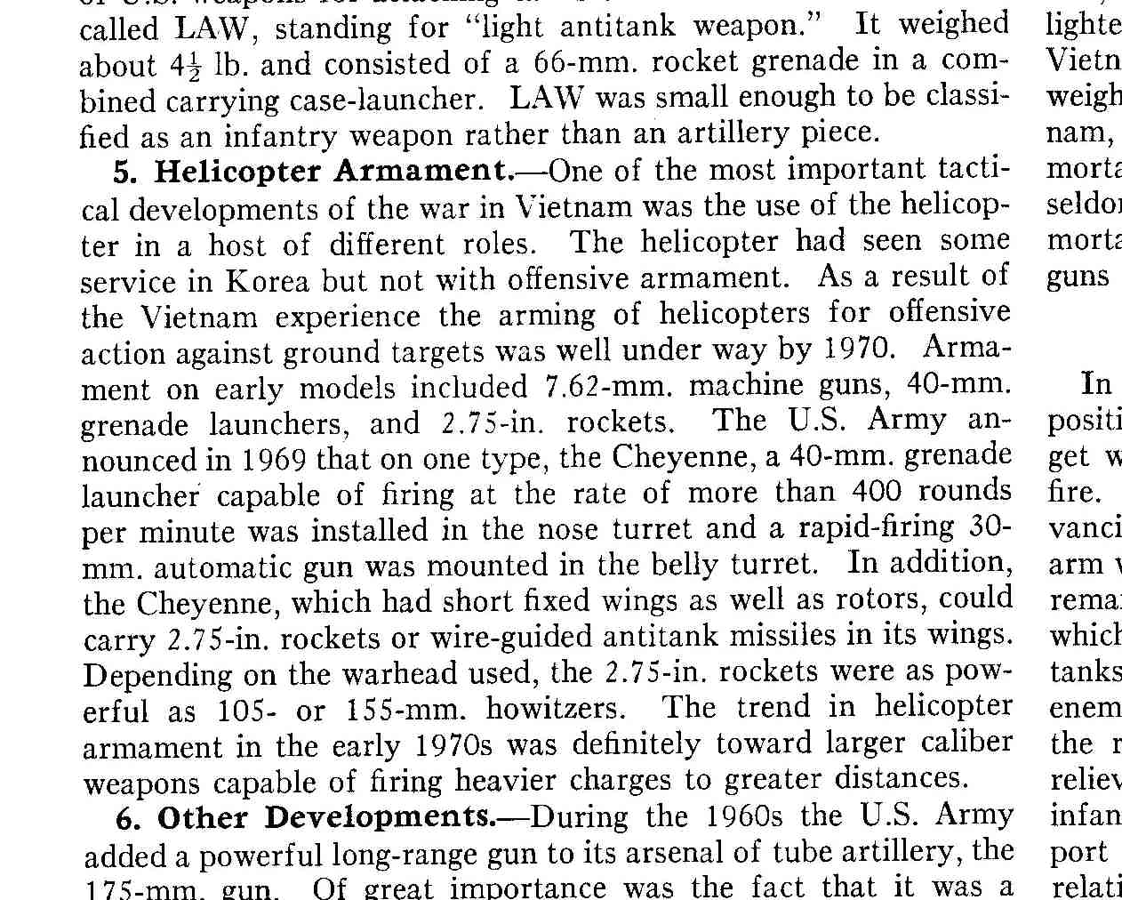

Many people are fortunate enough to own encyclopaedias. If you don’t own one, you can go to your local library and use their encyclopaedias to look for information.

Internet

You can also search the Internet for information. The Internet is like a very large library. Where a library is filled with books containing information, the Internet is made up of web sites that are filled with information.

Searching the Internet is a lot like using an Index book: you go online to a website such as Mweb or MSN and you will find a Search option somewhere on the first page, that is also called the Home page of the website. The Search option will give you space in which to enter a keyword or keywords, just like you would look in an Index. You then click on a button and the computer searches for websites that contain information about the word you typed in.

Because the Internet is a worldwide resource of information, there is an awful lot of information to be found out there, so you have to be very specific when you search for information on the Internet.

If you, for example, enter dogs as your keyword, you will end up with a couple of million hits. It is impossible for you to visit all those websites, so you have to narrow down your search, for example by typing in the specific breed of dog you want information on: golden retriever or whatever breed of dog you want information on. This will give you less hits, hopefully only about twenty or thirty websites, which is much more manageable.

## What Do We Read?

We read, or look at and interpret a variety of written and visual material during our lives, including:

* Textbooks
* Magazines: a periodical publication containing articles and pictures
* Newspapers: a daily or weekly publication containing news, articles and advertisements
* brochures: a leaflet containing information about a product or service
* policies: a document containing the course of action adopted or proposed by an organisation – how the organisation goes about its business
* questionnaires: a document containing printed questions that have to be completed, usually done to conduct a survey
* notices: announcements or advertisements printed in the media
* memorandum: a note sent from one person to another in an organisation
* agenda: a list of matters that have to be discussed and/or dealt with in a meeting
* application forms: forms similar to questionnaires, that have to be completed when you are applying for something – job applications, credit applications at shops and so on
* documentary: a factual report of real events where use is made of documents, film, photographs and sound recordings in order to convey the message
* novel: a story of book length about imaginary people and events
* photographs: still pictures made with cameras
* diagrams: are discussed fully later on
* blueprints: design plans or other technical drawings
* films: a story or event recorded by a camera and shown in a cinema or on television

We also read the following in order to familiarise ourselves with the instructions and directions given:

* instructions to play games and effect basic repairs to objects
* classroom and workplace procedures
* recipe: a list of ingredients and instructions for preparing a dish
* schedule: a plan for doing something, giving lists of intended events and times
* map: a diagram of an are showing physical features, cities, roads, etc
* warranties: a written guarantee that promises to repair or replace an article if necessary within a certain period, if certain conditions are met.
* Simple instructions and directions are read and interpreted and subsequent explanations are consistent with the intention of the text

Each of the above serves a different purpose, but all of them influence how we read and look at things.

## Read Instructions

Games

Whenever you buy a game, it will contain instructions on how to play the game. The example below shows the instructions for a word game called Boggle.

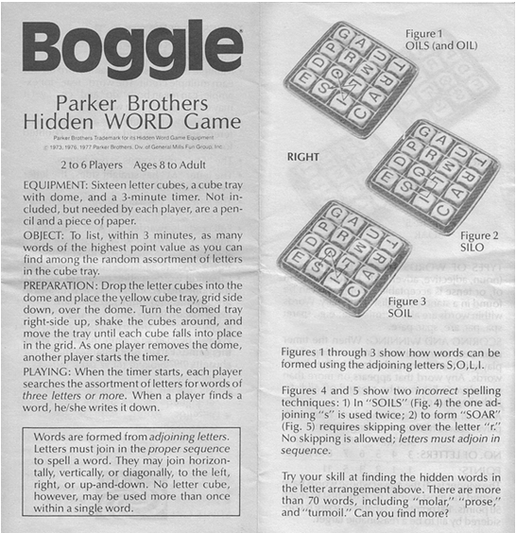

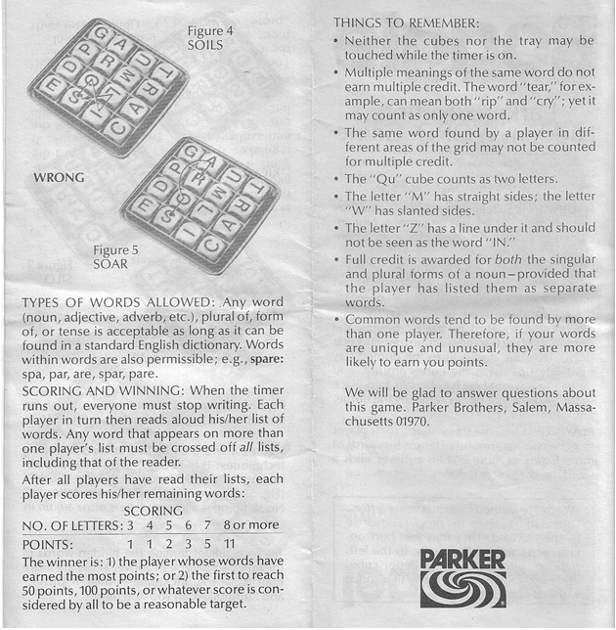

Repairing objects

To repair something you would usually need a set of instructions that tell you what to do and what tools or equipment you will need. Examples are changing a flat tyre or replacing a plug on an electrical device.

Forms

We have to read and complete forms all the time:

* to apply for a banking account
* to apply for a vehicle registration
* to apply for a driver’s licence
* to apply for an ID book, etc.

When we complete forms, we have to read the instructions carefully so that we do not complete areas of the form that do not apply to us.

Maps

It is much easier to explain a route through using a map than giving long written instructions.

Recipes

Recipes give clear instructions on how to prepare a dish, what ingredients you need and how long the dish will take to cook or bake.

Schedules

Schedules can be a list of activities that have to be completed, as per the example below.

|  |  |  |  |
| --- | --- | --- | --- |
| **Activity** | **Person Responsible** | **Resources required** | **Deadline date** |
| Invite all the participants | Jabu | List and contact details of all participants | 15 March 2005 |
| Book the venue | Jabu | List of venues | 1 April 2005 |
| Book the facilitator | Jabu | List of facilitators | 15 April 2005 |
| Develop the programme for the workshop | Jabu | Consultation with the facilitator | 30 April 2005 |
| Secure the budget for the workshop | Jabu | Budget line items | 1 May 2005 |

A schedule can also be a list of items that are available to be sold:

|  |  |  |  |  |  |
| --- | --- | --- | --- | --- | --- |
| **Code** | **Title** | **Pages** | **ISBN** | **Version** | **CD?** |
| Csac597x | Access 97 Expert User Part 1 | 236 | 1840050896 | 76 | CD |
| Csac597y | Access 97 Expert User Part 2 | 308 | 1840052554 | 78 | CD |
| Csac800p | Access 2000 | 320 | 1840051612 | 76 | CD |
| Csac800x | Access 2000 Expert | 350 | 1840052465 | 78 | CD |
| Csol800p | MS Outlook 2000 | 300 | 1840052643 | 79 | CD |
| Cspp597x | PowerPoint 97 Expert User | 318 | 1840051086 | 76 | CD |
| Cspp800p | PowerPoint 2000 | 300 | 1840050500 | 76 | CD |
| Cspp800x | PowerPoint 2000 Expert | 258 | 1840052007 | 74 | CD |
| Cswd597p | Word 97 Proficient User | 338 | 1840051167 | 75 | CD |
| Cswd597x | Word 97 Expert | 344 | 1840052198 | 74 | CD |
| Cswd800p | Word 2000 | 342 | 1840050594 | 75 | CD |
| Cswd800x | Word 2000 Expert | 350 | 1840052090 | 74 | CD |
| Csxl597p | Excel 97 Proficient User | 298 | 1840051434 | 76 | CD |
| Csxl597x | Excel 97 Expert | 288 | 1840052376 | 74 | CD |
| Csxl800p | Excel 2000 | 294 | 1840050691 | 76 | CD |
| Csxl800x | Excel 2000 Expert | 324 | 1840052287 | 74 | CD |
| Ssiei50i | Internet Explorer 5.0 | 216 | 1840050799 | 74 | CD |
| Sswn200i | MS Windows 2000 | 232 | 1840051914 | 74 | No |
| Sswn500i | MS Windows 95/98 | 202 | 184005171X | 75 | No |
| Sspc500i | Basic Concepts of IT | 246 | 1840052732 | 79 | No |
| Diof200i | ECDL with MS Office 2000 | 762 | 1840052813 | 88 | CD |
| Diof897i | ECDL with MS Office 97 | 764 | 1840052902 | 88 | CD |

Procedures

In the classroom or workplace, there are always procedures that have to be followed. These procedures are usually recorded in a manual that has to be read and understood so that you know what to do.

For example, the procedure below details the typical filing process:

There are eight basic steps in a typical filing routine.

#### Collecting the items to be filed.

If this is your responsibility, ensure that you collect the filing every day.

#### Inspecting.

* Make sure that the items are intended for filing.
* Also ensure that confidential items do not lie around for everyone to see, they should preferably be placed in a separate folder and filed immediately.

#### Indexing.

* Which indexing system is used, where will the correspondence be placed?
* Allocating a file reference number to the correspondence, according to the recognized filing system used by your organization.
* Make very sure that you allocate the correct reference to correspondence, as a document that was indexed incorrectly can be lost for a long period of time.
* Certain files and correspondence will be confidential and only certain staff members will be allowed access to these files. Ensure that they are coded correctly and also that a notation is made on the outside of the file.

#### Cross referencing.

* If the correspondence refers to more than one file, use a cross-referencing system,
* or, depending on the procedure in your company, add a copy of the correspondence to the other file as well.

#### Sorting.

* Sort the filing in the method of classification used by your organization – alphabetical, numerical, alpha-numerical.
* Having the filing sorted in the correct order will speed up the filing process.
* There are various types of sorters that can be used to help you sort the correspondence for filing:
* Concertina file: it has 26 partitions, one for each letter of the alphabet. It is convenient for temporary sorting or storing as the file can expand when it becomes fuller.
* Pigeon hole: this is a shelf with 26 pigeon holes, one for each letter of the alphabet. It is mainly used in a mail room for sorting mail and is seldom used for general filing.
* Flap sorter, also known as an alphabetical sorter: this commonly called Long John Sorter. It is a thick cardboard strip with 26 flaps, one for each letter of the alphabet. Correspondence is sorted in the flaps before being placed in file folders.

pe01496_

#### Filing.

* File the correspondence, ensuring that you place the documents in the correct file.
* Looking for correspondence that has been misfiled is a big waste of time for you and your co-workers looking for the information.
* Ensure that you file confidential documents first
* Documents must be filed chronologically, with the most recent date on top.
* Ensure that you file the documents with their attachments and enclosures

Activity 1(8963 SO1, AC1-7)

SECTION 2: IDENTIFY MAIN IDEAS

#### Outcome

Identify the main ideas in different text types: textbooks, magazines, newspapers, brochures, policies, questionnaires, notices, videos.

#### Assessment criteria

On completion of this section you will be able to ensure that:

* The main ideas are identified and distinguished from supporting information
* The author’s purpose is identified and the identification is justified by reference to the text
* Information and/or ideas from the text are presented in a form appropriate to a learning task or activity: Summary (e.g. mind-map, point-form, sub-headings, paragraph form), paraphrase, illustrations, role-play and simulation
* Socio-cultural issues in texts are identified and explained with reference to relevant passages or extracts from the text: Idioms, slang, jargon (language specific to a trade, business or industry), proverbs

## Determine The Author’s Purpose

One of the reasons why we read written text is to determine the purpose of the text – why did the author write this specific article, textbook, instruction manual or whatever you are reading.

Once we have determined what we think is the purpose of the text, we have to be able to justify what we think in terms of what is written in the article, textbook, etc.

In other words, we have to be able to understand what the author means, and we must be able to support out argument from what the author writes.

## Present ideas from the text

Once you have determined the purpose of the text, you can present your ideas and impressions, using the following ways:

* summary: has been discussed previously
* paraphrase: has been discussed previously
* illustrations: discussed previously – you can add illustrations in the form of diagrams, charts, cartoons, photos, etc.

Role play

Role-plays: participants are presented with a situation, often a problem or an incident, to which they have to respond, by assuming a specific role.

Simulation

Simulations: mirror actual activities or conditions. This is used by airline pilots and astronauts, where the flying conditions are simulated in a flying chamber so that the pilots can get used to flying conditions without actually flying an aeroplane.

## Identify socio-cultural issues

Idioms and Proverbs

**An idiom is a group of words/signs that, through usage, has taken on a special meaning different from the literal meaning (e.g. "keep your shirt on!” or "It’s raining cats and dogs”)**

According to the dictionary, an idiom is an expression that is natural to a specific language, while a proverb is a short saying stating a general truth or piece of advice.

Many proverbs and idioms can be translated into other languages, but many cannot, since what is applicable in Germany is not necessarily important in South Africa. Idioms and proverbs tend to be culturally based, as they originate as a saying that is popular with the people who speak the same language and undergo similar experiences.

#### Examples of proverbs

* Beauty is in the eye of the beholder. This means that everybody has his own idea about beauty.
* Business is business. In business, there should be no other considerations.
* Easy come easy go. When you have not earned it, you tend to be wasteful
* To be green with envy. To be very envious of what someone else has or has achieved. This is a good example of differences in language, since in Afrikaans envy and jealousy is yellow, not green. So, if you were making this statement in Afrikaans, you would say that someone is yellow with envy – the actual expression is to wear a yellow jacket. (die geel baadjie aanhê)
* To be as like as two peas. To be similar. In Afrikaans, we would say: soos twee druppels water op mekaar lyk (to look as similar as two drops of water)
* To cross the Rubicon. To commit oneself to an enterprise or a course of action.
* Long absent, soon forgotten: we do not miss what we have not seen or had for a long time
* To live in grand style. To lead a life of wealth and luxury. In Afrikaans this is stated as: “op groot voet lewe”, which, when translated literally would state: “living in a big foot”.

#### Examples of idioms

* to cause bad blood: to cause ill feeling
* to get in by the back door: to obtain a privileged position in an irregular manner
* his bar is worse than his bite: his gruff manner conceals a friendly nature
* the Cape Doctor: the south-east wind that blows in the Cape
* to put someone back on his feet: to help someone recover from a setback

Jargon

Words or expressions that are used by a specific trade, business or industry.

* **A paper tiger:** when a committee or other body is established to investigate an occurrence, and nothing much happens, it is called a paper tiger.

It means that the committee is not doing what it is supposed to do, the members of the committee postpone actions and make up imaginary problems as to why they cannot do the work in time.

* In the training environment in South Africa we find a lot of jargon – words that are used in a context not previously used and existing words put together to mean something that is unique to the education and training environment.

We talk about Unit Standards, which previously was called training courses, we talk about assessments rather than tests and we have standards generating bodies and standards governing bodies, and so on.

* **Electrocardiograph**: monitors the heartbeat
* **Government fiscal matters**: to do with the governments budget and how they spend the money that we pay in taxes.
* The **metallurgist** in charge is Karis Allen, 35, a specialist in fractions and corrosion: a metallurgist is a person who specialises in studying metals, fractions and corrosion in this instance means how metal, such as steel, breaks and corrodes

Slang

Casual, very informal speech/signing, using expressive but informal words and expressions

Slang is usually related to age or social group rather than to trade or profession (jargon). It is used to stress an identity for those in the know and to exclude those who do not know the terms, for example, words to describe money, grown-ups, police, and activities.

* My Bra
* Howzit Broe
* Whazzup

Activity 2 (8963 SO2, AC1-4)

SECTION3: READ/VIEW AND RESPOND TO TEXT

#### Outcome

Read/View and respond to texts for a variety of purposes.

**Outcome Range**

Textbooks, magazines, newspapers, brochures, policies, questionnaires, notices, memoranda, signed texts, agendas, application forms, documentaries, novels, photographs, diagrams, blueprints, films, official documents and any other appropriate types

#### Assessment criteria

On completion of this section you will be able to ensure that:

* Different text types are categorised in terms of their intended target audience
* The purpose of the text is identified and the identification is justified by reference to the text
* Different points of view in texts are identified and observations are justified by reference to the text
* Own ideas and/or arguments are supported with a range of reasons and facts relevant to the topic of discussion
* The relevance of texts is evaluated and justified in terms of meaning to self and others in peer, community or work group
* Implicit and explicit messages in texts are identified and explained with reference to the purpose of the text

## Reading and viewing resources

As mentioned previously, we read much more than we think we read.. In the course of a typical day we may read the following for our entertainment and pleasure:

* magazines
* newspapers
* notices: this could be a notice of a special offer in a shop, or a notice of a sport event, or a notice of any other type of entertainment
* novels: a novel is basically a long short story. The dictionary defines it as a prose story of book length about imagery people and events.

We also view or look at the following:

* photographs: in magazines, newspapers, and on notices, etc.
* documentaries: on television or in the movies, a documentary is a factual report of real events that uses film, photographs and sound recordings. The DVD of the famous 438 cricket game that the Proteas won against Australia is an example of a documentary.

At work and while studying we may be required to read the following:

* textbooks: discussed in a previous section
* brochures: a booklet containing information about a product or service
* policies: this could be an insurance policy or a workplace policy about HIV/AIDS assistance to employees
* questionnaires: a set of written questions, such as for a test or for a survey
* memoranda: a memorandum is a form of internal correspondence in a business where employees and departments communicate with each other
* agendas: a list of items to be discussed at a meeting
* application forms: discussed previously
* diagrams: discussed previously
* blueprints: a design plan or technical drawing, called a blueprint because the overall colour used to be blue. Includes architectural designs, drawings of equipment, machinery and tools
* official documents: includes all business correspondence such as reports, business letters, minutes of meetings, tender documents, government publications such as tender publications, etc.

## Text Types

In the printed media, newspapers, magazines, brochures, text books, use is made of different techniques in order to

* get your attention,
* help the writer to get the message across,
* indicate a change of topic, a main point or sometimes both
* encourage you to read the written piece

They use:

* Different font Types and sizes
* **Bold**, *italics* and underline
* Visual aids, such as cartoons, diagrams, and so on
* Titles and subtitles
* Captions: a title or brief explanation printed with a visual aid, which can be a photo, an illustration, a diagram or a cartoon
* Photos
* The layout of the page
* A summary of a piece of the article is quoted

## Purpose and different points of view

There are many reasons why authors write texts

* To **persuade** readers to his/her point of view: the article about the behaviour of Mr Zuma’s supporters outside the court was written to persuade readers. When an author is writing to persuade, he wants you to accept his opinion about issues, policies and situations.
* To **inform** readers: in SA Computer you will find a lot of articles that inform readers about new developments in Information Technology. In other magazines you will find fashion articles, articles about healthy eating and fitness, etc. These articles were all written to inform readers.
* To **entertain** readers: the short stories found in magazines were written to entertain. Fables, fairy tales, fictional novels, cartoons, short, funny pieces in magazines were all written to entertain.

Just as we each have our own point of view about matters such as crime, the role of the husband and wife in a marriage, the performance of our sport teams, etc. authors also have differing points of view.

This is why it is important to read more than one article about any subject – so that you can get different views about the subject.

## Own ideas

When you write text, you have the right to include your own ideas or arguments about a subject, unless it is business correspondence and you were not asked for your ideas.

When you put forward your own views on the subject, make sure that you support your ideas with a range of reasons and facts that are relevant to the topic of discussion.

For example, if you feel that Mr Zuma was treated unfairly by the press, you have to explain clearly why you feel so and you have to support your point of view with facts and justify you point of view by explaining your reasons.

## Relevance of text

The text you read for your research or write to put forward your own ideas has to be about the topic that is being discussed. If you feel that Mr Zuma was treated unfairly by the press at the time of the trial where he was accused of rape, you have to stick to the subject.

Reading about truck hijackings has no relevance to the subject. On the other hand, writing about another rape case also has no relevance to the subject at hand.

When you read or write text, always evaluate the text to find out if the text has meaning to yourself and others.

Reading about slavery in Sudan might interest you, but it is possible that it will not interest your friends or co-workers at all. Members of the community you live in will probably also not be interested in the subject.

This is a silly example, but it helps to show you that when you read and write for research or your work, you have to stick to the subject and then also make sure that the content of the text will be relevant to the audience you are writing for.

## Implicit and Explicit Text

Whenever an author writes some text, certain facts will stated clearly, while others are not stated clearly, only hinted at.

When facts are stated clearly, we call them explicit. Explicit means clear and detailed, with no room for confusion. In the article about slavery, the name of the blind woman is stated clearly, as well as the fact that she is blind. These are stated explicitly.

The opposite of explicit is implicit. Implicit means suggested, though not directly expressed. In other words, it is hinted at and you, the reader, should be able to identify what the author means. Referring back to the article about slavery, the writer states:

*At the first cracks of gunfire, the villagers of Nyamlell in southern Sudan dropped their hoes and scattered into the bush.*

The author does not say that it happened during the day, he also does not say that the villagers were working in their fields, yet we know this.

How do we know this? The author says the villagers dropped their hoes. A hoe is a long-handled gardening tool with a thin metal blade that is used to turn earth and cut through weeds. So, in one sentence the author tells us implicitly that it was daytime and that the villagers were working in their fields.

Activity 3 (8963 SO3, AC1-6)

SECTION4: LANGUAGE STRUCTURES AND FEATURES

#### Outcome

Identify and discuss how language structures and features may influence a reader.

#### Assessment criteria

On completion of this section you will be able to ensure that:

* The choice of words/signs, language usage, symbols, pictures and tone/sign size and pace is described in terms of how a point of view is shaped or supported: Bias (cultural, religious or peer preferences, misrepresentation, discrimination, racist, sexist, ageist); humour; irony; sarcasm, use of omission and silence, figurative expressions, repetition; hyperbole; generalisations; stereotyping; pictures and captions; typography and grammar
* Sentence structures are identified, analysed and related to purpose, audience, and text

## Language Structures And Features

Writers use language structures and features all the time, in order to influence what you, the reader, thinks when you have read the written piece.

Languge structures and features include

* The choice of words.
* Use of language.
* Symbols.
* Pictures.
* Tone.

If we look at the article about slavery, we can see some examples in the first paragraph.

“But the blind Dinka woman could only pull her seven-year-old son and twelve-year-old daughter close. Shaking with fear, they hid in their windowless hut and prayed.”

If the author had not told us that they were shaking with fear, we would have felt differently about the paragraph.

Dealing With Bias

What Does Bias Mean? An opinion or tendency to be strongly for or against a person or thing.

We are all biased in some way or other. We feel strongly about certain subjects, such as pornography, schooling in mother language, and many other subjects.

Then there are subjects over which are biased, but do not necessarily feel too strongly about it, so we don’t get all worked up about it. This could be school uniforms, what to wear to the movies, and so on.

We all have opinions about everything, some opinions are stronger than others. Unfortunately, although we would like it to be so, our opinions and views are not always the right ones and, when we do not want to be convinced otherwise, we are biased.

I have a bias- I hate school uniforms and believe that it should be done away with totally. Children should be allowed to wear what they choose to school. I feel strongly about this and I refuse to be convinced otherwise. This is, of course based totally on my own dislike of uniforms and having to look like anyone else, so I am not necessarily right in my point of view, especially since most other people seem to like school uniforms. Luckily, this bias of mine is relatively harmless.

Unfortunately, not all biases are harmless. Bias can take many forms: it can be based on cultural or religious beliefs, it can show itself in a misrepresentation of facts, it can be discriminatory in terms of race, sex or age. It can also be due to peer preferences.

Most of us have suffered from other people’s biases in some way or other. I have suffered from bias because I am a woman, it was thought that I cannot do what a man can do and, further, that I should not be allowed to prove that I can do administrative and managerial work as good as my male counterparts. To me, it was not a pleasant experience.

If I were biased against Muslims, I would interpret the article about slavery as meaning that all Muslim Arabs are kidnapping people to use and sell as slaves, even though the author of the article does not state this. My bias would then end in me disliking all Arabs and all Muslims, since, in my view they are all slave traders. Clearly, this is not true, since most races and nations have good and bad people and there are slave traders in South Africa as well, who are not Muslims or Arabs.

Whenever you read a written piece of text, you have to bear in mind that you yourself are biased and also that the author is also probably biased. You must always be able to determine the bias in yourself and the author.

Also, whenever you communicate in writing or verbally, bear in mind your own bias as well as the bias of your audience.

Lastly, remember your painful experience at the hands of some other person and his/her bias, before you treat people with disrespect because they disagree with you.

Whenever you read a written piece of text, you have to bear in mind that you yourself are biased and also that the author is also probably biased. You must always be able to determine the bias in yourself and the author.

Also, whenever you communicate in writing or verbally, bear in mind your own bias as well as the bias of your audience.

Lastly, remember your painful experience at the hands of some other person and his/her bias, before you treat people with disrespect because they disagree with you.

Humour

In the dictionary, humour is stated as being:” the quality of being amusing”. Jokes are humorous, so can text in an article be humorous or even a novel (long story) or parts of a novel.

Irony and sSarcasm

Irony and sarcasm are very similar. When an author uses irony, he states one thing, while meaning the opposite. Irony can be funny, but it does not have to be.

* as funny as cancer
* as clear as mud
* as pleasant as a root-canal

An example of irony in real life is when John Hinckley tried to assassinate (kill) President Ronald Reagan (a previous American president), all of his shots initially missed the President; however a bullet ricocheted off (bounced off) the bullet-proof windows of the Presidential limousine and struck Reagan in the chest. Thus, the windows made to protect the President from gunfire were partially responsible for his being shot.

If someone were to go on a trip and decide not to take a plane because they are worried about crashing, and take a bus instead, it would be ironic if a plane hit the bus they took, thereby realizing their fears of crashing with a plane, despite measures taken at the outset of the journey to avoid such a fate.

**Sarcasm**is stating the opposite of an intended meaning especially in order to sneeringly, slyly, jest or mock a person, situation or thing. It is strongly associated with irony. Sarcasm is a particular kind of personal criticism leveled against a person or group of persons. If you were talking to one of the team players that lost the game badly, and you say to him: “Well, you guys really played well” you are being sarcastic.

Sarcasm is can be used in a humorous manner, but can also express annoyance or anger. It is often in the place of other forms of expression. For example, instead of becoming angry and yelling at someone in a conflict, a person might choose to use sarcasm as an alternative.

"Shut up, will you?" "Oh, I'm sorry, Your Highness, should I go get you your coffee and tea now?"

In this case it is implied that the first person was treating the second like a servant. Instead of directly pointing this out, however, the second person plays the part, so to speak, in the situation created by the first person.

This is normally used where the two people in question do not see eye to eye. Therefore the second person does not like the tone and phrasing of the first person's remark. The second person uses sarcasm to make fun of the first person to amuse themselves, and any possible bystanders who share the same feeling towards person one.

Hyperbole

An exaggerated statement that is not meant to be taken in the strict sense of the words.

“I have told **you ten million times** that it is a bat habit to exaggerate.”

Generalisations

Make a general or broad statement based on specific cases.

“Nobody from the Cape eats pap”

This is not true, most people from the Cape prefer to eat something else, but some of them do eat pap as much as anyone else.

When the soccer or rugby team loses two or three games in a row, we tend to say things like: “We can’t play soccer or rugby, we always lose”. This is also not true, since they do win games.

Beware of general statements when you read or write something. Writers should be careful of using general statements, as readers tend to believe what they read.

Stereotyping

An over-simplified idea of the typical characteristics of a person or thing.

**All blondes are stupid**. This is a stereotyping, since not all people with blonde hair are stupid. We just notice it, since blonde women are more noticeable to men, and when a blonde woman does something stupid, all blondes are called stupid.

Figurative Expressions

A word or phrase used in a non-literal sense to add interest to speech or writing.

* Food for thought. We cannot really eat our thoughts. The expression means that it is something to think about.
* He is as strong as an ox. He is not really as strong as an ox, we only say this in order to illustrate how strong he is

Repetition

The saying of the same thing over again in different words. This is incorrect use of grammar.

We tend to get into the bad habit of using more than one word that has the same meaning, to illustrate what we are saying:

* Milk dairy
* Reverse backwards
* I will kill you dead
* They arrived one after the other in succession
* Hurry up quickly
* We smell it in our noses

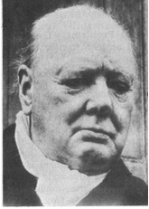There is also another use for repetition, where the writer or speaker repeats words and phrases. This is very effective to emphasise the importance of the statement. Sir Winston Churchill made very good use of repetition in his famous speeches during World War 11.

On 22 May 1940, after the British soldiers had been evacuated from Dunkirk, he said:

“***We shall fight*** on the beaches, ***we shall fight*** on the landing-grounds, ***we shall fight*** in the fields and in the streets, ***we shall fight*** in the hills; *we shall* never surrender…

On 13 May 1940, just after he was elected prime Minister, he said that he had one aim:

“**Victory – victory** at all costs, **victory** in spite of terror; **victory**, however long and hard the road may be.”

Of course, he said many more memorable things and it is worthwhile reading about him. He was the Prime Minister of Britain during World War 11 and he was a rather colourful character – just what the British needed during wartime.

Grammar

Grammar is the whole structure of a language, including the rules for the way words are formed and their relationship to each other in sentences.

This has to do with the words we use in sentences and also how we use them.

In the section about textbooks I quoted the following example:

If you say: “ My husband and I have been nearly married for two years.” it literally means that for two years you and your husband have been almost married, but have not gotten married yet. You probably mean that for two years you have been thinking about getting married, but cannot make up your minds to actually do it.

If you say: “My husband and I have been married for nearly two years” it means that you and your husband got married nearly two years ago and you are still together.

Below is a quote from the article about slavery, as written by the author.:

Once the Arabs seized the cattle, they moved from hut to hut gathering grain, blankets, salt – and human booty. Deep in the shadows of one hut, they discovered Abuk. Grabbing the terrified woman by her bead necklace, a militiaman growled, “Now you belong to me!” In all, 282 Dinka, including Abuk’s mother, sister and niece were herded up and forced to march north.

If I substitute the word “booty” in the first sentence with “bodies”, it would mean that the slave traders gathered the remains of dead people to take with them.

If I change the word order of the third sentence, I can change the meaning of the sentence as well:

“Grabbing the woman by her bead necklace, a terrified militiaman growled ….”

This, of course, means that the militiaman is terrified, and not the woman.

It is easy to change the meaning of a sentence or paragraph just by changing the order of the words in the sentence or paragraph. You must always be aware of this and ensure that, when you are writing something (especially your summaries) you use grammar correctly. If you don’t you can be misunderstood and this could sometimes have serious consequences.

People can be misquoted simply by changing the word order of the sentences. When we read and write text, we have to be careful of our use of grammar.

Captions

A caption is a title or brief explanation printed with an illustration or cartoon.

Captions can be added to a photo, an illustration, a cartoon, a graph or any other picture.



I can add the following captions to the above pictures, and with each different caption the meaning of the pictures change:

* My father is laughing at our neighbour, whose dogs are taking her for a walk.
* My uncle, looking at our neighbour because he likes her and wants to date her.
* Our neighbour, whose dogs have been scared off by our dog.
* The person on the left’s dog has been to doggy school and knows how to behave, whereas the person on the right’s dogs obviously have not been to doggy school.

I hope that in future, when you see a picture with captions, you will analyse the picture and take into consideration that captions can influence what you think.

Pictures

Writers also use pictures to illustrate their points and to influence your thinking of the matter.

Typography

Typogrpahy is the style and appearance of printed material. This has already been discussed and includes:

* The type and size of the font
* Headings, sub-headings, etc.
* Titles
* Paragraphs
* Numbers and bullets, etc.

Omissions and Silence

Two of the tactics most used by journalists who write for newspapers and magazines are omissions and silence. Many people are misquoted in this way.

**Omission is something that has been left out.**

Below is a paragraph from the article about slavery. If I leave something out, it changes the entire meaning of the paragraph.

*Once the Arabs seized the cattle, they moved from hut to hut gathering grain, blankets, salt – and human booty. Deep in the shadows of one hut, they discovered Abuk. Grabbing the terrified woman by her bead necklace, a militiaman growled, “Now you belong to me!” in all, 282 Dinka, including Abuk’s mother, sister and niece were herded up and forced to march north.*

Now read the paragraph where human booty and the last sentence has been left out:

*Once the Arabs seized the cattle, they moved from hut to hut gathering grain, blankets and salt. Deep in the shadows of one hut, they discovered Abuk. Grabbing the terrified woman by her bead necklace, a militiaman growled, “Now you belong to me!”*

Do you see that the whole meaning of the paragraph has now changed and that there is now no reference to slavery?

**Silence means not saying or writing anything.**

If the author of the article about slavery did not write the article, we would never have known that it is going on. Silence can be just as dangerous as omission. If we don’t write and talk about what is going on in the world around us, we will never be able to identify problems. If problems are not identified, solutions cannot be found.

## Sentence structures

Sentence Length

The sentence may be regarded as the core of language communication, because a sentence is a complete thought that conveys (gives) a meaning. In other words, you use a sentence to explain yourself to other people, or to give your opinion about something. The end of a sentence is indicated by a full stop, called a period these days.

A sentence must make sense, therefore a sentence must express a complete thought. In order to do this a sentence must contain a verb (doing something) and a noun ( a subject) and the sentence must contain a thought that includes an idea that is relevant to the subject or the doing.

If you say: “The accident happened as I crossed the road.”, it makes sense to everyone who hears it and reads it. If you say: My dog was run over and Vin Diesel visited South Africa.”, it will not make much sense to other people. The two concepts have nothing to do with each other. In an instance like this, you will have to use two or more sentences or even two paragraphs.

A short sentence could be: Thabo takes the dog for a walk.

Authors use short sentences to heighten (increase) tension in a written piece. Longer sentences make a written piece more relaxed and not as filled with tension. If you are writing about strikes and unrest, your sentences would be shorter, while the sentence in a written piece about farming would be longer to create a more relaxed atmosphere.

Generally, we would try to vary the length of sentences in any written piece. A written piece that has only long or short sentences can be tiring to read.

There are three basic types of sentences.

Simple Sentences

These have one verb and one subject and object. “The boy is playing with the ball.”

Compound Sentences

but, and, or

A compound sentence is made up of two or more thoughts or sentences that are related to each other. The thoughts or sentences are then connected to each other to form one sentence by using the following words: **but, and, or**.

“The boy is playing with the ball, but his mother is calling him.”

“the boy is playing with the ball and some other children are watching.”

Sentences should have the same topic if you want to create a compound sentence. The following two sentences are not related to each other and should not be joined: “It is late.” and “I like reading.” “It is late and I like reading” does not make sense, since they do not share the same topic: lateness and reading do not have anything to do with each other.

“It is late and I am going to bed.” is a better example.

Complex Sentences

Consist of one independent sentence with one or more dependent clause that relates to it. The sentence and the clauses are **separated by a comma.**

,

“Although it is raining, the boy is playing outside.” Can you see that*: “Although it is raining”* is not a full sentence, it does not have a subject, so it is called a clause and has to be added to a sentence.

The clauses and the sentence must relate to the same topic if you want to create a complex sentence. “Although it is raining, I like reading.” Is a pointless sentence, since they do not share the same subject. “I have to go to the shop, even though it is raining,” is a better example of a complex sentence.

**Remember:**

* **Too many short sentences will make your text appear choppy and curt.**
* **Too many long sentences will have the opposite effect, your text will appear confusing.**
* **Short sentences should be varied with longer sentences to give your text an even flow.**

Activity 4 (8963 SO4, AC1-2)

SECTION 5: AUDIENCE, PURPOSE & CONTEXT

#### Outcome

Write/sign for a specific audience, purpose and context.

**Outcome Range**

Write/sign for a specific audience, purpose and context: Narrative, discursive, reflective, argumentative, descriptive, expository, transactional, business correspondence, electronic texts, multi-media presentations.

#### Assessment criteria

On completion of this section you will be able to ensure that:

* A range of appropriate texts is identified and produced in response to tasks or learning activities
* Format and content are appropriate to the conventions of the text type, and to the nature and level of the target audience, as well as to the task.: Format, visual presentation (headings, sub-headings, bullets, numbering, font, etc), appropriate dress

## Styles Of Writing

Written/signed forms may include narratives (folklore/short stories/novels/dramas), dialogues, sets of instructions, advertisements, editorials, brochures, manuals, agendas and minutes, diary entries, journals, lists, charts, plays, reports, journals, essays/signed narratives, poems and letters.

We have already covered some of these topics, such as reading and understanding, paraphrasing and so on. We will now move on to actual writing of text.

### Narrative

Narrative style means to tell the story without using dialogue. It is also used to provide a commentary for a film or television programme.

“Scared but holding steady, a Brazilian boy offers his arm for vaccination against the mosquito-born yellow fever virus. Bringing misery to the vulnerable, viruses cause diseases ranging from the common cold and measles to hepatitis and AIDS. Viruses appear to infect all living things – yet are not quite alive themselves. Particles of genetic material – the essence of life – they lie as inert as the dead until an opportunity arises to invade a host.”

### Discursive

Write/sign about a topic in detail, similar to when you are having a discussion with friends about a topic. It might also happen that you include unrelated topics in the text.

### Reflective

Thoughtful. In the following text, the person is thinking about growing up.

“As my stepfather’s postings and later my own were all at the whim of the Foreign Office, I’d mostly lived those twenty years abroad in scattered three- or four-year segments, some blazing, some boring, from Caracas to Lima, from Moscow to Cairo to Madrid, housed in Foreign Office lodgings from one-bedroom concrete to gilt-decked mansions, counting nowhere home. I was rootless and nomadic, well used to it and content.”

### Argumentative

A set of reasons given in support of something. Following is an extract from National Geographic October 1995, when civil war was raging in Rwanda with devastating effects not only on the people but also on the wildlife.

A fragile home threatened by war

“Among the last of its kind, a young gorilla peers from its leafy refuge in Rwanda – a nation bloodied by ethnic slaughter. Conservationists fear that Rwanda’s instability could endanger the gorilla’s survival. Others ask: How should the plight of the world’s rarest ape be weighed against more than 500,000 human dead?”

### Descriptive

Describing without expressing judgement. In the following passage, the writer does not try to persuade you to buy the item, he merely states the features of the product.

“The Nokia HS-12W Wireless Stereo Headset has been designed for people who listen to MP3s on their phones and need to effortlessly switch between music and phone mode in an instant. The display serves to provide music information, caller ID and MMS/SMS notification, while the built-in stereo FM RDS radio provides automatic channel search.”

### Expository

A full description and explanation of a theory. Usually used in the media to reveal something discreditable. Any scandal that is reported in the media is written in expository style.

### Transactional

Relating to a business transaction. This would usually be invoices, debit and credit notes, notes to purchase and so on.

### Business correspondence

Will include all business correspondence: letters, faxes, memos, buying orders, invoices, credit notes, debit notes and so on.

### Electronic texts

Would be sent via e-mail. There is a specific set of rules regulating e-mails.

#### Professional e-mail

* Keep it short and simple
* Don’t be over concerned about spelling, punctuation or grammar
* Use the subject line if some action is expected
* For a list of items, use bullets
* If you cannot avoid sending a long message, attach the file as an enclosure

#### E-mail Etiquette

* Only send carbon copies (Cc) to people who need to see the information
* Don’t send blind copies (Bcc) unless necessary
* Use the “urgent message” only if it is URGENT
* Don’t use all capital letters
* Put addresses in the “To”, “Copies”, space and always in alphabetical order by the addressee’s surname
* If your message is of great importance, urgent, confidential or could be misconstrued – do not use e-mail
* If you are feeling upset or angry rather wait to calm down before verbalizing your thoughts on e-mail

### Multi-Media Presentations

A multi-media presentation is what it says: a presentation using more than one medium. In other words, you include a visual presentation on a PC, you can also use a projector or a TV and video combination, or even photos and other visual images posted against the wall, as long as you use more than one medium. The first medium is usually paper-based in the form of a manual, a book, notes and so on. Multi-media presentations are very effective since they make use of more senses than just our eyes.

to give examples of media that can be used to enhance your communication, we used the learning environment as an example.

You should determine which media would be most effective during the delivery of learning. But, what media are available? In the table below some of the available media in open learning are provided.

**Available media in open learning**

|  |  |
| --- | --- |
| **Print-based** | **Audiovisual or technology-based** |
| Books, pamphlets and, reports already published. | Audio cassettes, CD’s. |
| Self-sufficient learner guides specially written. | Radio broadcasts. |
| Learner guides written to “wrap around” already published material. | Slides or film. |
| Workbooks for use along with other multimedia such as audiotape, video, computer-based programmes. | Video programmes. |
| Maps, charts, photographs, posters. | Television broadcasts. |
| Articles from newspapers, periodicals, journals. | CBT or multimedia. |
| Handwritten material. | Interactive video |
| Information published on the Inter-net. | Human interaction (at a distance) |
| Practical or project work | Telephone, fax, mail and e-mail communication. |
| Materials, equipment, specimens for practical application or experiments. | Video, telephone or computer conferencing. |
| Practical workplace assignments. |  |

#### Selection criteria

When selecting media there are important criteria to which it must adhere to, to be effective in the learning environment. What will follow is a list of criteria that may be useful in the media selection process.

|  |  |
| --- | --- |
| **Criteria for Media Selection** | **Measured against each medium.** |
| Does it support the outcomes? |  |
| Is it accurate and current? |  |
| Is it aesthetically pleasing? |  |
| Does it arouse motivation and maintain interest. |  |
| Does it endeavour to stimulate the use of all the senses? |  |
| Does it allow learner participation? |  |
| Is the technical quality good? |  |
| Does it support the overall learning experience? |  |
| Does it relate to your learner profile? |  |
| Have you considered using more than one medium? |  |

An additional table of learning media is provided. From this table select suitable media for a specific learning event that you will present in the next week.

|  |
| --- |
|  |
|  |
|  |
|  |
|  |
|  |
|  |
|  |

Table of learning media

|  |  |  |  |
| --- | --- | --- | --- |
| **MEDIUM** | **USES** | **ADVANTAGES** | **DISADVANTAGES** |
| AUDIO TAPE | Language instruction  Provide factual information  Guide on walking tour | Easily made, duplicated and used. Literacy not required. Very portable. Cheap | No visual stimulation. Concentration tends to wander. Limited application |
| CHALKBOARD WHITEBOARD | Recording information. Sketches, points for discussion and calculations | Common in training rooms. Easy to use. Relatively cheap  Colours can be used. | Not permanent.  Limited to small audience. Not portable.  No movement  Review is not possible |
| FLIPCHART | Same as whiteboard  Brainstorming | Compact, cheap and portable. Can prepare.  Review is easy. | Limited audience size.  No movement  Pages become tatty |
| OVERHEAD PROJECTOR | Similar to board and flip chart  Can use Polaroid materials to show movement  Build progressive visuals | Very versatile and portable. Face audience. Movement is possible. Attractive transparencies  Review is easy. Cheap | Needs electricity and screen.  Movement not possible without correct equipment |
| SLIDES AND AUDIO TAPE | Teaching factual information and procedures.  Project realistic pictures and use real sounds  Very versatile uses | Professional synchronised presentation. Utilise programmed instruction method. Suitable for large audience. | Needs electricity. Slides costly to duplicate. No movement. Dark room needed for large screen. |
| VIDEO | Brings the ‘real’ world to the audience.  Teach processes, procedures, operation skills. Record role plays and provide feedback on practical activities | Programmed instruction format can be used. Easy to make copies. Immediate replay. Shows movement. Can be very objective. Use under normal lighting. | Complex and expensive production process. Expensive replay equipment. With a monitor the audience size is limited. Video projector suitable for large audience but very expensive |
| COMPUTER AIDED INSTRUCTION | Can be used for all of the above where multi media programmes are used. | Branching programmed instruction is possible creating an interactive approach. Captivating for the learners. Instant evaluation and feedback. Records can be kept. | Hardware and authoring soft wear is very expensive. Expertise and much time are needed for programme production. Can intimidate unfamiliar learners. |
| SIMULATORS | All of the above. Developing psychomotor skill. Practise procedures, which are complex, expensive/dangerous. Learn to cope with crisis | Very realistic and engrossing. Practise difficult, dangerous tasks in a safe way. Immediate evaluation and feedback provided. Develop confidence. | As for computer aided instruction. May instil a false sense of security in learners. Design and set up costs are very high. |

## Structure your writing

One of the reasons why we read written text is to determine the purpose of the text – why did the author write this specific article, textbook, instruction manual or whatever you are reading.

Once we have determined what we think is the purpose of the text, we have to be able to justify what we think in terms of what is written in the article, textbook, etc.

In other words, we have to be able to understand what the author means, and we must be able to support out argument from what the author writes.

In the same way, when you write text, you have to make sure that

You know the **purpose** for writing/signing the text

Who the **target audience** is that you are writing/signing for

That the **context** of your writing is clear in relation to the learning task or activity

There are many reasons why authors write texts

* To **persuade** readers to his/her point of view: the article in handout 1 about the behaviour of mr Zuma’s supporters outside the court was written to persuade readers. When an author is writing to persuade, he wants you to accept his opinion about issues, policies and situations.
* To **inform** readers: in SA Computer you will find a lot of articles that inform readers about new developments in Information Technology. In other magazines you will find fashion articles, articles about healthy eating and fitness, etc. These articles were all written to inform readers.
* To **entertain** readers: the short stories found in magazines were written to entertain. Fables, fairy tales, fictional novels, cartoons, short, funny pieces in magazines were all written to entertain.

BOOK054Before you start writing/signing your text you have to plan what you are going to write

* Who will you be writing for: your friends and family, the general public, a business document, a newspaper or magazine article, etc.
* In which register will you be writing the text: formal or informal
* Which writing style will you use: narrative, discursive, expository, etc.
* Will you write in the first person or the third person?
* Determine the research you will do
* Organise your writing: make sure ideas and facts flow logically

Make your writing/signing interesting

* Use numbers and bullets to separate ideas, facts and paragraphs. You will find examples of bullets and numbers in this learner guide
* Use punctuation correctly: commas, periods, etc.
* Use titles, subtitles, headings, contents and index

BOOK032Use an introduction and a conclusion

* Use visual images and captions with these images
* Vary the length of your sentences
* Structure your paragraphs correctly
* If any action is required, make suggestions about the actions
* Put ideas forward
* Use appendices or addenda if required
* Use NMF’s (non manual features) appropriately

Diction

* Choose words or signs that are familiar and easy to understand
* Make sure that you are using the correct words or signs
* Do not use technical language, legalisms, etc. when writing/signing for the general public. When it is a business document, use of technical terms and jargon will be acceptable
* Do not use slang or write in dialect unless you are writing to entertain

## Produce Writing/Signing That Is Appropriate

When you write/sign, you always have to take the audience into consideration. For a letter to friends, you will use the **informal register**, you can use slang and jargon freely and your layout will be informal. The diction, language features and structures, pictures and sentence lengths will all be more informal than you would use for a business document.

When you are writing/signing a document for the Information Technology department, your presentation will be formal, so you will use the **formal register**. You can use jargon and technical language freely, without explanatory notes. Your diagrams and other visual aids can be technical, as long as it relates to the IT industry.

When you are writing/singing a note or a message to a friend, telling him/her about something funny that happened to you, you will use the **comedic register**: something funny is always written in the comedic register.

When you are writing/signing to a client who is not an expert in IT, you will still use the **formal register**. You will, however, use less jargon and technical language and, where you have to, you will add explanations. Language structure and features will be formal.

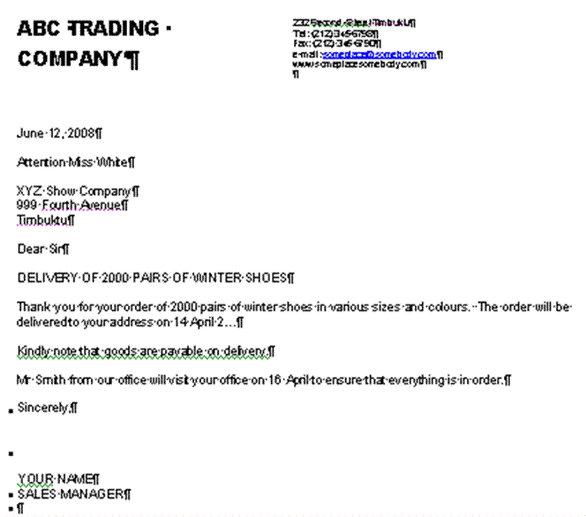

This is a layout of a letter done in the **formal register**. Your choice of words/signs will be formal, you will use headings and sub headings, you will use bold or italic fonts, (or NMF’s to emphasise certain aspects) and so on. Can you see that this letter does not look the same as the letter to your friend? It is important to use the register that is appropriate to the audience you are writing to. If you don’t, the reader can feel insulted or even refuse to take you seriously.

The form that your writing takes must also be appropriate to the context and purpose. For example, a friend’s mother has died and you must write/sign a **letter of condolence**. Your writing will be more formal than if you were writing to the friend, although not quite as formal as when you are writing to our President. You will not use humour, jargon, technical or ambiguous words. The style will be sympathetic.

When you are inviting a client to a Christmas function, you will use the formal register but you will tone down the formality. You could introduce the theme of the party with a little humour or a funny picture, you will not use titles, heading and so on.

If you are unsure of the difference in the registers, go to a stationer that sells cards and look at birthday cards, cards about illness and death, invitations.

There will be more than one example of each and some will be more formal than others. Take note of the tone and style that is used, note the diction and the language structure. Make notes, if necessary and refer back to your notes when necessary.

To express yourself clearly in writing/signing you should pay special attention to:

* Reading and understanding, also called comprehension.
* Assembling facts and constructing prose (text).
* Sentence structure.
* Paragraphing.
* Assembling paragraphs.
* Making a summary
* Taking notes.
* Expanding notes.
* Paraphrasing.
* NMF’s

## A clear point of view

Make sure that your writing shows a clear point of view. If you confuse the reader, that person will stop reading your text. follow these rules to make sure that you clearly state your point of view

The ten golden rules of meaningful written communication

1. **Correctness**: grammar, spelling, punctuation, style, format and composition
2. **Conciseness** Brief, specific and to the point, include only what is really necessary. Don’t elaborate on facts and details.
3. **Completeness** Include all the relevant information you want to share as well as what the reader wants to know
4. **Clearness** Clarity and readability – choose words carefully to eliminate any assumptions and misinterpretations.
5. **Courtesy** be considerate of the readers, respect their feelings and their rights. Test your approach by asking yourself; “Would I enjoy reading what I have written?”
6. **Simplicity** Keep writing simple, use short yet detailed sentences, avoid using too many descriptive words ( adverbs and adjectives)
7. **Accuracy** Always give accurate hones information – incorrect information can cost time and money.
8. **Concreteness** be realistic, positive, appeal to the readers by keeping their background, needs, and level of understanding in mind.
9. **Personality** the readers must know that you care about their interests
10. **Sincerity** being sincere builds confidence, watch the tone of your writing, focus on expressing yourself clearly and creating a good impression.

Pointers to think of before you write

* If you are uncertain ask questions. Do not make assumptions make sure your interpretation is correct.
* Be well prepared. If you have a clear understanding of what is required of you, your feedback will be more meaningful. Know your topic or subject matter and you will command attention and respect.
* Choose your words carefully as they not only express your thoughts, they also impress the receiver. The impression your words make motivates the reaction you receive.
* Think before you write. Organise your thoughts and know what you want to say. Don’t just ramble on. Develop a logical pattern when putting pen to paper.
* Use clear simple language. Select vocabulary that your audience will relate to and understand.
* Be specific in your choice of words so that your message or information can be correctly interpreted. Focus on what you want to say.
* Give complete details- address all the relevant facts and answer all the questions and give the necessary explanatory information.
* Apply the KISS rule (Keep it Short and Simple) too much unnecessary information can lead to reading boredom.
* Focus on correctness. Correct facts, correct answers, correct language usage, correct grammar, correct spelling, correct punctuation, correct format and style. Always use a dictionary.
* Be polite and considerate respect the thoughts and opinions of others even if you do not agree.
* Always try to write as you would speak. Don’t make the written format too complicated.
* Avoid using slang (its cool) make sure you use appropriate jargon and subject vocabulary that is relevant.

## Use critical thinking skills

Use the following critical thinking skills to help you organise your thoughts and thereby your writing:

Mind maps

Discussed in a previous session

Highlights

Discussed in a previous session

Brainstorming

This is a highly effective way of finding solutions to problems, provided you implement the process correctly. You can also use it to clarify your thinking about a topic. It involves the generation of a large number of unconventional ideas whilst eliminating the usual tendencies to criticise or prematurely reject these unusual ideas.

Brainstorming usually done in groups.

**The Brainstorming Process**

#### Selection

Select a topic for brainstorming and also select the members of the group.

#### The Topic

The group is given advance notice of the topic in the form of a brief description of one or two sentences. The group facilitator discusses with the group a limited amount of background information relating to the problem.

#### Warm-Up Session

Members are introduced to the concepts of brainstorming in a relaxed manner.

The group discussion should try to identify the barriers of creative thinking and show how they can be overcome.

The purpose of brainstorming is to generate as many ideas as possible in a short period of time. It does not matter if the ideas are silly, this is actually the purpose of brainstorming.

When using brainstorming, creative thinking is very important, as is overcoming the barriers to creative problem-solving.

The actual brainstorming process is explained, together with the four rules of brainstorming:

1. Free association: participants must state the first idea that came into their heads, no matter how silly or absurd it may seem.
2. Clarification: the person whose idea it was can elaborate on the idea, or someone else can, as one idea leads to another. No evaluation of the idea is allowed at this time.
3. Suspension of judgement: nobody is allowed to pass any comment on anyone else’s ideas. This is not the purpose of brainstorming at all.
4. Speed: brainstorming should happen as quickly as possible.

Short practice-runs will demonstrate how little time it takes to produce 50 to 100 ideas. At the end of the warm-up session, the original problem is restarted in as many ways as possible. For example, the problem of reduced profit could be redefined as how to beat competitors, or how to improve marketing. All statements are written down by the leader.

It should develop in a light-hearted, easy-going atmosphere. Brainstorming is a fun thing to do and it should be so for everyone.

#### Brainstorm

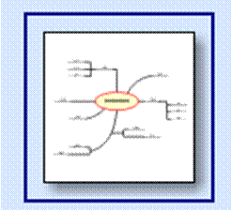The facilitator reads out the statements and calls for ideas. As they flow, they are numbered and written up on a large flipchart with a large felt-tip pen.

Each sheet is torn off when full and displayed elsewhere in the room. Freedom of expression should be encouraged. The ideas may number from 150 to 600, or more.

There should be pre-set timescale for this session.

Now the solutions can be considered for practicality and so on.

Activity 5 (8964 SO1, AC1-2)

SECTION 6: GRAMMATICAL STRUCTURES

#### Outcome

Use grammatical structures and writing/signing conventions to produce coherent and cohesive texts for specific contexts.

#### Assessment criteria

On completion of this section you will be able to ensure that:

* Clear, well-structured sentences are used
* A variety of sentence structures, lengths and types is employed where appropriate
* Paragraph/chunks of signing conventions are constructed showing awareness of topic
* Punctuation/non-manual features (NMFs) are used appropriately
* Register is chosen to suit audience and purpose
* Link devices are used correctly to write/sign sustained pieces
* Texts are organised and structured to have a clearly defined beginning, middle and end

## Register

Register refers to the type and style of written work produced by writers.

Informal Register

This kind of writing is informal. It would include letters to your friends, e-mails to friends and colleagues. It would also include internal correspondence in an organisation.

If you write a note to your facilitator about one of your assignments, this would fall under the informal register.

While your grammar and punctuation should still be correct, you can use a more informal tone and style and also more informal words. Newspaper and magazine articles are usually written in the informal register.

Formal Register

Letters to the head of a department or branch or head office of an organisation and also letters to clients would be more formal, therefore you will use the formal register.

If you write a letter to the head of the college the format of the letter, the grammar, words and style would be formal.

For example, if you are writing a letter to the president of our country, you will not write like this:

Howzit Thabo, my Bra

I just want to tell you that the trains are late everyday. You must do something about it or I will not vote for you again.

If the trains are late again tomorrow, I am going to set fire to it, because my boss has said that he will fire me if I am late again.

Bye

When he has a meeting in your city or town and you are addressing him personally, you can certainly talk to him like this. Writing, however, is always more formal than talking so you have to choose the correct register if you want people to take you seriously.

A letter to our president should rather be written as follows:

Dear Mr Mbeki

I live in Soweto and have to travel to the centre of Johannesburg every day. When I arrive late for work, I get into trouble.

For the past two weeks, the trains have been late every day and I have been late for work every day. My supervisor is now threatening me with disciplinary steps if the situation does not improve.

Please look into the matter from your end.

Yours faithfully

## Punctuation/NMF’s

* Punctuation/NMF’s should **clarify the meaning** of text
* Punctuation/NMF’s should make the written material **more readable**
* Punctuation/NMF’s should be reader-oriented: the most important reason for using full stops (periods) is to **help your reader understand** you. Of course, when you use periods (full stops) in the right places, your work will automatically be grammatically correct.
* Punctuation marks/NMF’s indicate the **emphasis**, **tone** and **undertone** in a piece of writing

Writers are not free to punctuate as they wish, certain rules have to be followed:

* A period or full stop at the end of a sentence indicates a long pause.
* A question is always indicated by a question mark. (?)
* An exclamation mark always indicates an exclamation. (!)
* A quote **must** always be placed within quotation marks. (“…”)

Period

* Use at the end of a sentence.
* Use after a declarative or imperative statement: Write in pencil.
* Used after certain abbreviations: etc.

Do not use periods at the end of a heading or a theme title.

Comma

Commas are used to:

* Separate an introductory phrase from the body of the sentence: “During the discussions in parliament, it was decided that ….” Doing this, tells the reader that the introductory phrase is less important than the main part of the sentence. In the example, the important part of the sentence is the decision that was made, the place where it was made is not that important.

,

* Separate two independent clauses that are joined by a conjunction. Examples of conjunctions are: “and”, “but”, “or”, “nor”, “for”, “yet”, “so”. You will place the comma after the first independent clause and before the conjunction: “I have finished reading this book, and I am taking it back to my friend. “It is raining outside, but inside the room it is dry and warm.”
* A separable (non-restrictive) clause from the principal clause. This is when you insert an interesting clause, word or phrase into a sentence: “The water, polluted by industrial waste, is poisonous.” The clause that was inserted is interesting, but not essential to the point of the sentence. Of course, when the clause is essential to the sentence, you will not use commas.
* Separate elements in a simple series. When you quote a list or series of things in a sentence, you must separate them with a comma: “All the furniture, domestic appliances, office equipment and other business articles must be included in the inventory.” “I want to buy the red dress, yellow jersey, white slacks and black shoes.”
* Separate transitional words or phrases such as: “well”, “yes”, “no” and “finally” from the rest of the sentence. “Yes, I will make the opening speech for the debate.” “No, the blue jacket does not look good with the brown slacks.”

Ellipses

The ellipse (…) is three spaced periods that indicate the intentional omission of words in a quotation, a remark that is not complete or to show that the author did not cite all the information: “I understand your problem…”

...

When you use an ellipse with other punctuation marks, such as a question mark, the ellipse follows the question mark: “Why don’t you tell me what is bothering you?...”

Semi-colons

;

The semi-colon (;) is a stronger punctuation mark than a comma, but not as strong as a period. When you use a semi-colon, you are indicating a longer pause than a comma, but the pause is not as long that of the full stop.

* Use a semi-colon when you want to separate ideas that are related that follow a colon: “the secretary should: prepare the chairman’s agenda; take minutes of the meeting; read the minutes …”
* Semi-colons are also used if items in a series contain a comma: “Are you going to Parys, Free State; or Paris, France?”

Dash

* Use the dash sparingly. To many dashes in a piece of writing is bad style.

(-)

* The dash shows an abrupt break in the thought or construction of a sentence: “I believe – no, I am sure – that he is responsible.”
* A dash takes the place of **to**: “January – March” or “1994 – 2004”.

## Sentences

Use clear, well-structured sentences by using punctuation marks or NMF’s. Also vary the length of your sentences as discussed in a previous sentence.

## Paragraphs

During the previous unit standard we discussed sentences and how they should be formed. As an introduction to writing your own texts, herewith an overview about writing paragraphs and documents.

The sentences in a paragraph should form a unit. The reader must be able to easily see how a sentence follows on the one preceding it. A paragraph starts with a topic sentence, that introduces the topic of the paragraph to the reader. The topic sentence acts as a base and holds the paragraph together. Sentences that follow in the same paragraph should enlarge on the topic or theme introduced in the first sentence. We call them supporting sentences. Supporting sentences should provide **specific details** about the topic in order to clarify the topic sentence and make the paragraph interesting.

If the sentence does not contribute to the theme of the paragraph, it should not be included. You should also avoid adding data that is not relevant to the topic

✓

**Hints for writing good paragraphs**

1. Each paragraph should have only one theme.
2. Do not write paragraphs that are longer than 10 or 12 lines, as longer paragraphs become boring and confusing.
3. Mix long and short paragraphs in a document to create interest and attention with the reader.

## Document

When you are writing a document, it should be about a specific topic or theme. The text you are writing will usually consist **of more than one paragraph**, each with its own topic but relating to the main topic of the document.

Your piece of writing should start with an **introduction** of the theme of the document. Your first paragraph would therefore be the introductory paragraph. Keep your introductory paragraph short, relevant, and introduce the theme of the document. The introductory paragraph must get the **attention of the reader**.

Your paragraphs must follow each other in a logical way, from point A to point B to point C. The last sentence of the previous paragraph should lead to the next paragraph. One thought should be connected to the next thought in a logical way. Do not jump around from one topic to another without giving the reader some clues about your purpose.

## Arranging The Paragraphs In A Logical Order

You can use cause and effect and contrast to help you arrange your paragraphs in a logical way.

* **Contrast** is when you contrast one theme, thought, opinion or product with another.
* **Cause and effect**: you can, for example, progress from the causes of war to the consequences(effect) of the civil war on ordinary people.
* If you are writing about something that happens over a period of time, you can arrange your paragraphs **chronologically**: start with the earliest date and end with the latest date. When writing about droughts in South Africa you can start with the big drought in the 1930s and end with the current drought.

1930 - 2006

Any arguments used in your document must be **supported by sound reasons and facts**. You have to justify your feeling about the matter with facts in order to persuade the reader to your point of view. Something your neighbour said about the matter is not fact – you have to verify the statement your neighbour made.

Ensure that you **state your point of view clearly**. Remember other people also have to understand your point of view.

***A fragile home threatened by war.***

*Among the last of its kind, a young gorilla peers from its leafy refuge in Rwanda – a nation bloodied by ethnic slaughter. Conservationists fear that Rwanda’s instability could endanger the gorilla’s survival. Others ask: How should the plight of the world’s rarest ape be weighed against more than 500,000 human dead?*

PRIMA002

As it stands the paragraph above is clear. If I leave out certain key words, I can change the paragraph so that it does not make any sense:

“A young gorilla peers from its leafy refuge and instability could endanger the gorilla’s survival.” What on earth am I talking about? Where is the gorilla, why would its survival be endangered and what is the instability that I wrote about?

If you want your writing to be clear, you have to ensure that you give the reader **all the information** he/she requires to understand your reasoning.

“They said it is going to rain today.” This is a terrible sentence. Who are “they”, where did they get their information from, where is it going to rain, where do they live – do they even live in the same area as you and I?

✓

**Always check your facts for correctness** before you commit them to writing. Readers are very critical and will never forgive you if you get your facts wrong. Anything you write in future will be viewed with suspicion

“The Weather Bureau predicts that there is an 80% chance of rain in Gauteng today.” Now you have stated the source of your fact, you have backed your statement with an estimate of the possibility of rain and you have also made it clear where it will rain. If it doesn’t rain, your readers cannot be angry with you, since you only reported what the Weather Bureau predicted.

At the end of your document, you have to come to a **conclusion**, where you connect all the facts that you stated previously. State your conclusion or recommendation clearly and make sure that it is based on the facts you stated. The conclusion can be:

* A short **summary** of the main points of your document.
* A **direct-approach** conclusion where you show the reader how the message relates to him/her.
* **Plan of action** conclusion where you answer the question of what should be done about the matters discussed in the body of your document.

Organise the material

Before you start writing a document, you have to gather information. This is called research. Once you have gathered information, the material you have collected has to be organised. Follow these steps:

#### Sorting and categorizing

Arrange or organise the information with common features or characteristics systematically in groups.

All the information with similar content is grouped together. Your classification will depend on the order in which you are going to write the document: you can sort the information **chronologically**, using **contrast** or **cause and effect**.

#### Sifting for relevance

Once you have classified the information and data, you have to sift through it for relevance.

Keep only the information that is **relevant** to your topic, everything else can be discarded. In other words, if you are writing about plants that flower in summer, any information about plants that flower in autumn is not relevant, you cannot use it to enhance your writing and you should throw it away or put it to one side in case you need it in the future.

#### Validity and reliability

Now you have to check your information for **validity and reliability**. The obvious way of doing this is to **check your facts with more than one source**:

* check more than one manual,
* talk to more than one expert,
* visit more than one website, to ensure that your facts are correct.

Preferably, you should use more than one manual, more than one website and the knowledge of more than one expert for each aspect that has to be checked. If most of or all your sources state the same basic fact, you can be reasonably sure that the fact is correct.

#### Recording

Once you have sifted and verified your information, record it in the categories you have selected. This recording is in draft form, usually in the form of rough notes.

Now you are ready to draft your first copy of the final document.

You will never use your first draft for the final document without reading and rereading and making changes.

Your first draft is never good enough for the final product, you have to check and recheck and recheck again in order to make corrections to your writing that is an improvement on the original.

When you are checking your document, check the following:

* Your use of grammar.
* Diction.
* The sentence and paragraph structure.

If necessary, which it usually is, make changes to ensure consistency.

Ensure that your ideas and topics **flow logically** from one to the other in the sentences as well as the paragraphs.

Identify and remove inappropriate or potentially offensive language.

Be on the lookout specifically for jargon and technical language. Don’t use them too much, replace them with other explanatory words. Too much jargon and technical language confuses a reader who is not familiar with it. The reader will lose interest and stop reading. I am sure you have stopped reading an article or document because of excessive use of jargon and technical language.

Beware of using offensive language with regards to gender, rank, family, sports and wealth

You might find a sexist joke funny, the other party might not. Do not make fun of a person’s gender or rank. Also, do not refer to “that old woman”, she might be someone’s mother. Do not call your boss the “Big Chief”, call him by his proper rank.

Activity 6 (8964 SO 2, AC 1-7

# SECTION 7: ADAPT LANGUAGE

#### Outcome

Adapt language to suit context

**Outcome Range**

Socio-cultural, inclusivity, human rights, technical/workplace, environmental contexts

#### Assessment criteria

On completion of this section you will be able to ensure that:

* Inappropriate language is identified and adapted: Excessive use of jargon, insensitive choice of words/signs, (gender; rank; hierarchies in familiar settings or organisations; family; sports; wealth) offensive or incorrect register
* Complex wording/signing of ideas is simplified where necessary

When you write, make sure that you adapt the language to suit the context you are writing for. Contexts include:

* Socio-cultural: refer to the section about socio-cultural language
* inclusivity: include everything expected or required of your text. In other words, state the opinion of more than one person or expert, include all the facts that are needed to make a decision, etc.
* human rights: refer to the section about bias
* technical/workplace: refer to the section about jargon and words used in specific workplaces
* environmental contexts: bear in mind the environment of the people you are writing for, e.g. is it business correspondence, are you writing to a friend, etc.

Identify inappropriate language and remove this language from your text. For example, do not include jargon when writing for the general public, avoid bias and make sure that you use the correct register.

Where you have to use complex words, make sure that you explain them.

Activity 7 (8964 SO3, AC 1-2)

# SECTION 8: EDIT WRITING

#### Outcome

Draft and edit own writing

#### Assessment criteria

On completion of this section you will be able to ensure that:

* Planning, drafting, editing and redrafting improve the suitability of the intended purpose and audience
* Cohesive devices to link parts of texts with other parts and to link ideas are checked and adapted to promote overall coherence of the text.
* Major grammatical errors are identified and changes improve structure and readability/viewability of text
* Spelling/handshape, punctuation/non-manual features (NMFs), register, sentence and paragraph structure are checked and corrected where necessary, and the selection of vocabulary is appropriate to content
* Points of view, where expressed, are supported with a simple range of reasons and facts
* Sources used in writing/signing are acknowledged and accurately recorded in format appropriate to the task or learning activity

## Redrafting

You will never use your first draft for the final document without reading and rereading and making changes.

Your first draft is never good enough for the final product, you have to check and recheck and recheck again in order to make corrections to your writing that is an improvement on the original.

When you are checking your document, check the following:

* Your use of grammar.
* Diction
* Spelling/handshape
* The sentence and paragraph structure.

If necessary, which it usually is, make changes to ensure consistency.

Ensure that your ideas and topics flow logically from one to the other in the sentences as well as the paragraphs.

Identify and remove inappropriate or potentially offensive language/signs. Be on the lookout specifically for jargon and technical language. Don’t use them too much, replace them with other explanatory words. Too much jargon and technical language confuses a reader who is not familiar with it.

The reader will lose interest and stop reading. I am sure you have stopped reading an article or document because of excessive use of jargon and technical language.

Beware of using offensive language with regards to gender, rank, family, sports, wealth and obfuscation.

You might find a sexist joke funny, the other party might not. Do not make fun of a person’s gender or rank. Also, do not refer to “that old woman”, she might be someone’s mother. Do not call your boss the “Big Chief” call him by his proper rank.

**Obfuscation** means to make unclear or hard to understand. “I will horizontalise your perpendicularity” actually means that I will knock you over. Perpendicular means upright and horizontal means parallel to the ground. When you write something, do not make it more difficult than it has to be.

While you are redrafting your piece, experiment with the layout: use titles, headings, colour and so on. This way you can see what the finished product will look like. Add pictures, captions and visual effects at the appropriate places. Visualise what it will look like. Move them around until you are happy with the result – all the graphics, for example, should not be on the same side of the page. Vary their positions from the left to the centre to the right and so on.

Bibliography

Make sure that you acknowledge sources that were used in composing your texts. A bibliography is a record of the resources and sources you used during your research. Follow the following format when quoting the sources of your information:

* Author surname and initials
* The year it was published
* The title of the book
* Where it was published
* The name of the publisher

When you quote the author directly, you have to add the following to your text where you use the quote: (Sayles & Chandler, 1971:185)

Sayles & Chandler are the authors

1971 is the year the book was published

185 is the page number where the quote appears

Then, of course, you have to add the details of book to the bibliography.

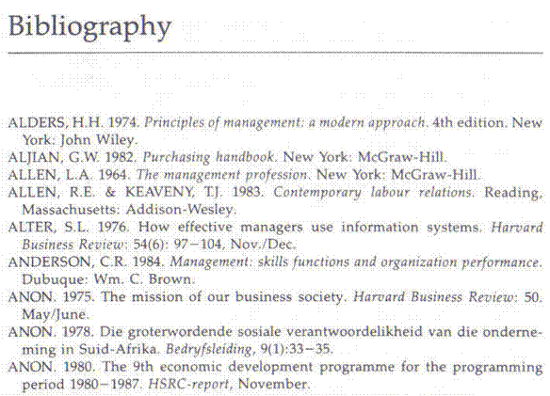

**Keep your rough copies for your portfolio of evidence, as you have to prove that you did redraft your work.**

Activity 8 (8964 SO4, AC 1-6)

# UNIT STANDARD 8962

#### Unit Standard Title

Maintain and adapt oral communication

#### NQF Level

2

#### Credits

5

#### Purpose Of The Unit Standard

This unit standard will be useful to learners who need a sound foundation of spoken language ability for further language growth, and for application in real life contexts. Learners talk confidently in both formal and informal contexts and actively listen for ideas and information in interactions with other people. They are aware of the ways others speak to influence listeners and audiences. In conveying their ideas and information they select language and a register that is accessible to their audience and fit for their purpose.

Learners credited with this unit standard are able to:

* use a variety of strategies to maintain communication
* adapt speech to accommodate cultural sensitivities without losing own meaning
* use knowledge of language structures and conventions to shape or decode meaning of unfamiliar vocabulary or constructions
* organise and present information in a focused and coherent manner
* identify and explain how speakers influence audiences.

#### Learning Assumed To Be In Place And Recognition Of Prior Learning

The credit calculation is based on the assumption that learners are already competent in terms of the full spectrum of language knowledge laid down in the national curriculum statements up to and including GETC or NQF level 1.

Learners can:

* listen for information and enjoyment, and respond appropriately and critically in a wide range of situations;
* communicate confidently and effectively in spoken language in a wide range of situations.

#### Unit Standard Range

* Speaking and listening in defined oral interactions in socio-cultural, learning and workplace situations, in both formal and informal contexts.
* Specific range statements are provided in the body of the unit standard where they apply to particular specific outcomes or assessment criteria.

#### Specific Outcomes and Assessment Criteria:

**Specific Outcome 1**

Use a variety of speaking and listening strategies to maintain communication.

**Assessment Criteria**

* Questions to obtain information and clarify meaning are appropriate to the context, and are used to maintain interaction.
* **RANGE** Questions must include: who, what, when, where, why and how questions.
* Interaction is sustained through exchanges with others to clarify understanding, information, ideas and opinions.
* Intonation (tone), volume, pitch, stress, repetition and pace are used in a manner that supports and conveys meaning.
* Sustained interactions reflect an ability to discuss a series of events.
* The main ideas are clearly distinguished during the interactions and are supported by information appropriate to the context and topic of discussion.
* Interactions are coherent, and conclusions and opinions that are justified by evidence and arguments during the interaction are recognised, then supported or countered.
* One's speech is corrected or adapted to promote clarity and understanding during the interaction.

**Specific Outcome 2**

Adapt speech to accommodate socio-cultural sensitivities without losing own meaning.

**Assessment Criteria**

* The effects of combining the spoken word with visual features and body language is explained with reference to purpose and audience, and used appropriately.
* Intonation is used appropriately to support intentions in spoken texts and its impact is explained.
* The impact of using appropriate or inappropriate forms of politeness on interaction in a specific context is explained.
* One's ideas and opinions are expressed in ways that reflect respect for others and sensitivity to cultural differences and ways of constructing meaning.

**Specific Outcome 3**

Shape or decode meaning of unfamiliar vocabulary or constructions.

**Outcome Notes**

Use knowledge of language structures and conventions to shape or decode meaning of unfamiliar vocabulary or constructions.

**Assessment Criteria**

* New or borrowed words, idioms, slang, acronyms and technical terms are identified and used appropriately in speaking.
* New words are explored and meaning constructed from a range of contextual clues in order to extend vocabulary.
* **RANGE** Contextual clues include: parts of speech; derivatives; compound words; roots, prefixes, suffixes; compound derivatives; etymology; synonym, antonym, homonym; homophone.
* Meaning in speaking is supported by the appropriate use of a variety of sentence structures, the pause, intonation, pace and stress.

**Specific Outcome 4**

Organise and present information in a focused and coherent manner.

**Outcome Range**

Coherent in articulation, pronunciation, volume, tempo, intonation, use of non-verbal cues, body language, tone, volume, gestures and eye contact.

**Assessment Criteria**

* Speech is organised in a way that makes its meaning and purpose accessible to listeners.
* Style and register suit purpose and audience.
* Data and information appropriate to purpose and audience and context are identified, located and selected, and logically structured and presented.
* **RANGE** Sources of information include (where available) libraries, manuals, directories, internet, atlases, files, journals, archives, museums, schedules, government departments.
* Illustrative aids used to promote understanding in the communication process are appropriate to the topic, audience and context.
* Own points of view and ideas are presented coherently in prepared and unprepared talks.
* **RANGE** At least two different techniques of speech and delivery, two purposes and two different audiences.
* Conclusions are formulated in clear, simple language that summarises the main supporting evidence and states own point of view.

**Specific Outcome 5**

Identify and explain how speakers influence audiences.

**Assessment Criteria**

* Speaker's choice of words, language usage, symbols, pictures and tone is explored and explained in terms of impact on audience.
* **RANGE** Bias (cultural, religious or peer preferences, misrepresentation, discrimination, racist, sexist, ageist); humour; irony; sarcasm
* Speaker's omission of pertinent facts and opinions is recognised and explained in terms of impact on audience.
* The impact of different techniques of spoken communication are identified and evaluated in terms of their influence on selected audiences.
* **RANGE** Stress, intonation, rhythm, repetition, rhetorical questions, use of first person for inclusion, analogies, use of passive, 'politically correct' language.

#### Unit Standard Accreditation And Moderation Options

* Providers of learning towards this unit standard will need to meet the accreditation requirements of the GENFETQA.
* Moderation Option: The moderation requirements of the GENFETQA must be met in order to award credit to learners for this unit standard.

#### Unit Standard Essential Embedded Knowledge

The following essential embedded knowledge will be assessed by means of the specific outcomes in terms of the stipulated assessment criteria:

* Learners can understand and explain that languages have certain features and conventions, which can be manipulated. Learners can apply this knowledge and adapt language to suit different contexts, audiences and purposes.
* Candidates are unlikely to achieve all the specific outcomes, to the standards described in the assessment criteria, without knowledge of the stated embedded knowledge. This means that for the most part, the possession or lack of the knowledge can be directly inferred from the quality of the candidate`s performance. Where direct assessment of knowledge is required, assessment criteria have been included in the body of the unit standard.

#### Critical Cross-field Outcomes (CCFO):

**Identifying**

Identify and solve problems: using context to decode and make meaning individually and in groups in oral, reading and written activities.

**Working**

Work effectively with others and in teams: using interactive speech in activities, discussion and research projects.

**Organising**

Organise and manage oneself and one`s activities responsibly and effectively through using language.

**Collecting**

Collect, analyse, organise and critically evaluate information: fundamental to the process of developing language capability across language applications and fields of study.

**Communicating**

Communicate effectively using visual, mathematical and/or language skills: in formal and informal communications.

**Demonstrating**

Understand the world as a set of inter-related parts of a system: through using language to explore and express links, and exploring a global range of contexts and texts.

**Unit Standard CCFO**

Contribute to the full development of self by engaging with texts that stimulate awareness and development of life skills and the learning process.

**UNIT STANDARD 8967**

#### Unit Standard Title

Use language and communication in occupational learning programmes

#### NQF Level

2

#### Credits

5

#### Purpose Of The Unit Standard

The purpose of this unit standard is to facilitate learning and to ensure that learners are able to cope with learning in the context of learnerships, skills programmes and other learning programmes. Many adult learners in the FET band have not been in a learning situation for a long time, and need learning and study strategies and skills to enable successful progression.

Learners competent at this level will be able to deal with learning materials, to access and use useful resources, to seek clarification and help when necessary, and apply a range of learning strategies. They do this with an understanding of the features and processes of the workplaces of the workplaces and occupations to which their learning programmes refer.

Learners credited with this standard are able to:

* find and use suitable learning resources
* use learning strategies
* manage occupational learning programme materials
* plan and gather relevant information for use in a given context
* function in a team
* reflect on how characteristics of the workplace and occupational context affect learning

#### Learning Assumed To Be In Place And Recognition Of Prior Learning

The credit calculation is based on the assumption that learners are already competent in terms of the full spectrum of language knowledge and communication skills laid down in the national curriculum statements up to and including GETC or NQF level 1.

#### Unit Standard Range

* Learning materials appropriate to the learners in a given context.
* Specific range statements are provided in the body of the unit standard where they apply to particular outcomes or assessment criteria.

#### Specific Outcomes and Assessment Criteria:

**Specific Outcome 1**

Find and use suitable learning resources.

**Assessment Criteria**

* Relevant learning resources are identified.
* **RANGE** Resource centres, dictionaries, internet, other learners.
* Learning resources are used effectively through appropriate selection of information and acknowledgement of sources.

**Specific Outcome 2**

Use learning strategies.

**Assessment Criteria**

* Information is summarised for learning purposes.
* Specific techniques are selected and applied appropriately.
* **RANGE** Mind maps, note taking, memorising, key words, underlining, skimming and scanning.
* Relevant questions are asked.
* **RANGE** Checking understanding, clarifying meaning, getting information, asking for help.
* Texts are read for detail.
* Spoken input is listened to for detail.
* Learning takes place through communicating with others in groups or as individuals.
* **RANGE** Facilitators, other learners, colleagues.

**Specific Outcome 3**

Manage occupational learning materials.

**Assessment Criteria**

* Occupational learning materials are well organised.
* **RANGE** Texts, handouts, textbooks, charts, maps, plans, and diagrams.
* Layout and presentation of learning materials is understood and used effectively.
* **RANGE** Index, contents page, or glossaries are used effectively.
* Technical language/terminology is engaged with, and clarification sought if needed.

**Specific Outcome 4**

Plan and gather relevant information for a given context.

**Assessment Criteria**

* Appropriate or relevant topic and scope is identified and defined.
* Information gathering steps are planned and sequenced appropriately.
* Information gathering techniques are applied.
* **RANGE** Gathering information, reading, interviewing, using appropriate electronic sources.
* Information is sifted for relevance.
* Information is classified, categorised and sorted.
* Conclusions are presented in the appropriate format.

**Specific Outcome 5**

Function in a team.

**Assessment Criteria**

* Active participation happens in group learning situations.
* **RANGE** Discussions, activities, workshops.
* Responsibilities in the team are taken up and group work conventions are applied in learning situations.
* **RANGE** Turn taking, rotation of roles: conducting, chairing, recording, and reporting.
* Conflict management and negotiating techniques are practised.
* Teamwork results in meaningful products or outcomes.

**Specific Outcome 6**

Reflect on how characteristics of the workplace and occupational context affect learning.

**Assessment Criteria**

* Features of the occupational environment are described and discussed.
* **RANGE** Workplace/occupational focus:

Services, manufacturing, financial, educational.

* Organisation type:

Government, parastatal, heavy/light industry, large organisation, small business.

* Ways in which these features affect learning processes and/or application of learning are described and discussed.
* **RANGE** Technological resources, communication resources, communication strategies and multilingual needs in relation to necessary client or colleague interaction.

#### Unit Standard Accreditation And Moderation Options

* Providers of learning towards this unit standard will need to meet the accreditation requirements of the GENFETQA.
* Moderation Option: The moderation requirements of the GENFETQA must be met in order to award credit to learners for this unit standard.

#### Unit Standard Essential Embedded Knowledge

Learners can understand and explain that language has certain features and conventions, which can be managed for learning purposes. Learners are aware that there are skills, strategies and resources, which will facilitate learning. They are familiar with the workplace context in which their learning will be applied.

#### Critical Cross-field Outcomes (CCFO):

**Identifying**

Identify and solve problems: using learning programme material and learning tasks to solve problems.

**Working**

Working effectively with others and in teams: using interactive speech and roles in activities, discussions and projects.

**Organising**

Organise and manage oneself and one`s activities responsibly and effectively: through organisation of learning materials and assignments.

**Collecting**

Collecting, analysing, organising and critically evaluating information: through application of information processing skills in study.

**Communicating**

Communicate effectively using visual, mathematical and/or language skills in formal and informal learning situations.

**Science**

Use science and technology effectively and critically: using electronic media for learning.

**Demonstrating**

Reflect on and explore a variety of strategies to learn more effectively.

**Contributing**

Explore education and career opportunities.

SECTION 1: SPEAKING AND LISTENING STRATEGIES

#### Outcome

Use a variety of speaking and listening strategies to maintain communication

#### Assessment criteria

On completion of this section you will be able to ensure that:

* Questions to obtain information and clarify meaning are appropriate to the context, and are used to maintain interaction: Questions must include: who, what, when, where, why and how questions
* Interaction is sustained through exchanges with others to clarify understanding, information, ideas and opinions
* Intonation (tone)/NMFs, volume/sign size, pace and rhythm, pitch/NMFs, stress, repetition and pacing are used in a manner that supports and conveys meaning
* Sustained interactions reflect an ability to discuss a series of events
* The main ideas are clearly distinguished during the interactions and are supported by information appropriate to the context and topic of discussion
* Interactions are coherent, and conclusions and opinions that are justified by evidence and arguments during the interaction are recognised, then supported or countered.
* Own speech/signing is corrected or adapted to promote clarity and understanding during the interaction

**DEFINITION OF COMMUNICATION**

*“****Human communication is the process whereby meaning is created between two or more people.”* (Tubbs & Moss, 1994)**

The Communication Process

*Message*

**Communicator** **Recipient**

*Feedback*

Communication is the interaction between at least two people, the communicator and the recipient. There can, however, be more than one recipient, like an audience listening to a speech or watching a movie.

#### The Communicator

starts the communication process by conveying a ***message*** about what he feels, thinks or believes about a matter that he wishes to share with others.

#### Message

is that which the communicator wishes to convey to others by way of communication and can be used by the communicator to attempt to persuade someone to his way of thinking or it can be an idea, thought or feeling that the communicator wishes to share with others. This message needs to be communicated in some form, for while the message remains a thought in the communicator’s mind it cannot be received or interpreted by a recipient.

#### The Recipient

receives the message, interprets it and reacts. This reaction is called *feedback.*

#### Feedback

is not always verbal, but can also be conveyed by means of other reactions e.g. applause after a good performance, joy after receiving good news or even a bloody nose after insulting someone.

Activity 1

We will start this section with a practical communication exercise, called a rumour clinic. The facilitator will nominate five people to leave the room. One of the learners that remain in the room will be called forward. The facilitator will read/sign a piece of text to the learner, who must try to remember everything the facilitator says. This learner will be called learner 1 The facilitator will read/sign the text only once. One of the learners who was sent outside will be called in, we will call him/her learner 2. Learner 1 then repeats everything s/he remembers once to learner 2. Learner 2 repeats everything once to the next learner from outside the classroom. This process then continues until the last learner from outside, learner 6 has heard the message once. Learner 6 then repeats the message to the class.

While this process is happening, the learners in the classroom may not make any comments, they must only listen/view.

Once the last learner has repeated the message to the class, the entire class will discuss the differences in the message from learner 1 to learner 6. The facilitator will take notes.

How did the message differ from what the facilitator read to learner 6?

|  |
| --- |
|  |
|  |
|  |

Was this an effective communication?

|  |
| --- |
|  |
|  |
|  |

What did you learn from this exercise?

|  |
| --- |
|  |
|  |
|  |

What do you think can be done to improve the communication?

|  |
| --- |
|  |
|  |
|  |

How would the communication have been improved if the learners had been offered the opportunity to ask/sign who, what, when, where, why and how questions?

|  |
| --- |
|  |
|  |
|  |

Do you think we should all improve our listening/viewing skills?

|  |
| --- |
|  |
|  |
|  |

## Dos' And Don’ts On Listening/Viewing

Recognise that you think about four times as fast as the person can talk/sign. This naturally gives your brain extra time to think. Don't use that extra time to start thinking about something else. If you do, you will find yourself dividing your attention between listening to or viewing the speaker and listening to yourself. To accomplish your primary task, that of gathering information from the speaker, you must give the speaker your undivided attention.

Do not let certain words, phrases or ideas prejudice you against the speaker so you cannot listen objectively to what is being said. If the speaker uses/signs a word incorrectly, or mispronounces a word or uses the wrong tense in a sentence, do not dwell on it, but rather let it go. Your task is to listen/view objectively to the content and not the form.

If you are annoyed or irritated by what has been said/signed, do not interrupt the speaker/signer to try to straighten it out. Furthermore, do not dwell on it in your own mind as it will distract you from listening.

If the speaker says/signs something that you do not understand, do not tune out, especially if you feel that it will take too much time and effort to understand.

Do not deliberately turn your thoughts to other subjects if you believe that the speaker/signer has nothing interesting to say/sign. This is a natural result of boredom. Once you feel that the speaker/signer is dull or uninteresting, you invariably occupy your mind with thoughts that are more interesting to you. You must force yourself to listen/view. A method useful in dealing with this problem is to try to find out just how boring the person can really be. It may sound a bit. silly, but playing the game "How Big a Bore Have I Here?", helps you to listen to the person, to the bitter end.

Do not let a person's appearance or speech/sign pattern influence you into thinking that the candidate may not have anything worthwhile to say/sign. So the candidate is not attired to a smart up‑to‑date, tasteful outfit, but rather in seedy, tasteless, outmoded clothes. As much as you want to tune the person out, don't do it. You never know what or who is hiding beneath.

The only way you're going to find out is by listening/viewing

Finally, do not pretend to be listening if you're not. Pay attention!

### Active Listening

You have to apply active listening/viewing skills to hear and understand what they are saying. You have to pay attention and focus on what the speaker says/signs in order to respond appropriately to their comments and questions.

Active listening/viewing is a **skill** and is as important as giving orders in obtaining results.



* Give your full attention to what is being said/signed.
* Make sure that you really understand by asking the who, what, when, where, why and how questions.
* Listen/view between the lines.
* Look for non-verbal clues.
* Mentally summarise and evaluate objectively.

#### What Makes A Good Listener?

This is actually a question of feedback. Good listeners use a variety of verbal and non-verbal clues to keep the other person talking. These include the use of phrases such as:

* “Yes”
* “I understand”
* “And then what”
* “Tell me more”
* “If I understand you correctly…”

When communicating with someone else you must always strive to do it as **naturally and evenly** as possible. Be yourself!!

## Use questions

When you are engaged in verbal communication, the easiest way to obtain information is to use questions. You can also use questions to clarify the meaning of the other person’s verbal communication.

The typical questions to ask are:

#### WHAT

1. **What** were your duties?
2. **What** did you do then?
3. **What** subjects did you take?
4. **What** happened then?
5. **What** sort of...?

#### WHEN

1. **When** was that ?
2. **When** did that happen...?
3. **When** did you go...?
4. **When** did you decide...?
5. **When** did the company

#### WHY

1. **Why** was that...?
2. **Why** did you choose...?
3. **Why** do you think that...?
4. **Why** did you do...?
5. **Why** did they...?

#### WHERE

**Where** was that...?

**Where** did you go next...?

**Where** were you when...?

**Where** did you go...?

**Where** do you think...?

#### WHICH

**Which** school was that...?

**Which** course did you...?

**Which** were your best...?

**Which** department was...?

**Which** was that...?

#### HOW

**How** did that come about...?

**How** do you think that...?

**How** much did that...?

**How** did you get...?

**How** was that...?

Guidelines when asking questions:

1. Your questions should have a purpose, that is, be goal directed.
2. Time your questions so that you do not interrupt the speaker’s thinking process.
3. Ask questions that are clearly worded, avoid ambiguity or a question with more than one answer.
4. Your questions should have answers. In other words, there is little point asking a question when the person is unable to respond or it places them in an uncomfortable position.
5. During conflict when emotions usually run high, avoid emotive or leading questions that disclose your bias and feelings, as this often adds fuel to the fire.
6. Word your questions in a descriptive manner. Being descriptive, it is much less likely to cause animosity as you are being specific and non-judgmental.

## Sustain Interaction

Perhaps the most basic technique for gaining a depth of understanding is the use of follow-up questions that request elaboration. Whenever you feel that the speaker has made a statement that is not clear, is lacking in specifics, does not adequately cover the topic, then you should ask the speaker to elaborate more on the topic. This is very easy to do.

Some types of phrases that you can use to request a candidate to elaborate are:

* Could you say more about that?
* Could you tell me more about this?
* Could you explain that in more detail?
* I would like to hear more about that.
* Could you give me an example of that?
* Perhaps you can clarify that for me.

You can also sustain interaction with someone else to clarify understanding, get information or exchange ideas and opinions through the way you speak.

#### Environment

Have a non-threatening atmosphere.

Help people feel physically and mentally comfortable and relaxed.

#### Guidelines when asking questions:

1. Your questions should have a purpose, that is, be goal directed.
2. Time your questions so that you do not interrupt the speaker’s thinking process.
3. Ask questions that are clearly worded, avoid ambiguity or a question with more than one answer.
4. Your questions should have answers. In other words, there is little point asking a question when the person is unable to respond or it places them in an uncomfortable position.
5. During conflict when emotions usually run high, avoid emotive or leading questions that disclose your bias and feelings, as this often adds fuel to the fire.
6. Word your questions in a descriptive manner. Being descriptive, it is much less likely to cause animosity as you are being specific and non-judgmental.

#### Clarify your thinking:

1. Analyse the problem or idea to be communicated until it is clear in your own mind.
2. Decide what you want to achieve and plan your communication to achieve it.
3. Organise your ideas. Discuss and review your points with others before expressing them.

#### Obtain favourable attention:

* Have the receiver’s full attention to ensure you achieve your communication objectives.
* Ensure the receiver’s desire to understand the message.

#### Make it simple and specific:

* Phrase your message in simple terms.
* Be conscious of the experience level and the language which the receiver will readily understand.
* Make the message concise, with its purpose obvious.
* Make sure the message cannot be misinterpreted.
* Be specific.

#### Make effective use of feedback:

* Follow up your communication.
* Ensure the receiver actually did receive the message you meant him/her to receive.
* Observe his/her non verbal communication.

#### Use “you” appeal:

* Use “you” and “your”. Ignore the words “I” and “my”.
* Express your message from the receiver’s viewpoint.
* Phrase the message in terms of his/her interest.

#### Note social climate and specific situaton:

* Timing must be appropriate.
* Physical setting must be considered.

## Speak in a way that conveys meaning

The way that you speak can reinforce your message and influence your audience. When you speak in the same **tone, pitch, volume and pace** all the time it becomes boring for the audience and they can fall asleep. If you listen to public speakers, TV and radio commentators, you will notice that they vary the tone, pitch, volume and pace when they speak, in order to capture and maintain the interest of the audience.

The tones, pitch, pace and volume of your voice can determine how a listener will interpret what you are saying.

By controlling these vocal/signing characteristics you can become a more effective speaker/signer.

* The ***tone*** is the sound of your voice, e.g. bright or deep, and expresses your feeling or mood. A bright tone will indicate feelings of excitement, joy, etc. while a deep tone will indicate feelings of placidity or sorrow. So when you are addressing a serious subject, your will use a deeper tone of voice, while a lighter tone of voice is appropriate for a more light hearted subject. In SASL the tone of voice is represented by non manual features (NMF’s)
* ***Pitch*** is determined by the tension on your vocal cords, i.e. how high or low your voice sounds. Generally you will speak at a high pitch when excited and at a lower pitch when relaxed. In SASL the pitch is represented by non manual features (NMF’s)
* 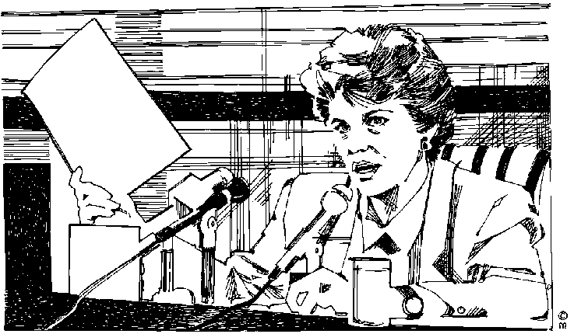The ***pace***or speed at which you speak/sign can also influence your audience. When you are telling/signing someone that you have won the Lotto you will talk much faster than when you are telling/signing him that you cannot attend a major sporting event.

You need to adapt the ***volume*** of your voice to the environment and the audience, as well as the subject you are communicating. Factors such as:

* being indoors or outdoors,
* number of listeners in a room,
* the size of the room,
* background noise and
* availability of amplification will determine the volume at which you speak.

The **volume/sign size** of your voice can also indicate whether you are excited or relaxed, angry or friendly. When you are saying/ signing something important, you will increase the volume of your voice/sign size in order to stress the importance of the point you are making.

**Pause** is a useful technique to stress important points in your presentation. When you pause for a couple of seconds just after making an important point, the audience knows that what you have said is important.

Using **keywords/signs** is another technique to stress important points. In every presentation, not everything you say will be equally important. Some points will be main points and others will be extra information to explain what you are saying/ signing. You will use the main points to identify keywords/signs in your presentation. When you get to the keywords you will **stress** them by adjusting the tone, pitch, volume and pace of your voice. This will give the audience the cue that the keywords and the point you made are important. In SASL you will use NMF’s and sign size to stress the important points

Now that you know what it means to vary the tone, pitch, volume and pace of the way you speak, you can use these methods to:

* Enhance the meaning of what you are saying to the audience
* Respond appropriately to the audience, even in differing circumstances

In SASL you can use NMF’s and sign size to achieve the above.

Repetition

Repetition is when the speaker repeats words and phrases. This is very effective to emphasise the importance of the statement. Sir Winston Churchill made very good use of repetition in his famous speeches during World War II.

On 22 May 1940, after the British soldiers had been evacuated from Dunkirk, he said:

“***We shall fight*** on the beaches, ***we shall fight*** on the landing-grounds, ***we shall fight*** in the fields and in the streets, ***we shall fight*** in the hills; *we shall* never surrender…

On 13 May 1940, just after he was elected prime Minister, he said that he had one aim:

“**Victory – victory** at all costs, **victory** in spite of terror; **victory**, however long and hard the road may be.”

## Extract The Main Idea

When people are telling or signing information they always tend to add a lot of information that supports the main idea. We have to learn to look for the main idea whenever someone else is speaking/signing.

Listen for keywords, emphasis on certain points, tone, pitch, pace, volume, pause, repetition, etc.

If you are still unsure – ask a question to get clarification.

## Recognise evidence and arguments

Your own verbal interactions must be coherent, meaning that the conclusions and opinions you arrive at must be justified by evidence that can be supported.

If you do not agree with the speaker, you have to be able to argue the point with facts and without losing your temper.

## Sustained interaction

In order to sustain a verbal interaction, for example during a debate, you have to be able to listen carefully. This means you have to improve your listening skills as well as your memorising skills if the debate is going to pass from the speaker to you and back again. You have to LISTEN to what the speaker is saying, memorise important points you want to reply to, frame your reply in your mind and finally, when the speaker has stopped talking, you reply to specific points that the speaker raised.

## Adapt own speech

During the verbal interaction, you have to adapt your own speech/signing in order to make sure that the listener understands what you are saying. You also have to make sure that your speech is clear.

#### Consider tone as well as content:

Watch your tone of voice.

Remember that body language and facial expressions will affect the receiver’s reactions.

#### Always plant mental pictures as goal images:

Plant vivid and attractive mental pictures in the mind of the receiver.

#### Talk only in positive terms:

Remember that talking in positive terms avoids any possibility of planting the wrong goal image in the receiver’s mind.

#### Impress, repeat, associate, to get retention:

Ensure that the message is retained in the receiver’s memory and that he/she can recall it readily.

Deliver the message with sufficient emphasis and conviction.

Repeat when necessary.

Have patience.

#### Offer and earn liking and respect:

Show liking for the receiver.

Respect the receiver’s viewpoint.

Conduct yourself in a way that earns you his liking and respect.

#### Nullify barriers to transmission and reception:

Identify, nullify, and overcome any other barriers to communication

## Barriers To Effective Communication

Many barriers to effective communication exist and can be detrimental to effective communication. Following are a few that have bearing on what is dealt with in this unit standard.

### Poor interpersonal skills

Poor interpersonal skills include poor listening and/or sensitivity to nonverbal communication.

We have discussed listening skills and nonverbal communication at length. When you deal with clients, you have no excuse for not listening to what the client is saying or listening to non verbal communication. It is part of you job and you have to do it. when a client is discussing something with you, the client is entitled to your undivided attention.

Tip You cannot listen while you are talking. In order for you to listen, you have to keep quiet and pay attention.

### Failure to identify the needs of the receiver

This happens when you listen to only part of what the person is saying and then start jumping to conclusions instead of listening to the speaker until he has stopped talking.

Only then can you come to conclusions, which you have to check with the client anyway, by repeating the issue as you understand it to the client.

“Am I correct in understanding that you want ….. done” or “As I understand, the problem is …..”

### Different cultural backgrounds

The audience will not always take differences in cultural backgrounds into account, but you have to. You are not allowed to judge anyone you are talking/signing to because their cultural background is different to yours.

When you are speaking/signing, it is part of your job and your duty to take the audience’s different cultural backgrounds into consideration. You have to ensure that your presentation does not include material that can be offensive to cultures other than your own.

If you don’t know much about other cultural beliefs, you have to make an effort to find out what they are. This will make future communication easier.

### Lack of intercultural understanding

This is a major problem in our country today. Unfortunately, when you are dealing with other people, you have to ensure that you do not suffer from a lack of intercultural understanding. Just as your culture is important to you, their cultures are important to them. Put yourself in their shoes and try to understand that it is not acceptable to offend people only because their culture is different to yours.

### Messages with too much/little information

Many people find it difficult to express themselves clearly when they are under stress. They will usually either give you too much or too little information.

You have to be aware of this, so that you can:

* Focus on the important and relevant issues when a person gives too much information
* Ensure that you get all the relevant information when a person gives too little information

“I was mugged, they hit me over the head, there was blood all over the place, I had to go to the hospital to get stitches and my handbag was stolen.” This is an example of too much information. You have to find out what the problem is that has to be addressed.

“My handbag was stolen.” This is too little information and you have to find out what the issue is that the person wants resolved.

### Use of insensitive or abusive language by the sender or receiver

This is never acceptable, but can sometimes happen when a person is angry or irritated and perceives that his problem is not going to be addressed properly.

The best way to handle this is to calm the person down without saying anything about his insensitive or abusive language.

You will find in most instances that the person will apologise as soon as he can see that his problem is going to be addressed in a way that is satisfactory to him.

You must always be aware of how you talk/sign to other people in order to ensure that you do not use insensitive or abusive language, as many people stop listening when you talk to them in a way that they don’t like.

1. Sustained interactions reflect an ability to discuss a series of events
2. The main ideas are clearly distinguished during the interactions and are supported by information appropriate to the context and topic of discussion
3. Interactions are coherent, and conclusions and opinions that are justified by evidence and arguments during the interaction are recognised, then supported or countered.
4. Own speech/signing is corrected or adapted to promote clarity and understanding during the interaction

## Effective verbal communication

In summary, we can say that communication is a two-way process between the speaker and the listener.

The speaker should adjust his/her way of speaking to fit the situation, make sure that what he says is clear and understandable and be aware of non-verbal signs from the listener. The speaker should also make use of tone, pitch, volume, stress, repetition, etc. to make sure that the attention of the listener stays with him.

The listener must apply active listing skills, respect the speaker enough to listen to what s/he is saying and be prepared to defend or state his/her point of view.

Both the listener and the speaker should identify barriers to communication and make efforts to overcome these barriers during the communication.

The ability to sustain a verbal interaction is very important to all communications and relationships.

Activity 2 (8962 SO1, AC 1-7)

SECTION 2: ADAPT SPEECH/SIGNING

#### Outcome

Adapt speech/signing to accommodate socio-cultural sensitivities without losing own intention

#### Assessment criteria

On completion of this section you will be able to ensure that:

* The effects of combining the spoken/signed word with visual features and body language are explained and used appropriately with reference to purpose, audience and context
* Intonation/NMFs is/are used appropriately to support intentions in spoken/signed texts and its impact is explained
* The impact on interaction of using appropriate or inappropriate forms of politeness in a -specific context is explained
* Own ideas and opinions are expressed in ways that reflect respect for others and sensitivity to socio- cultural differences and ways of constructing meaning

## Facial Expression, Gesture And Inflection

Perhaps the main advantage that we derive from talking face to face is that we are able to reinforce our speech/signs with facial expressions, gestures, voice /inflections and other physical devices: meanings of sentences can easily be modified by putting the stress on different words in otherwise identical phrases or sentences. Let us consider a simple, short example:

'I am going out' This is a plain statement of fact.

'I am going out' The stressed 'I' suggests that the speaker does not Care what the others are going to do; he is going out anyway.

'I am going out' This indicates that the speaker is determined to go 6ut whatever is said to the contrary.

'I am going out' This suggests an argumentative state of mind where the speaker's intention is in danger of being frustrated.

'I am going out!' This is suggestive of the speaker being in a temper. These are his final words and he slams the door behind him.

To make these various meanings plain in written language, the sentences would have to be completely restructured and many more words employed.

In a similar fashion, meaning when speaking/signing can be modified or reinforced by facial expression or gesture. 'Please be more careful' as it stands, is a reprimand. It becomes a very gentle reprimand, or even no reproach at all, if said/signed with a smile.

Similarly, a straightforward 'I don't know' means just that. If the speaker shrugs his shoulders, or raises his eyes to heaven when saying/ signing it, he can be expressing exasperation.

Body language is much discussed nowadays, and this involves, in the main, unconscious or automatic gesture. The speaker/signer uses physical gestures to make his home.: When he is making statements about which he feels very passionately, he will pound the table or the lectern with his fist, or will raise a finger to heaven at the same time bringing his shoulder forward and up.

This is an extreme example of the use of gesture, but the use of the hands and shoulders is very common whilst speaking. Similarly, our stance and deportment can add meaning to our verbal communication and can also indicate our attitude to our correspondent. For example, if a person being interviewed for a new post slouches in his chair and speaks in a slovenly manner, however highly he is qualified, the interviewer will get the impression that the interviewee is less than interested in the proposition.

## Non-Verbal Signs And Signals

Infants communicate entirely without words; through touch, warmth and various emotional and sensory perceptions, others decode a child's many non-verbal signals and recognises and satisfies his many needs and desires. Adults also communicate largely through non‑verbal means. We say that we have "good vibes" or "feelings" about situations or people; we form quick and sometimes strong opinions about people from the way they look, the way they dress, and from their general posture. We make judgements about the quality of character of individuals based upon their looks, aroma, style of behaviour and how we perceive them to "feel" about us.

Movement

The non‑verbal messages transmitted by our movements, physical attitudes and facial expressions are reliable indicators of emotional feelings or contemplated action. Athletes train carefully to read the body language of their opponents and learn how to conceal their own intentions.

If you pace a lot while signing/speaking, it could indicate nervousness or restlessness, for example.

Gesture

Actions do indeed reinforce verbal communication. Recall the last time that someone told you that you did a good job. Recall, too, that when he put his arm on your shoulder, or shook your hand, or smiled broadly and nodded his head, how much more meaning the compliment had.

Often physical movements and facial expressions totally replace verbal communication. Has someone ever walked away from you without replying or approached you closely, looked you directly in the eye, and shaken his head negatively? Has anyone ever laughed at an idea you've presented or "nodded off" while you were speaking?

These substitutions for language are very clear in their meaning.

Non-verbal signals assist communication by signalling ‑ through facial expression, hand gesture or other movement ‑ that we have finished speaking/signing.

We also signal in the same way when we wish to speak: we may point to another person or hold up a palm for silence. We may extend an upward palm to indicate that it is time for someone to respond. We lean back in a chair after making a point, saying in essence, "How do you react to that? Now it is your turn to speak"

Cultural Influence

Communication is also influenced by culture. Because of the vast cultural differences that influence human development, human beings have a variety of languages and appropriate gestures and expressions that accompany communication in those languages. An Italian or Latin American uses different gestures from an Englishman or Scandinavian. In America, men are taught that it is not manly to reveal one's emotions to others. In France and Italy, on the other hand, emotions are readily revealed, read and accepted. Thus, gestures and facial expressions do not have universally understood meanings; therefore we must be very careful when trying to read body language and attach meaning to non‑verbal communication out of the context of its cultural milieu.

Response or feedback

Good communication involves an exchange of ideas; it is not one-way. We share with, or connect with, those to whom we wish to communicate. Whether they reply verbally or just physically, we get feedback that enhances and illuminates our communication.

One must never assume that one has been understood by others until some action has been taken as a result of what one has said/signed. This action need not be affirmative to assure that communication has occurred. All that is necessary is some reassurance that the receiver of the stimuli has thought about what was said.

Eye Contact

Eye contact enhances the influence and credibility of the speaker/signer. There is a saying *"A man who has nothing to hide can look me in the eye"*. Maintain eye contact, without staring. Eye contact signals interest and concern and demands attention. Failure to maintain good eye contact creates diversions and distractions and may convey an attitude of antagonism.

Direct and prolonged eye contact, although thought by many people to be a sign of sincerity, tends to cause anxiety in some, for they feel that it is too intimate. There is good reason to believe that the person who looks carefully at another individual tends to dominate that situation. Eye contact is the first acknowledged interaction between individuals.

Looking at someone in order to perceive his non‑verbal signals does not mean staring, which is intrusive and rude. When we stare, others tend to feel that their privacy has been violated, particularly if we look too long at one part of the body. Such direct assessment of the physical elements of another individual can be destructive to further communication.

Body Language

Arms folded across the body or legs crossed indicate a defensiveness or a protectiveness; they are a signal that the individual is on guard.

Open arms and uncrossed legs generally indicate a relaxed, receptive and trusting inner feeling. We lean toward people or things we like; we lean away or turn away from things we are ashamed of, embarrassed by or strongly disagree with. Occasionally we lean forward if we wish to attack an idea or an individual. The "full front" position is the strongest position an individual can take when conversing and indicates the greatest interest.

Empathy

The best exercise for finding out meaning in non‑verbal communication is to attempt to empathize with the other individual. In other words, ask "What would I do if I were in his situation with this kind of stimulus? How would I react? How would I feel inside if I conveyed those non-verbal signals to another individual?"

Empathy is the ability to create in oneself the same feelings and emotional state of another individual. In non-verbal communications, some signals are intended and some are not. Control of non-verbal signals improves one's ability to communicate clearly and accurately with others.

In Summary

When we refer to verbal communication, we mean words or symbols chosen to express meaning. But different words mean different things to different people, and interpretation and comprehension of the words require reflection. The meaning of non-verbal communication, however, is usually more obvious; non-verbal communication is more visible and offers fewer opportunities for personal interpretation. Words convey information, but they may also be used to deceive, to confuse and to mislead.

**Non-verbal communication tends to be more direct, more revealing and more influential**. Verbal language tends to be intellectual; non-verbal language, emotional. Non-verbal communication helps to maintain attention by giving vivid visual signals that reinforce attitudes and ideas that have been translated verbally. Therefore, emotional reinforcement compels attention, which promotes understanding.

It is even safe to generalize that verbal messages may conceal while non-verbal messages always reveal; verbal messages are informative, and non-verbal messages are expressive; verbal messages are intentional; non‑verbal messages are often unintentional. How often have we walked away from a meeting, an interview or a speech with mixed feelings about what was said or was expected because a speaker provided different verbal and non‑verbal signals.

We react to people according to what we perceive them to be ‑ how sincere and well-motivated they seem - and the consequences of our doing what they seem to wish us to do.

### Nonverbal Messages

You can use your own body language to enhance your verbal message in the following ways;-

A nonverbal message **reinforces** the verbal message by adding to its meaning. Banging your hand on the table while reprimanding someone conveys a stronger message than words alone, adds emphasis to your statement and captures the listener’s attention.

A nonverbal message can **complement** a verbal message when it conveys the same meaning. A greeting in a friendly tone of voice, accompanied by a warm smile will compliment your verbal message.

A nonverbal message may **substitute** the verbal message. When you arrive home and are irritable and impatient it is not necessary to tell anyone that you had a terrible day at work. Likewise a passionate hug and kiss will tell your spouse that you love him/her without you having to say it.

Nonverbal behaviour functions to **regulate** the flow of verbal interaction. Slight hand movements, eye contact, tone of voice, nodding of the head and other nonverbal behaviour tells the recipient to talk, repeat a statement, hurry up or finish the conversation.

For example, the chairperson at a meeting uses eye contact or hand gestures instead of words to indicate who’s turn it is to speak.

A nonverbal message can **accentuate** what is said. While addressing an audience a speaker may talk louder and wave his finger in the air to stress a point that he is making. Speakers at political meetings are very good at this.

A nonverbal message may **contradict** the verbal message. This happens when a speaker says one thing but does another. A new company executive about to make his first presentation to the board of directors may claim not to be nervous despite his trembling hands and sweating forehead. Contradictory cues often tell us when someone is being sarcastic or merely teasing.

## Appropriate and inappropriate forms of politeness

When you are polite when talking to your audience, you will remove some of the barriers to communication. Always show respect for your audience when talking.

Be careful of becoming too familiar with the person you are talking to. Do not make personal comments, respect other people’s personal space and definitely do not touch the other person if you are not on intimate terms with that person.

When you use inappropriate forms of politeness, such as first names or touching the other person’s shoulder, and the listener does not like your actions, s/he will stop listening and the verbal interaction will not continue.

## Express own ideas and opinions

Make sure that you express your own ideas and opinions in ways that show respect for others. You must also be aware of socio-cultural differences and make sure that your verbal communication does not overstep boundaries.

Be aware of your own biases and the way you are inclined to stereotype people and make sure that this does not come out in your speech. Do not, for example, say :”All blondes are stupid”. You might be talking to someone whose wife or girlfriend is blonde.

Activity 3 (8962 SO2, AC1-4)

SECTION 3: LANGUAGE STRUCTURES

#### Outcome

Use knowledge of language structures and conventions to shape or decode meaning of unfamiliar vocabulary or constructions

#### Assessment criteria

On completion of this section you will be able to ensure that:

* New or borrowed words/signs are identified when listening/viewing, idioms, slang, acronyms and technical terms are identified and used appropriately in speaking/signing
* New words/signs are explored and meaning constructed from a range of contextual clues in order to extend vocabulary. Contextual clues include: parts of speech/signing; derivatives; compound words; roots, prefixes, suffixes; compound derivatives; etymology; synonym, antonym, homonym; homophone
* Meaning in speaking/signing is supported by the appropriate use of pause, intonation/NMFs, pace, stress and a variety of sentence structures

## Identify New Or Borrowed Words/Signs

Borrowed words

Borrowed words are words that are incorporated into a language from another language.

This happens a lot in South Africa, where we have Afrikaans, Zulu and Xhosa word in English, and so on.

The English language has borrowed from other languages for a long long time, that is why there is an estimated vocabulary of over one million words in English.

In Afrikaans, we have borrowed words such as lorry and box from English. It is spelt differently in Afrikaans: a lorrie and a boks, but the word originated from English.

Using borrowed word in a written piece can be controversial. Although there is nothing wrong with using borrowed words, it can offend language purists.

For example, in Afrikaans, I would never write a formal piece of writing using lorrie or boks, as language purists will be very offended by this. The only time I would use borrowed words in Afrikaans, is when I am writing a story and I am quoting the way people talk.

This attitude varies from language to language, most South African languages don’t mind borrowed words.

If you are unsure, use a different word or quote the borrowed word in italics or inverted commas.

New words

also known as neologisms: A new word or expression

This is, of course, a borrowed word, before it is officially incorporated into the language. It can also be a new word that is created around a particular circumstance or happening.

* Surf the web
* Internet
* World Wide Web
* e-mail

All the above are words and expressions that were created when computers became popular and new terms had to be found to describe the functions available.

New words can be used freely if your audience is familiar with them. It not, you will have to include an explanation of the neologism the first time you use it, so that your readers are informed.

Idioms and Proverbs

An idiom is a group of words/signs that, through usage, has taken on a special meaning different from the literal meaning (e.g. "keep your shirt on!” or "It’s raining cats and dogs”)

According to the dictionary, an idiom is an expression that is natural to a specific language, while a proverb is a short saying stating a general truth or piece of advice.

Many proverbs and idioms can be translated into other languages, but many cannot, since what is applicable in Germany is not necessarily important in South Africa. Idioms and proverbs tend to be culturally based, as they originate as a saying that is popular with the people who speak the same language and undergo similar experiences.

#### Examples of proverbs

* Beauty is in the eye of the beholder. This means that everybody has his own idea about beauty.
* Business is business. In business, there should be no other considerations.
* Easy come easy go. When you have not earned it, you tend to be wasteful
* To be green with envy. To be very envious of what someone else has or has achieved. This is a good example of differences in language, since in Afrikaans envy and jealousy is yellow, not green. So, if you were making this statement in Afrikaans, you would say that someone is yellow with envy – the actual expression is to wear a yellow jacket. (die geel baadjie aanhê)
* To be as like as two peas. To be similar. In Afrikaans, we would say: soos twee druppels water op mekaar lyk (to look as similar as two drops of water)
* To cross the Rubicon. To commit oneself to an enterprise or a course of action.
* Long absent, soon forgotten: we do not miss what we have not seen or had for a long time
* To live in grand style. To lead a life of wealth and luxury. In Afrikaans this is stated as: “op groot voet lewe”, which, when translated literally would state: “living in a big foot”.

#### Examples of idioms

* to cause bad blood: to cause ill feeling
* to get in by the back door: to obtain a privileged position in an irregular manner
* his bar is worse than his bite: his gruff manner conceals a friendly nature
* the Cape Doctor: the south-east wind that blows in the Cape
* to put someone back on his feet: to help someone recover from a setback

Jargon or Technical language

The terminology used in a field or understood by a trade, profession or group of people e.g. in metal -working, the term "pig" means a mould for casting metal.

It differs from jargon in being more generally understood and used, for example, by many people rather than a few and it does not have the negative connotations that the word "jargon" carries

* Lawyers and Information Technology specialists use a lot of technical terms. In the case of lawyers, the technical language is called legalese. Doctors, electricians and plumbers also use technical terms.
* Plumbers talk about male and female couplings, nipples, etc.
* IT people talk about RAM, Gigabytes, WiFi, etc.
* A paper tiger: when a committee or other body is established to investigate an occurrence, and nothing much happens, it is called a paper tiger.
* It means that the committee is not doing what it is supposed to do, the members of the committee postpone actions and make up imaginary problems as to why they cannot do the work in time.
* In the training environment in South Africa we find a lot of jargon – words that are used in a context not previously used and existing words put together to mean something that is unique to the education and training environment.

We talk about Unit Standards, which previously was called training courses, we talk about assessments rather than tests and we have standards generating bodies and standards governing bodies, and so on.

Can you think of more examples?

Slang

Casual, very informal speech/signing, using expressive but informal words and expressions.

Slang is usually related to age or social group rather than to trade or profession (jargon). It is used to stress an identity for those in the know and to exclude those who do not know the terms, for example, words to describe money, grown-ups, police, and activities.

* My Bra
* Howzit Broe
* Whazzup

Acronym

A word formed from the first letter of other words

* SDF: skills development facilitator
* FNB: First National Bank
* ABET: adult basic education and training
* ESCOM: Electricity Supply Commission
* Soweto: South Western Township
* Soshanguve: Sotho, Shangaan, Nguni, Venda

## Construct meaning from contextual clues

Contextual Clues

The parts that immediately come before or after a word or passage and clarify its meaning.

Sometimes when you hear/view a piece of writing, there will be words that you don’t know the meaning of. Very often, when this happens, you can determine the meaning of the word by looking at the whole sentence. Below is a quote from a newspaper article in the Pretoria News of 26 July 2005 about Orlando Pirates:

*Orlando Pirates will not take part in future Telkom Charity Cup tournaments.*

*That’s unless what club chairman Irvin Khoza called a “fake voting contest to select the participating teams, which in no way resembles reality” is abolished.*

*The scathing outburst by the “Iron Duke” of South African football, follows the bizarre omission of The Buccaneers from Saturday’s four-team annual extravaganza at FNB stadium.*

If there are words you don’t understand, you can infer the meaning by looking at the whole sentence, for example in the last paragraph the word scathing is used. Without knowing the meaning of the word, we can deduce that it means something like angry, disgusted, nasty or something similar.

Scathing means: harshly critical

Word-Attack Skills

Word-Attack skills are a variety of strategies that experienced readers use in order to understand text. Using these strategies help people to decode, pronounce and understand unfamiliar words.

#### Visualise

Many people think visually, in other words in pictures. They use shapes, movemenet and colours. These people can benefit from this technique:

* Imagine a fictional story taking place as if it were a movie. Imagine the character’s features. Picture the plot in time and space.
* Imagine processes and explanations happening visually. Use nouns, verbs and adjectives to create pictures, diagrams or other mental pictures.
* Use graphic organisers to lay out information. Make sketches or diagrams on scrap paper.

#### Ask and answer questions

Using this technique will help you to recognise when you are confused and it encourages active learning. This technique is similar to predicting.

* Think about the subject based on the title, chapter heads and visual information. Make notes about anything you are curious about.
* Pause and write down any questions. Be sure to write down questions if you are confused.
* Look for the answers while listening/viewing. Pause and write down the answers.
* Were all your questions answered? Could the answers come from other sources?

#### Retell and summarise

Retelling the text in your own words clears up language issues; it challenges you to aim for complete retention. Summarising allows you to discriminate between main ideas and supplementary information.

* Make a note of the main ideas or events.
* Review the information or story. Note main ideas or events and the details that support them.
* Retell or summarise the text. Focus on the important points and support them with relevant details.
* Refer to the speaker/signer to check the retelling or summary.

#### Connect the text to life experiences, other texts and prior knowledge

When you connect text to your experience and knowledge it helps you to personalise the information and it also helps you to remember the information.

* Is the subject familiar? Do the characters resemble people that are familiar to your? Where did you learn about the concept: from school, at home or from other experiences?
* Is the style or genre familiar? Does it resemble other texts? For this purpose you may consider Television shows, movies and games as texts. Anything that reminds you of the current text will help.
* Write down similarities between the current text and experiences, knowledge or other texts.

#### Individual words

* **Use picture clues, if they are available**. Look at the picture: are there people, objects or actions in the picture that might make sense in the sentence?
* **Sound out the word**. Start with the first letter and say each letter out loud. Blend the sounds together and try to say the word. Does the word make sense in the sentence?
* **Look for chunks in the word**. Look for familiar letter chunks. They may be sounds, **prefixes, suffixes**, endings or whole words. Read each chunk by itself. Then blend the chunks together and sound out the word. Does that word make sense in the sentence?
* **Connect to a word you know**. Think of a word that looks like the unfamiliar word. Compare the familiar word to the unfamiliar word. Decide if the familiar word is a chunk or form of the unfamiliar word. Use the known word in the sentence to see If it makes sense. If so, the meaning of the two words are close enough for understanding.
* **Use prior knowledge**. Think about what you know about the subject of the, paragraph or sentence. Do you know anything that might make sense in the sentence?

Homonyms and homophones

Homonyms are words that have the same spelling but different meanings, such as

* I **can** climb that tree and
* I have bought a **can** of soup.

Homophones are words that are pronounced the same but have different meanings:

* this book is **new** and
* surely he **knew** he was not supposed to climb the tree?

Synonyms and antonyms

Synonyms are different words that have the same meaning.

If we look at a word such as income, the following words have the same meaning, even though they are entirely different words:

* Pay
* Earnings
* Interest
* Proceeds
* profits

An antonym is a word that has the opposite meaning, for example happy and unhappy.

The antonyms for income are:

* expenditure
* expenses

Etymology and derivatives

Etymology is an account of the origin and history of the form and meaning of a word/sign.

If we look at the word describe, we will see that it originated (started) in Latin from the word describere, meaning “write down”.

A derivative of a word is a different form of the word that has the same meaning: describable is a derivative of describe.

* Describe your feelings about the game on Saturday.
* Are your feelings about the game on Saturday describable?

Compound words

Compound words are words that are made up of two or more existing words.

* workplace = work + place
* girlfriend = girl + friend
* paperweight = paper + weight
* paragliding = para (short for parachute) + gliding
* jawbone = jaw + bone

Roots

A form from which words have been made by adding prefixes or suffixes or by other modification.

Prefixes and suffixes

A **prefix** is a word that is placed before another word, such as non-conformance.

A **suffix** is a letter of group of letters added at the end of a word to form a derivative, e.g. suffocate – suffocating; suggest - suggestion

## Support meaning in speaking/signing

Remember that you can add meaning to your verbal communication by using pause, intonation/NMF’s, pace, volume and stressing keywords. This has been discussed in a previous section. You can also use a variety of sentence structures to add meaning to your speech.

Sentence Length

The sentence may be regarded as the core of language communication, because a sentence is a complete thought that conveys (gives) a meaning. In other words, you use a sentence to explain yourself to other people, or to give your opinion about something. The end of a sentence is indicated by a full stop, called a period these days.

A sentence must make sense, therefore a sentence must express a complete thought. In order to do this a sentence must contain a verb (doing something) and a noun ( a subject) and the sentence must contain a thought that includes an idea that is relevant to the subject or the doing.

If you say: “The accident happened as I crossed the road.”, it makes sense to everyone who hears it and reads it. If you say: My dog was run over and Vin Diesel visited South Africa.”, it will not make much sense to other people. The two concepts have nothing to do with each other. In an instance like this, you will have to use two or more sentences or even two paragraphs.

A short sentence could be: Thabo takes the dog for a walk.

Authors use short sentences to heighten (increase) tension in a written piece. Longer sentences make a written piece more relaxed and not as filled with tension. If you are writing about strikes and unrest, your sentences would be shorter, while the sentence in a written piece about farming would be longer to create a more relaxed atmosphere.

Generally, we would try to vary the length of sentences in any written piece. A written piece that has only long or short sentences can be tiring to read.

There are three basic types of sentences.

Simple Sentences

These have one verb and one subject and object. “The boy is playing with the ball.”

Compound Sentences

but, and, or

A compound sentence is made up of two or more thoughts or sentences that are related to each other. The thoughts or sentences are then connected to each other to form one sentence by using the following words: **but, and, or**.

“The boy is playing with the ball, but his mother is calling him.”

“The boy is playing with the ball and some other children are watching.”

Sentences should have the same topic if you want to create a compound sentence. The following two sentences are not related to each other and should not be joined: “It is late.” and “I like reading.” “It is late and I like reading” does not make sense, since they do not share the same topic: lateness and reading do not have anything to do with each other.

**“It is late and I am going to bed.” is a better example.**

Complex Sentences

Consist of one independent sentence with one or more dependent clause that relates to it. The sentence and the clauses are **separated by a comma.**

,

“Although it is raining, the boy is playing outside.” Can you see that*: “Although it is raining”* is not a full sentence, it does not have a subject, so it is called a clause and has to be added to a sentence.

The clauses and the sentence must relate to the same topic if you want to create a complex sentence. “Although it is raining, I like reading.” Is a pointless sentence, since they do not share the same subject. “I have to go to the shop, even though it is raining,” is a better example of a complex sentence.

#### Remember:

* Too many short sentences will make your text appear choppy and curt.
* Too many long sentences will have the opposite effect, your text will appear confusing.
* Short sentences should be varied with longer sentences to give your text an even flow.

Activity 4 (8962 SO3, AC1-3)

SECTION 4: ORGANISE AND PRESENT INFORMATION

#### Outcome

Organise and present information in a focused and coherent manner

**Outcome Range**

Articulation, pronunciation, production of signs, volume, tempo, intonation/NMFs, non-verbal cues, body language, tone, register, volume, sign size and pace, gestures and eye contact in presentation

#### Assessment criteria

On completion of this section you will be able to ensure that:

* Speech/signing is organised in a way that makes its meaning and purpose accessible to listeners/audience
* Style and register suit purpose and audience
* Information appropriate to purpose, audience and context is identified, located, selected, logically structured and presented. Sources of information include (where available) libraries, manuals, directories, internet, video material, atlases, files, journals, archives, museums, schedules and official documents
* Illustrative aids used to promote understanding in the communication process are appropriate to the topic, audience and context
* Own points of view and ideas are presented coherently in prepared and unprepared talks. At least two different techniques of speech/sign delivery, two purposes and two different audiences
* Conclusions are formulated in clear, simple language, summarising the main evidence and stating own point of view

## Organise Your Information

Before you start preparing your speech, you have to gather information. This is called research. Once you have gathered information, the material you have collected has to be organised. Follow these steps:

Sorting and categorizing

Arrange or organise the information with common features or characteristics systematically in groups.

All the information with similar content is grouped together. Your classification will depend on the order in which you are going to write the document: you can sort the information **chronologically**, using **contrast** or **cause and effect**.

Sifting for relevance

Once you have classified the information and data, you have to sift through it for relevance.

Keep only the information that is **relevant** to your topic, everything else can be discarded. In other words, if you are writing about plants that flower in summer, any information about plants that flower in autumn is not relevant, you cannot use it to enhance your writing and you should throw it away or put it to one side in case you need it in the future.

Validity and reliability

Now you have to check your information for **validity and reliability**. The obvious way of doing this is to **check your facts with more than one source**:

* check more than one manual,
* talk to more than one expert,
* visit more than one website, to ensure that your facts are correct.

Preferably, you should use more than one manual, more than one website and the knowledge of more than one expert for each aspect that has to be checked. If most of or all your sources state the same basic fact, you can be reasonably sure that the fact is correct.

Recording

Once you have sifted and verified your information, record it in the categories you have selected. This recording is in draft form, usually in the form of rough notes. Read through your draft and make any changes you think are necessary.

When you are checking your document, check the following:

* Your use of grammar.
* Diction.
* The sentence and paragraph structure.

If necessary, which it usually is, make changes to ensure consistency.

Ensure that your ideas and topics **flow logically** from one to the other in the sentences as well as the paragraphs.

### Identify and remove inappropriate or potentially offensive language.

Be on the lookout specifically for jargon and technical language. Don’t use them too much, replace them with other explanatory words. Too much jargon and technical language confuses a listener/viewer who is not familiar with it. The listener/viewer will lose interest and stop listening/viewing.

Think of your reaction when a doctor explains in technical language what illness you have.

Beware of using offensive language with regards to gender, rank, family, sports and wealth

You might find a sexist joke funny, the other party might not. Do not make fun of a person’s gender or rank. Also, do not refer to “that old woman”, she might be someone’s mother. Do not call your boss the “Big Chief”, call him by his proper rank.

## Arranging The Paragraphs In A Logical Order

You can use cause and effect and contrast to help you arrange your paragraphs in a logical way.

* **Contrast** is when you contrast one theme, thought, opinion or product with another.
* **Cause and effect**: you can, for example, progress from the causes of war to the consequences(effect) of the civil war on ordinary people.

If you are writing about something that happens over a period of time, you can arrange your paragraphs **chronologically**: start with the earliest date and end with the latest date. When writing about droughts in South Africa you can start with the big drought in the 1930s and end with the current drought.

1930 - 2007

Any arguments used in your document must be **supported by sound reasons and facts**. You have to justify your feeling about the matter with facts in order to persuade the reader to your point of view. Something your neighbour said about the matter is not fact – you have to verify the statement your neighbour made.

Ensure that you **state your point of view clearly**. Remember other people also have to understand your point of view.

**A fragile home threatened by war.**

Among the last of its kind, a young gorilla peers from its leafy refuge in Rwanda – a nation bloodied by ethnic slaughter. Conservationists fear that Rwanda’s instability could endanger the gorilla’s survival. Others ask: How should the plight of the world’s rarest ape be weighed against more than 500,000 human dead?

As it stands the paragraph above is clear. If I leave out certain key words, I can change the paragraph so that it does not make any sense:

**“A young gorilla peers from its leafy refuge and instability could endanger the gorilla’s survival.”** What on earth am I talking about? Where is the gorilla, why would its survival be endangered and what is the instability that I wrote about?

If you want your communication to be clear, you have to ensure that you give the reader **all the information** he/she requires to understand your reasoning.

✓

“They said it is going to rain today.” This is a terrible sentence. Who are “they”, where did they get their information from, where is it going to rain, where do they live – do they even live in the same area as you and I?

**Always check your facts for correctness** before you commit them to writing. Readers are very critical and will never forgive you if you get your facts wrong. Anything you write in future will be viewed with suspicion

“The Weather Bureau predicts that there is an 80% chance of rain in Gauteng today.” Now you have stated the source of your fact, you have backed your statement with an estimate of the possibility of rain and you have also made it clear where it will rain. If it doesn’t rain, your readers cannot be angry with you, since you only reported what the Weather Bureau predicted.

At the end of your document, you have to come to a **conclusion**, where you connect all the facts that you stated previously. State your conclusion or recommendation clearly and make sure that it is based on the facts you stated. The conclusion can be:

* A short **summary** of the main points of your document.
* A **direct-approach** conclusion where you show the reader how the message relates to him/her.
* **Plan of action** conclusion where you answer the question of what should be done about the matters discussed in the body of your document.

## Register

Register refers to the type and style of communication..

Informal Register

This kind of communication is informal. It would include communication to friends and colleagues.

When you talk to your facilitator about one of your assignments, this would fall under the informal register.

While your grammar and punctuation should still be correct, you can use a more informal tone and style and also more informal words. Newspaper and magazine articles are usually written in the informal register.

Formal Register

When you communicate with the head of a department or branch, head office, customers and even your boss, the communication will be more formal, therefore you will use the formal register. The grammar, words and style would be formal.

When you are talking to the president, for example, you will not call him “My Bra” You will address him as Mr President. A Judge in court is called “Your Honour” and a customer is called Mr or Mrs. When addressing a minister in the parlaiment, you will say “Honourable Minister”.

If you are unsure of your audience, use the formal register.

## Sources of Information

Dictionaries

If reading is a form of communication then you, as the reader, have certain responsibilities in order to ensure that the communication process is successful. One of the actions that you will have to take is to ensure that you understand what the writer is trying to say to you.

One of the most common problems in communication is that the recipient of the communication – in this instance you as the reader – does not understand the message. If this is due to words being used that you don’t understand, it is your responsibility to find out what the words mean.

There are various resources that you could use to find out what words mean. You could use a dictionary or a thesaurus.

There are various kinds of dictionaries available:

#### Bilingual Dictionary

A bilingual dictionary, e.g. and Afrikaans/English dictionary will give the word, in Afrikaans with the English equivalent, and vice versa.

#### Explanatory Dictionary

An explanatory dictionary gives the word, its meaning as well as advice on how to use it in practice. This dictionary would be in one language only, English or Afrikaans or Sotho, etc. There is only one language involved, so there will not be references to the Afrikaans or Sotho equivalent.

In the front of the dictionary you will find a guide on how to use the dictionary.

Dictionaries usually also tell you how to pronounce the word correctly.

#### Thesaurus

A thesaurus is a dictionary that contains lists of words that have the same, similar or related meaning. If you look up the word walk in a thesaurus, you will find the following lists, usually with explanations of the words included:

|  |  |
| --- | --- |
| Saunter | Stroll |
| Amble | March |
| Stride | Pace |
| Hike | Toddle |
| Totter |  |

This will enable you to choose the exact word to use, or to determine the exact meaning of the word that was used in the piece of writing.

The sooner you get into the habit of looking up words that you don’t understand, the sooner you will improve your language and communication skills in general. If you don’t own a dictionary, you will probably find one at your place of employment and your local library will also have dictionaries.

This is an outcome, so you will be requested to look up words and their meanings as part of your assessment. Start using a dictionary now, so that you can get used to it.

Textbooks

A textbook is a book that is used as a standard work for the study of a subject. We all used textbooks in school in order to study the grammar, spelling and language rules for English, Afrikaans, Sotho or Zulu, we also used textbooks to study economics, history, geography and so on.

Having a textbook for a language is a valuable reference resource, because you can refer to the textbook to solve issues such as language structure. If you are unsure how to structure a sentence in English, a textbook will help you with this.

As an example, if you say: “ My husband and I have been nearly married for two years.” it literally means that for two years you and your husband have been almost married, but have not gotten married yet. You probably mean that for two years you have been thinking about getting married, but cannot make up your minds to actually do it.

If you say: “My husband and I have been married for nearly two years” it means that you got married almost two years ago.

This is a silly example, used to show you how important it is to state words in a sentence in the correct order. If you don’t, the recipient of the message can easily get the wrong message.

Of course, you get more kinds of textbooks than language textbooks. As stated, you get textbooks about geography, history, architecture, interior decorating, garden landscaping, computer software and hardware. There are textbooks about arts and crafts, woodworking, driving, just about anything that you want to learn about.

If you look up the word textbook in a thesaurus, you will find the following list:

* Schoolbook
* Manual
* Workbook

In other words, a textbook, or manual, contains information about a subject. This means that you can use a textbook to look up information about a subject. This learner guide is an example of a textbook or manual.

Encyclopaedias

An encyclopaedia is a book or a set of books giving information about many subjects.

Encyclopaedias are organised alphabetically, according to subject, from A to Z. When you are looking for information in an encyclopaedia, you have to refer to the Index Book first.

The Index Book is organised like an index in a text book. It is a lot bigger, since an encyclopaedia contains information about every known subject.

You will use the Index Book in an encyclopaedia the same way as the Index section in a textbook. First, you will identify the subject you are looking for: helicopters. Then you go to the Index Book and look under H for helicopters.

The Index Book will then tell you in which book, on which page and where on the page you will find the information you require on the subject, in this case helicopters.

From this example of an Index book, you can see what information you can find about helicopters.

If you want information about military helicopters, you will go to book 2 of the encyclopaedia, then page 544, section b of the page.

This particular encyclopaedia is called Encyclopaedia Britannica and it consists of 27 books filled with information, plus the Index book.

Many people are fortunate enough to own encyclopaedias. If you don’t own one, you can go to your local library and use their encyclopaedias to look for information.

Internet

You can also search the Internet for information. The Internet is like a very large library. Where a library is filled with books containing information, the Internet is made up of web sites that are filled with information.

Searching the Internet is a lot like using an Index book: you go online to a website such as Mweb or MSN and you will find a Search option somewhere on the first page, that is also called the Home page of the website. The Search option will give you space in which to enter a keyword or keywords, just like you would look in an Index. You then click on a button and the computer searches for websites that contain information about the word you typed in.

Because the Internet is a worldwide resource of information, there is an awful lot of information to be found out there, so you have to be very specific when you search for information on the Internet.

If you, for example, enter dogs as your keyword, you will end up with a couple of million hits. It is impossible for you to visit all those websites, so you have to narrow down your search, for example by typing in the specific breed of dog you want information on: golden retriever or whatever breed of dog you want information on. This will give you less hits, hopefully only about twenty or thirty websites, which is much more manageable.

Atlas

An atlas is a book of maps or charts and will give you information about geography.

Videos

Videos are also valuable sources of information. Most organisations have a video library that contains training material and other videos that serve as sources of information.

Libraries

Your local library is an excellent source of information. A library is where you can lend books to read at home on the condition that you return the books within two week. The charge is fee, you only pay a yearly membership fee of about R50.

You can also sit in the library and make use of the books without taking them out. There is no charge for this.

**The librarian will usually be able to help you find the specific books you need for research.**

Schedules

Schedules can be a list of activities that have to be completed, as per the example below.

|  |  |  |  |
| --- | --- | --- | --- |
| **Activity** | **Person Responsible** | **Resources required** | **Deadline date** |
| Invite all the participants | Jabu | List and contact details of all participants | 15 March 2005 |
| Book the venue | Jabu | List of venues | 1 April 2005 |
| Book the facilitator | Jabu | List of facilitators | 15 April 2005 |
| Develop the programme for the workshop | Jabu | Consultation with the facilitator | 30 April 2005 |
| Secure the budget for the workshop | Jabu | Budget line items | 1 May 2005 |

A schedule can also be a list of items that are available to be sold:

|  |  |  |  |  |  |
| --- | --- | --- | --- | --- | --- |
| Code | Title | Pages | ISBN | Version | CD? |
| Csac597x | Access 97 Expert User Part 1 | 236 | 1840050896 | 76 | CD |
| Csac597y | Access 97 Expert User Part 2 | 308 | 1840052554 | 78 | CD |
| Csac800p | Access 2000 | 320 | 1840051612 | 76 | CD |
| Csac800x | Access 2000 Expert | 350 | 1840052465 | 78 | CD |
| Csol800p | MS Outlook 2000 | 300 | 1840052643 | 79 | CD |
| Cspp597x | PowerPoint 97 Expert User | 318 | 1840051086 | 76 | CD |
| Cspp800p | PowerPoint 2000 | 300 | 1840050500 | 76 | CD |
| Cspp800x | PowerPoint 2000 Expert | 258 | 1840052007 | 74 | CD |
| Cswd597p | Word 97 Proficient User | 338 | 1840051167 | 75 | CD |
| Cswd597x | Word 97 Expert | 344 | 1840052198 | 74 | CD |
| Cswd800p | Word 2000 | 342 | 1840050594 | 75 | CD |
| Cswd800x | Word 2000 Expert | 350 | 1840052090 | 74 | CD |
| Csxl597p | Excel 97 Proficient User | 298 | 1840051434 | 76 | CD |
| Csxl597x | Excel 97 Expert | 288 | 1840052376 | 74 | CD |
| Csxl800p | Excel 2000 | 294 | 1840050691 | 76 | CD |
| Csxl800x | Excel 2000 Expert | 324 | 1840052287 | 74 | CD |
| Ssiei50i | Internet Explorer 5.0 | 216 | 1840050799 | 74 | CD |
| Sswn200i | MS Windows 2000 | 232 | 1840051914 | 74 | No |
| Sswn500i | MS Windows 95/98 | 202 | 184005171X | 75 | No |
| Sspc500i | Basic Concepts of IT | 246 | 1840052732 | 79 | No |
| Diof200i | ECDL with MS Office 2000 | 762 | 1840052813 | 88 | CD |
| Diof897i | ECDL with MS Office 97 | 764 | 1840052902 | 88 | CD |

Official documents

Includes all business correspondence such as reports, business letters, minutes of meetings, tender documents, government publications such as tender publications, etc.

Files

A file is a folder or a box where documents such as letters or reports are kept. Documents are usually sorted into separate files according to the subject or content of the documents.

Archive

An archive is a collection of historical documents or records. In business, documents and records are usually sent to the archives of the business once a year in order to make place for the documents of the new year.

Government departments also have archives where old documents and records are kept, for example birth and death certificates, appications for ID books and passports, etc.

Journal

A journal is a newspaper or magazine dealing with a particular subject. Most industries have journals that are published regularly.

Museum

A museum is a building in which objects of importance or interest are stored and displayed. The Transport Museum and Police Museum are examples of this.

Directory

A book listing people or organisations with details such as telephone numbers and addresses. A telephone directory (white pages and yellow pages) are examples of directories.

## Summaries

A summary is a brief statement of the main points of something.

“At the first cracks of gunfire, the villagers of Nyamlell in southern Sudan dropped their hoes and scattered into the bush. Abuk Marou Keer also heard the guns. But the blind Dinka woman could only pull her seven-year-old son and twelve-year-old daughter close. Shaking with fear, they hid in their windowless hut and prayed.”

If we take the first paragraph of the article about slavery, we can summarise as follows, using the who what where when how and why questions:

What happened? Where did it happen? Who fled? Why did Abuk not flee with her children?

“During the day, the villagers heard gunfire and fled. A blind Dinka woman could not flee, so she and her children hid in their hut.”

I have now summarised a 54-word paragraph into a 24-word paragraph, quoting only the main ideas of the paragraph.

Everything else is supporting information:

* The villagers dropping their hoes indicate that they were working in the fields, so it must be daytime. The blind woman’s name is supporting information, as well as the ages of her children.
* The last sentence is also supporting information.

The **purpose** of a summary is to take a big piece of text and break it into smaller parts that are easy to understand and, when you are learning something, memorise it easily, separating main ideas from supporting information.

**In everyday life we break big things into smaller parts all the time**: when you have a big piece of steak in your plate, you don’t put the whole steak into your mouth, you cut it into smaller pieces so that you can eat it.

We also do this with big tasks: doing the weekly washing, we break it into smaller pieces by sorting clothes into colours and materials and then we wash them, using more than one load. When we mow the lawn, we start with one piece, once that is finished we do the next piece, and so on.

It therefore makes sense to do this with reading material as well.

A **summary** can take many forms:

* As per the example above, which is called paraphrasing. Paraphrasing is when you rewrite something using different words.
* You can summarise in point form
* When you are summarising a big piece of text, you will make use of headings and sub-headings. This manual is an example of using headings and sub-headings to break a big piece of text into smaller pieces

### Point Form

This is when you summarise, using points. If we use the same example, it would look like this:

The villagers heard gunfire and fled.

A blind woman could not flee, so she and her children hid in their hut.

### Mind-map

A mind-map is a summary that looks like a diagram. When you are learning and trying to memorise facts, a mind-map is your easiest and best method of summarising.

A mind-map is more effective for studying than summarising facts in points, underneath each other, since the human brain is capable of absorbing facts in all directions, not only from top to bottom, but also from left to right.

With a mind-map, you follow ;the same procedures as for any other summary. You take a big piece of writing, break it into smaller parts by using headings and sub-headings, and then you summarise in point form or paragraph form.

A mind-map looks different, since it resembles a diagram. The one main point of the summary is quoted in the middle. This would be a heading in your summary.

The sub-headings are written on lines that flow out of the main point. Any further points would branch out from the lines that contain sub-headings.

## Visual Aids

During the planning of your speech you must also identify where you are going to make use of visual aids like:

* **Cue cards:** these are smaller than posters and contain only one visual cue. If you are doing a presentation to children about the importance of brushing teeth, you might have a cue card with a tooth, one with a toothbrush and one with toothpaste. You will show these to the audience at the appropriate place during your presentation. At the end of the presentation, you would summarise and at the appropriate place show the cue card without saying anything, encouraging the audience to name the object. You would show the card with the tooth, for example and maybe ask the audience: “Every morning you must brush your …” and then wait for the audience to supply the missing word.
* **Posters**: we have all seen posters of music stars, movies, videos and so on. A poster that you design for a presentation does not have to be as elaborate as one of these but if you plan it correctly it can have just as much impact.
* **Models**, etc. We have all seen models of trains, cars, houses, large buildings and so on. These are very effective visual aids and you should use them whenever appropriate and when you can get hold of one.

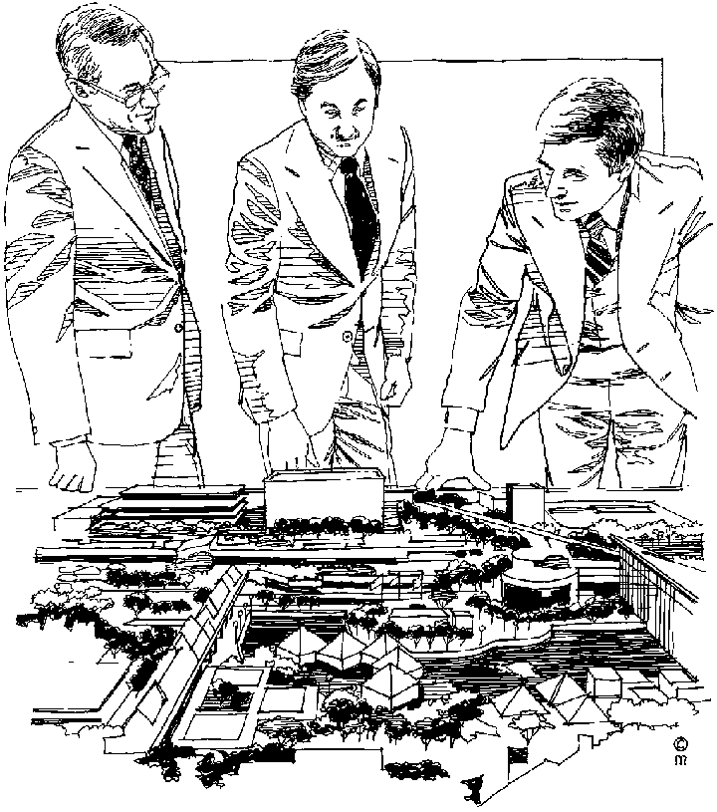

### Handouts And Multimedia

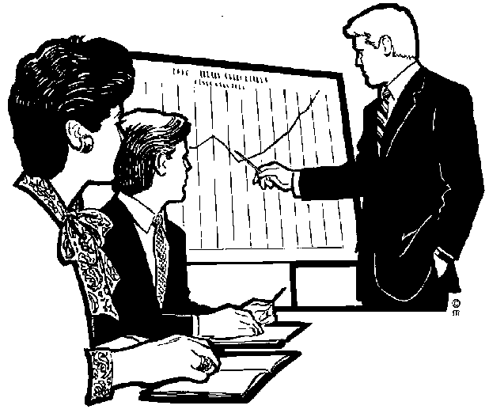You can also make use of handouts given to the audience. Handouts are notes about your presentation that you give to the audience.

Multi-media visual aids include:

* **Flipcharts**. You can use the flipchart to make notes during your presentation, much as your facilitator does during the lesson, or you can write out your flipchart sheets beforehand and put them up at the appropriate time.
* **Whiteboard**: same use as a flipchart, however you have to rub out what you have written as soon as you want to write something new.
* **Overhead projector**. You have to prepare the slides beforehand and show them at the appropriate time in your presentation. Your facilitator makes use of this visual aid during class.
* **Data projector**. It works like an overhead projector, but is connected to a computer and displays visual aids that you have prepared on the computer beforehand.
* **Slide shows**. These are prepared on a computerised presentation programme and can be shown on individual computers or through a data projector. You can, of course, also use photographic slides in a slide projector, although this method has become somewhat outdated.
* **Video presentations**. These are video clips or training videos prepared especially for the purpose of your presentation.

## Prepared and unprepared talks

Effective Speaking

The first step is to consider the audience. Who are they? How large an audience is it? Why are they there‑ Why are you addressing them?

Next is to decide what the aims are. Is the primary goal the imparting of knowledge? Is it to set going same form of activity? Or is it to get certain ideas accepted?

Then comes the consideration of the occasion and the mood.

These are basic factors in the situation and they demand more then technical excellence on its own. Mood and occasion are sensed by the practised and successful speaker in subtle ways. A restlessness among his listeners, a buzz of conversation, a deep intent silence, a readiness to laugh or a susceptibility to emotion, all are symptoms of the feeling of a meeting.

Speaking to people can be carried out in one of several ways.

#### By an impromptu address

ie. without any preparation.

Sometimes there is no alternative to this approach. When we are unexpectedly asked to make a statement on a matter and cannot find a valid reason for saying nothing, we speak 'off the cuff'.

In other circumstances, the spontaneity of the method will more than compensate for the absence of preparation if the speaker knows his subject and is eager to speak on it. This method can be successful when employed by an expert who has total control over his subject.

Nevertheless, one would advise an inexperienced speaker not to rely on the inspiration of the moment. A simple outline scheme of what is to be said will yield better results.

#### Giving an ex tempore address.

Material is planned and prepared in advance although detailed composition is left to the occasion itself. Notes remind the speaker of items he wishes to communicate and the logical order of his message. The degree of flexibility allowed gives the speaker a chance to be interesting and to avoid the stiltedness of saying what has been planned in advance to the letter.

#### Committing the whole piece to memory

This method, painstaking though it is, is sometimes adopted by the speaker who is afraid of drying up, that is of being embarrassingly at a loss for words. The danger of this method is that of dullness. To breathe life into memorised passages requires the skills of the actor. Moreover, a degree of anxiety about forgetting parts of the speech causes the speaker to hurry unduly. The pace of spontaneous speech is not that of remembered words and a conscious effort to slow down is often needed. This method also neglects to accommodate for the 'character' of the audience.

#### Reading aloud from a script

The loss of spontaneity is even more marked than is method (3) above. The pace of reading and of talking are very different. There are of course some very important official pronouncements where it is essential to get every word right; the method may be adopted then.

Choice of basic method is not the only decision to be made. One has to make up one' s mind whether to give a lecture or a talk to the group, followed by question time, or whether one is to introduce a few controversial points and devote most of the session to free discussion.

Preparation of Talks

The value of preparation for oral communication is often overlooked because man~y managers feel that speaking is as natural an activity as sleeping or eating; they may be confusing quantity with quality. Careful, detailed, copious preparation saves time for everyone.

#### Preparing a speech

Having looked at the question of the content of your speech, and how you should prepare your notes, we must now examine the steps required in the actual preparation of the speech.

These can be enumerated as follows:

1. Fix the purpose and aim of the speech. Is it to be informative, persuasive or evocative? Is it intended to offer new knowledge, to examine existing knowledge or to alter current thinking? Is it to instruct, to train or to further interest? Answers to these questions will set the tone and pattern of your speech.
2. Ascertain, or fix, the length of time you are to speak.
3. Gather your ideas, as suggested earlier.
4. Write your main headings and fill in with the outline of your talk, as explained under the section 'Notes'.
5. Familiarise yourself with the main pattern of what you will say, guided by your notes as in (4).
6. Endeavour to set time limits to each section of your speech. This will enable you to ensure that each part is given its appropriate quota of time. More important, it will help you to avoid over‑running your total allotted time or, worse still, to avoid running out of material before your allotted time.
7. Ask yourself whether your talk could be more inforrhative or more enter­taining if you used some form of visual aid, rather than relying entirely on your speech. (Visual aids are discussed in Section D).

#### Leave time for questions.

In preparing your speech, you will have to decide exactly how you will write your notes, and this is a matter of personal preference. Some speakers write their main headings and pertinent brief information on small cards, one card to a heading. The usual size for such cards is 5'1 x 311 and they should be written on one side only. They are easy to carry and easy to use. However, as they are separate, loose records, they can be dropped and become out of order, or individual cards can be mislaid or lost. Such events do not encourage a good speech. Other speakers use sheets of paper, often A4 size, and these can be stapled together to avoid mixing up the sheets or losing any.

As to setting the time limits to the sections of your speech, this is simply done by means of a chart as illustrated overleaf. As will be seen, each heading is allocated a specific period of time by the clock, and where visual and other aids are to be used, these are noted against the section heading in a column ruled for them. Inspection of this chart before the meeting will act as a reminder of what aids must be available, and the various times should be marked on the actual notes to be used for the speech. As a planning aid, this chart can be invaluable.

* The Opening or Introduction: This is planned to arrest attention, arouse interest in the theme of what is to follow. It is worthwhile to spend some time on working out an opening sentence which will make a strong impact. It is one way which may well be written down or remembered word for word by the speaker before uttering it; in this way he will be carried over his initial nervousness.
* The main body of the Speech: This contains most of the information. With the attention of the audience won, a good practice is to announce the plan of the talk, e.g. if you are going to cover four points, the audience can be told of what they are; each can then be taken up and developed in turn.
* The Conclusion: The main points are restated. A final sentence which drives home the message can be committed to paper or to memory in advance.

#### The Introduction

The audience gains its first intellectual impression of the spea‑k‑e7 during the introduction, and this first impression can be vital to the Success of the speech. An accomplished speaker achieves four things = his introduction:

* He gains attention.
* He establishes goodwill.
* He orients the audience by providing background
* He clearly states his specific purpose.

**Attention**

There are several ways to gain attention. Humour is commonly used, but this has many pitfalls. Some people just can't tell a funny story and make it sound funny; others have a warped sense of appropriateness and good taste; and some through ineptitude, alienate the audience. A humorous story used for attention must relate to the topic, otherwise the audience may be thinking about the story when the speaker has already gone on to the next point. Some speakers prefer to gain attention by starting with a question. This device is effective because it stimulates the audience to answer the question in their own minds. Caution: in using questions in the introduction, be prepared for unexpected responses that may require some modifications of the planned presentation.

A startling fact is frequently used in the introduction to gain attention. This fact may be statistical, or it may merely be an unusual statement. The use of a startling statement to gain attention is even more effective if the element of regency is involved. Consider appropriate reference to a statement made by a previous speaker on the program.

**Goodwill**

Once the speaker has gained attention, he must then establish 'goodwill. Always recognise that there are two sides to every issue, and by conceding a point to the opposition when it is obviously very hostile, the speaker may enhance his chance of a fair hearing. If the audience is strongly opposed, making people realise that they have something in common with the speaker is an affirmative step in establishing goodwill and common ground. Common ground may be achieved by referring to a previous experience that has been shared or by mentioning that the speaker is from the same country or town as the audience or is acquainted with someone whom the audience knows and respects. Although these techniques may not immediately promote mutual understanding, they establish a climate in which understanding is possible.

Most audiences enjoy a compliment and react favourably as long as the compliment does not become obvious flattery. Strive to mention examples of mutual achievement or areas of special interest. The good speaker establishes the impression that the audience's interests are the same as his own.

**Orientation**

Although it is extremely important in the introduction to gain attention and establish goodwill, you must also orient the audience to the subject. Give some background information on the topic; never assume that everyone is completely familiar with or knows the same amount of information. Unless the audience starts with a common understanding or background, some of the things said later will be meaningless. Definition of technical terms or special jargon used in the speech, background about events that resulted in the invitation to speak, and reference to the timeliness or urgency of the situation are good methods of orientating the audience.

**Specific Purpose**

The less effort an audience has to exert in listening, the more meaning the speech is going to have for them. It is much easier for an audience to listen if the purpose has been clearly stated. Statement of purpose in speech may involve some foreshadowing in which the main points are suggested. This foreshadowing, or preview of what is to come, can make it easier for the audience to follow the sequence of development.

Because of the importance of the introduction, it is advisable to write it out completely in paragraph form so that it may be analysed to ascertain if it meets all of the basic requirements: does it gain attention, establish goodwill, purpose?

#### The Body

The function of the body of the speech is to organise logically in outline form the sequence of ideas that develop, illustrate or illuminate the specific purpose of a speech. The material used in development may be information gained from personal knowledge and experience or from research.

The first step in preparing the body of the speech is to list all the ideas or material that you have gathered. Order or relative importance should not be considered at this time; brainstorm until everything is listed that should be included. The next task is to put these ideas into a form that is useful and meaningful to an audience, and this function is best accomplished by structuring a good outline.

Frequently, the speaker discovers that he has so much material or so many ideas that preparing an outline looks like a hopeless task. Should this happen to you, eliminate material in order to fit it in~o the time limits. Retain only those elements that appear vital to fulfilling the purpose. Some items may be eliminated; perhaps some can also be combined. The outline will help to reduce the amount of material to a workable number of items. When the purpose of the speech has been clearly defined, the way the supporting items fit together will become more apparent. In a speech of ten to thirty minutes, probably no more than three to five main points should be considered; they must clearly support and develop the specific purpose of the speech. All subordinated material should clearly relate to and support each main idea.

**Unity**

The principles of good order are then: unity, coherence and emphasis. Aristotle in his Poetics said that a play must be so constructed that omission of any part damages the whole and that each part of a plot must contribute to making the purpose or conclusion inevitable. Each part of a speech should also contribute to the inevitability of the specific purpose or the conclusion of a speech. The material should be unified to the point that it can be summarised in a single statement of purpose. This unity. is the first principle in structuring the parts of the speech. Unity assures that any material that is not part of the speaker's purpose is eliminated from the outline.

**Coherence**

The second principle of organisation ‑ coherence ‑ refers to the specific sequence of the parts of the speech. Coherence ‑ the principle of order and arrangement ‑ shows a clear and definite relationship between each part of the speech. Do not assume that what is to the speaker will be logically understood by the audience. *Establishing* coherence between the ideas in the speech is an important step in establishing and maintaining a favourable relationship With the audience. Not only inust audience members be able to recognise the logical progression of thought, but they must also distinguish the relative importance between each of the ideas. In emphasing and developing ideas, consider carefully the use of connecting transitions or phrases. Brief phrases, such as "in the meantime" or "for example', are useful", but also consider bridges of a more extended nature in order to avoid the trite and thereby enhance and vitalise style in presentation.

**Emphasis**

The next principle of organisation is arrangement of ideas in order of their out clearly. Two ways of emphasising proportion. The most emphatic positions beginning and at the end. More emphasis by giving it more space, more verbiage. by proportion.

Order emphasis, which involves the importance so that each stands ideas are by position and by in the speech body are a‑11 the may also be placed *on an* idea

This method is called emphasis

Speeches are organised chronologically, logically, topically, spatially, in order of difficulty and with a "need‑plan" structure. A chronological order involves an arrangement of ideas according to the order in which a number of events took place. The logical method of organisation is closely related to the chronological; however, this method goes further in that it involves accepting cause‑and-effect

#### The Conclusion

For many speakers, the conclusion is the most troublesome part of a speech. Most people don't know how to stop; they don' t know how to get from the main body of the speech to the conclusion. The conclusion should be a natural ending ‑ not an abrupt halt ‑ and this requires a good tra‑nsItion. The speaker tells the audience the purpose of his speech ‑2n the introduction; in the body of the speech he develops and carries out this purpose. Avoid the trite expressions "in conclusion" and "in summary" because such phrases weaken the conclusion by belabouring the obvious. The conclusion should be positive and reassuring to the audience. If the conclusion is weak, it will weaken the whole speech because this ils the final impression, that the audience takes with it.

The conclusion should be shorter than the introduction. Although most audiences prefer a straightforward conclusion, this does not preclude the use of appropriate quotations or mention of an incident or experience. You may ask for action or reinforce a specific point, but never introduce new ideas in the conclusion! The introduction of new ideas in the conclusion offers distractions that invariably confuse.

A summary of the highlights of the speech, for purposes of re‑emphasis and review, is the safest and most direct way of concluding. The speech intended to persuade may have in the conclusion a specific plea for action. If action is asked for, it should be simple and direct ‑ something that can be quickly and easily accomplished by the audience as a first step toward achieving the overall purpose of the speech.

Activity 5 (8962 SO4, AC1-6)

SECTION 5: HOW TO INFLUENCE THE AUDIENCE

#### Outcome

Identify and explain how speakers/signers influence audience

**Outcome Range**

Write/sign for a specific audience, purpose and context: Narrative, discursive, reflective, argumentative, descriptive, expository, transactional, business correspondence, electronic texts, multi-media presentations.

#### Assessment criteria

On completion of this section you will be able to ensure that:

* Speaker`s/signer`s choice of words, language usage, symbols, pictures and tone, sign size and pace is explored and explained in terms of impact on audience: Bias (cultural, religious or peer preferences, misrepresentation, discrimination, racist, sexist, ageist); humour; irony; sarcasm
* Speaker`s/signer`s omission or inclusion of pertinent facts and opinions is recognised and explained in terms of impact on audience
* The impact of different techniques of spoken/signed communication is identified and evaluated in terms of influence on selected audiences and used appropriately: Stress, intonation, NMFs, rhythm, repetition, rhetorical questions, use of first person for inclusion, analogies, use of passive, `politically correct` language

## Impact On The Audience

People who communicate orally use

* The choice of words/signs
* Use of language
* Symbols
* Pictures
* Tone
* Pace
* Sign size
* Sign parameters: building blocks of the sign/word: handshape, location, movement, palm orientation, non-manual sign.
* Sign devices: register, non-manual features (NMFs), placement, role-shift, parameter

In order to influence their audience.

If we look at the article about slavery, we can see some examples in the first paragraph.

“But the blind Dinka woman could only pull her seven-year-old son and twelve-year-old daughter close. Shaking with fear, they hid in their windowless hut and prayed.”

If the author had not told us that they were shaking with fear, we would have felt differently about the paragraph.

if you are, for example telling/signing someone this, you would use facial expressions, body movement, etc to emphasize and influence the audience.

Dealing With Bias

What Does Bias Mean? An opinion or tendency to be strongly for or against a person or thing.

We are all biased in some way or other. We feel strongly about certain subjects, such as pornography, schooling in mother language, and many other subjects.

Then there are subjects over which are biased, but do not necessarily feel too strongly about it, so we don’t get all worked up about it. This could be school uniforms, what to wear to the movies, and so on.

We all have opinions about everything, some opinions are stronger than others. Unfortunately, although we would like it to be so, our opinions and views are not always the right ones and, when we do not want to be convinced otherwise, we are biased.

Unfortunately, not all biases are harmless. Bias can take many forms: it can be based on cultural or religious beliefs, it can show itself in a misrepresentation of facts, it can be discriminatory in terms of race, sex or age. It can also be due to peer preferences.

Whenever you prepare a speech, you have to bear in mind that you yourself are biased and also that the author is also probably biased. You must always be able to determine the bias in yourself and the author.

Also, whenever you communicate in writing or verbally, bear in mind your own bias as well as the bias of your audience.

Lastly, remember your painful experience at the hands of some other person and his/her bias, before you treat people with disrespect because they disagree with you.

Humour

In the dictionary, humour is stated as being:” the quality of being amusing”.

Jokes are humorous, so can text in an article be humorous or even a novel (long story) or parts of a novel.

Irony and sSarcasm

Irony and sarcasm are very similar.

When an author uses irony, he states one thing, while meaning the opposite.

Irony can be funny, but it does not have to be.

* as funny as cancer
* as clear as mud
* as pleasant as a root-canal

An example of irony in real life is when John Hinckley tried to assassinate (kill) President Ronald Reagan (a previous American president), all of his shots initially missed the President; however a bullet ricocheted off (bounced off) the bullet-proof windows of the Presidential limousine and struck Reagan in the chest. Thus, the windows made to protect the President from gunfire were partially responsible for his being shot.

If someone were to go on a trip and decide not to take a plane because they are worried about crashing, and take a bus instead, it would be ironic if a plane hit the bus they took, thereby realizing their fears of crashing with a plane, despite measures taken at the outset of the journey to avoid such a fate.

Sarcasmis stating the opposite of an intended meaning especially in order to sneeringly, slyly, jest or mock a person, situation or thing.

It is strongly associated with irony. Sarcasm is a particular kind of personal criticism leveled against a person or group of persons. If you were talking to one of the team players that lost the game badly, and you say to him: “Well, you guys really played well” you are being sarcastic.

Sarcasm is can be used in a humorous manner, but can also express annoyance or anger. It is often in the place of other forms of expression. For example, instead of becoming angry and yelling at someone in a conflict, a person might choose to use sarcasm as an alternative.

"Shut up, will you?" "Oh, I'm sorry, Your Highness, should I go get you your coffee and tea now?"

In this case it is implied that the first person was treating the second like a servant. Instead of directly pointing this out, however, the second person plays the part, so to speak, in the situation created by the first person.

This is normally used where the two people in question do not see eye to eye. Therefore the second person does not like the tone and phrasing of the first person's remark. The second person uses sarcasm to make fun of the first person to amuse themselves, and any possible bystanders who share the same feeling towards person one.

## Purpose Of Communicating

### Narrative

Narrative style means to tell the story without using dialogue. It is also used to provide a commentary for a film or television programme.

“Scared but holding steady, a Brazilian boy offers his arm for vaccination against the mosquito-born yellow fever virus. Bringing misery to the vulnerable, viruses cause diseases ranging from the common cold and measles to hepatitis and AIDS. Viruses appear to infect all living things – yet are not quite alive themselves. Particles of genetic material – the essence of life – they lie as inert as the dead until an opportunity arises to invade a host.”

### Discursive

Write/sign about a topic in detail, similar to when you are having a discussion with friends about a topic. It might also happen that you include unrelated topics in the text.

### Reflective

Thoughtful. In the following text, the person is thinking about growing up.

“As my stepfather’s postings and later my own were all at the whim of the Foreign Office, I’d mostly lived those twenty years abroad in scattered three- or four-year segments, some blazing, some boring, from Caracas to Lima, from Moscow to Cairo to Madrid, housed in Foreign Office lodgings from one-bedroom concrete to gilt-decked mansions, counting nowhere home. I was rootless and nomadic, well used to it and content.”

### Argumentative

A set of reasons given in support of something.

Following is an extract from National Geographic October 1995, when civil war was raging in Rwanda with devastating effects not only on the people but also on the wildlife.

A fragile home threatened by war

“Among the last of its kind, a young gorilla peers from its leafy refuge in Rwanda – a nation bloodied by ethnic slaughter. Conservationists fear that Rwanda’s instability could endanger the gorilla’s survival. Others ask: How should the plight of the world’s rarest ape be weighed against more than 500,000 human dead?”

### Descriptive

Describing without expressing judgement.

In the following passage, the writer does not try to persuade you to buy the item, he merely states the features of the product.

“The Nokia HS-12W Wireless Stereo Headset has been designed for people who listen to MP3s on their phones and need to effortlessly switch between music and phone mode in an instant. The display serves to provide music information, caller ID and MMS/SMS notification, while the built-in stereo FM RDS radio provides automatic channel search.”

### Expository

A full description and explanation of a theory.

Usually used in the media to reveal something discreditable. Any scandal that is reported in the media is written in expository style.

### Transactional

Relating to a business transaction.

This would usually be invoices, debit and credit notes, notes to purchase and so on.

### Business correspondence

Will include all business correspondence: letters, faxes, memos, buying orders, invoices, credit notes, debit notes and so on.

### Electronic texts

Would be sent via e-mail. There is a specific set of rules regulating e-mails.

### Multi-Media Presentations

A multi-media presentation is what it says: a presentation using more than one medium. In other words, you include a visual presentation on a PC, you can also use a projector or a TV and video combination, or even photos and other visual images posted against the wall, as long as you use more than one medium. The first medium is usually paper-based in the form of a manual, a book, notes and so on. Multi-media presentations are very effective since they make use of more senses than just our eyes.

## Techniques of communication

Repetition

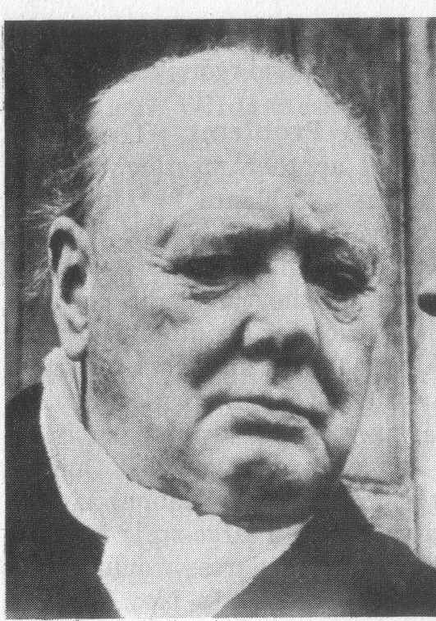Repeating words and phrases is very effective to emphasise the importance of the statement. Sir Winston Churchill made very good use of repetition in his famous speeches during World War 11.

On 22 May 1940, after the British soldiers had been evacuated from Dunkirk, he said:

“***We shall fight*** on the beaches, ***we shall fight*** on the landing-grounds, ***we shall fight*** in the fields and in the streets, ***we shall fight*** in the hills; *we shall* never surrender…

On 13 May 1940, just after he was elected prime Minister, he said that he had one aim:

“**Victory – victory** at all costs, **victory** in spite of terror; **victory**, however long and hard the road may be.”

Of course, he said many more memorable things and it is worthwhile reading about him. He was the Prime Minister of Britain during World War 11 and he was a rather colourful character – just what the British needed during wartime.

Rhetorical questions

Many speakers also use rhetorical questions to influence the audience. A rhetorical question is asked for effect or to make a statement rather than to obtain an answer. If you are speaking about poverty, you may use rhetorical questions as follows:

* Why must so many of our nation’s people live in poverty?
* Why does the government not do anything to relieve the poverty?
* Why does the government not do more to create jobs?
* Why do big business not become more involved in the fight against poverty?

Use of first person for inclusion

Speakers/signers who want to influence your thinking about a matter often use the first person “I” and “we”.

Comrades, why must you and I live in fear of our lives? We must take action to force the government to do something about crime in this country!

## Omissions Or Inclusion

Two of the tactics most used by journalists who write for newspapers and magazines is omission. Many people are misquoted in this way.

Omission is something that has been left out.

Below is a paragraph from the article about slavery. If I leave something out, it changes the entire meaning of the paragraph.

Once the Arabs seized the cattle, they moved from hut to hut gathering grain, blankets, salt – and human booty. Deep in the shadows of one hut, they discovered Abuk. Grabbing the terrified woman by her bead necklace, a militiaman growled, “Now you belong to me!” in all, 282 Dinka, including Abuk’s mother, sister and niece were herded up and forced to march north.

Now read the paragraph where human booty and the last sentence has been left out:

Once the Arabs seized the cattle, they moved from hut to hut gathering grain, blankets and salt. Deep in the shadows of one hut, they discovered Abuk. Grabbing the terrified woman by her bead necklace, a militiaman growled, “Now you belong to me!”

Do you see that the whole meaning of the paragraph has now changed and that there is now no reference to slavery?

Bear in mind that you can influence your audience by what you include in your oral communication and what you leave out.

Activity 6 (8962 SO5, AC1-3)

SECTION 6: LEARNING RESOURCES

#### Outcome

Find and use available learning resources

#### Assessment criteria

On completion of this section you will be able to ensure that:

* Relevant learning resources are identified
* Resource centres, dictionaries, general texts, internet, other learners, videos
* Learning resources are used effectively through appropriate selection of information and acknowledgement of sources

## Learning Resources

### Text Books

A textbook is a book that is used as a standard work for the study of a subject. We all used textbooks in school in order to study the grammar, spelling and language rules for English, Afrikaans, Sotho or Zulu, we also used textbooks to study economics, history, geography and so on.

Having a textbook for a language is a valuable reference resource, because you can refer to the textbook to solve issues

Of course, you get more kinds of textbooks than language textbooks. As stated, you get textbooks about geography, history, architecture, interior decorating, garden landscaping, computer software and hardware. There are textbooks about arts and crafts, woodworking, driving, just about anything that you want to learn about.

If you look up the word textbook in a thesaurus, you will find the following list:

* Schoolbook
* Manual
* Workbook

In other words, a textbook, or manual, contains information about a subject. This means that you can use a textbook to look up information about a subject. This learner guide is an example of a textbook or manual.

### Using Textbooks To Collect Information

You could read the entire book and hope you get the specific information you are looking for, but there are easier ways.

Textbooks are divided into chapters. Each chapter will contain information about a specific subject. The chapters can be subdivided into sections and, if the manual is comprehensive, even sub-sections.

#### Contents Page

The writers who compile text books always try to make it easy for us to find specific information about a certain subject. Every textbook will have a contents page, which will give the main headings of the different chapters of the textbook.

You can then go to that page and look at the contents from that page on. Following is a contents page of a textbook about General Management.

Can you see that subjects are grouped together in a sensible manner? Can you see that it is easy to obtain information about a specific subject?

If I need information about motivation, I will go to page 347, as indicated in the contents page. Here I will see that the chapter is further divided into sections, which are indicated by text typed in bold.

Now I can page through the chapter, looking only at the headings of sections until I find the information I am looking for.

Did you notice that the headings in this textbook are also numbered? All this is done to make it easy for you to find the information again. I would make a note of the page number, as well as the heading number: p347, 16.2 Meaning of motivation.

All this makes it easy for you to find the information the first time and also to refer back to the information afterwards.

#### Index

Most textbooks also contain an Index, situated at the back of the book. Using the Index, you can look up information by looking for a specific word. The Index is always sorted alphabetically, so if I want to look up the word motivation, I will have to go to M in the Index.

From the Index, under M, (shown on the next page) I can see that there are references to motivation on pages 10 as well as 347. I can therefore find information about motivation on page 10 and 347.

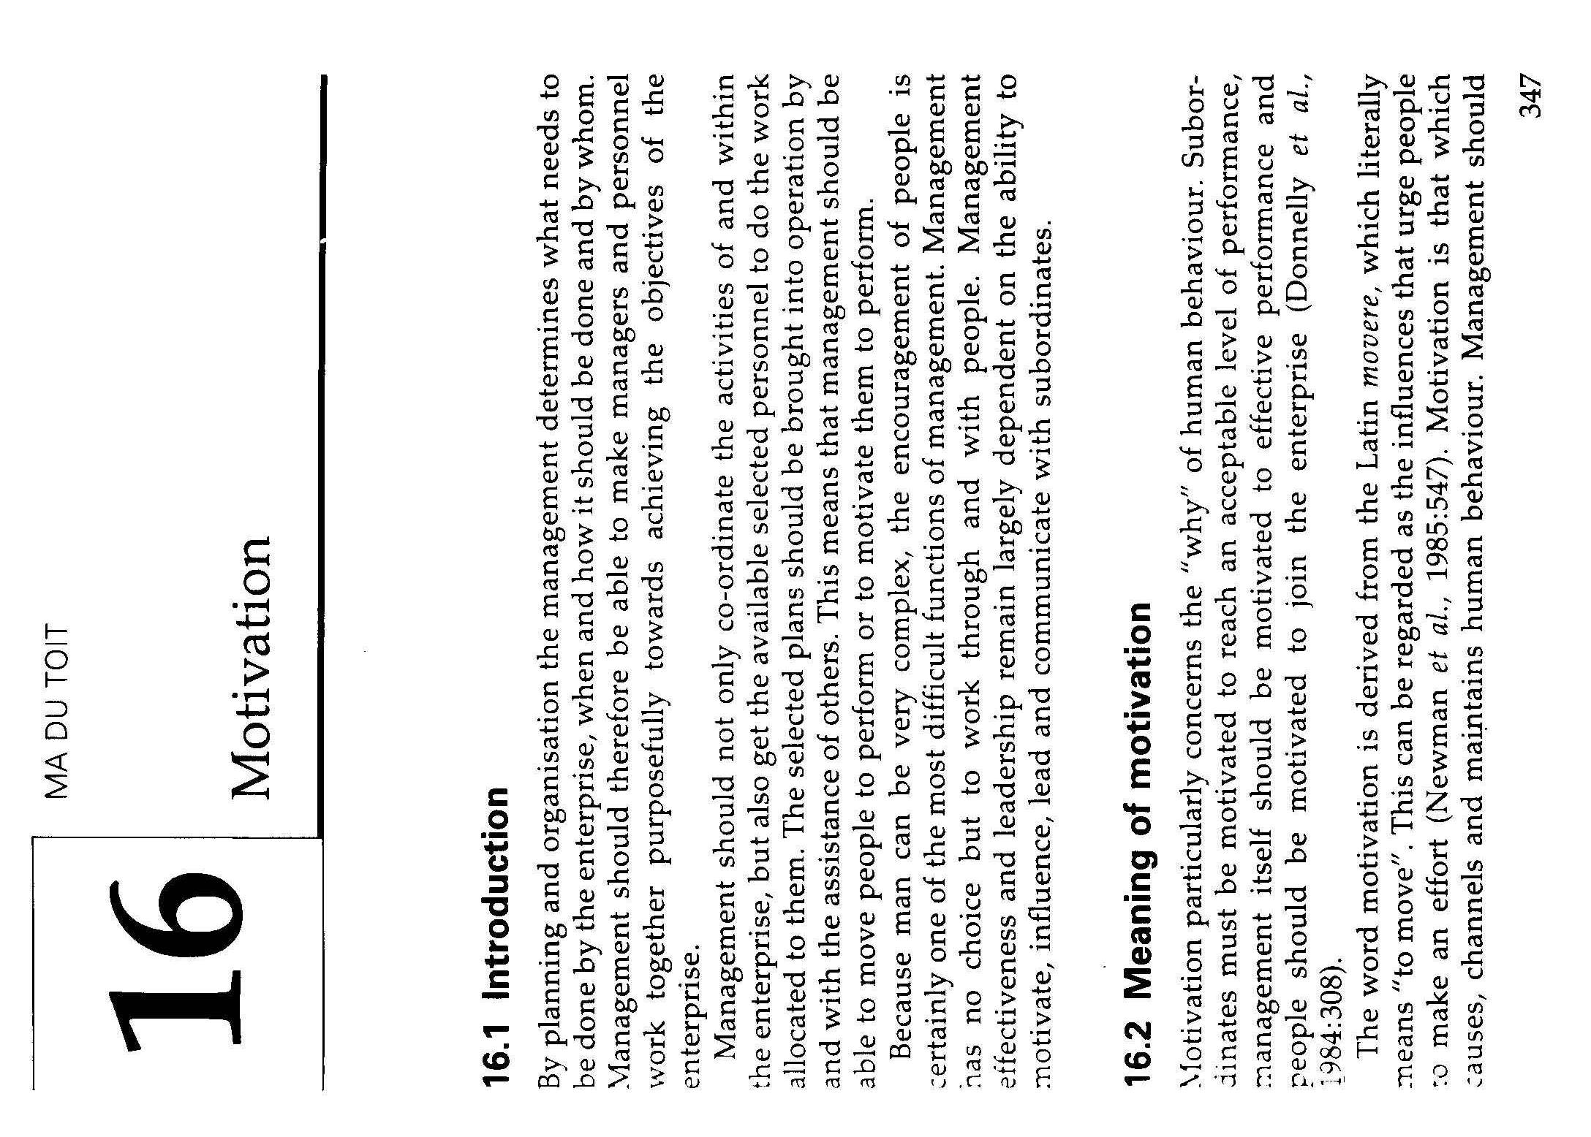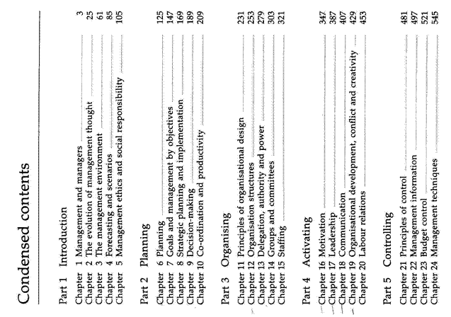

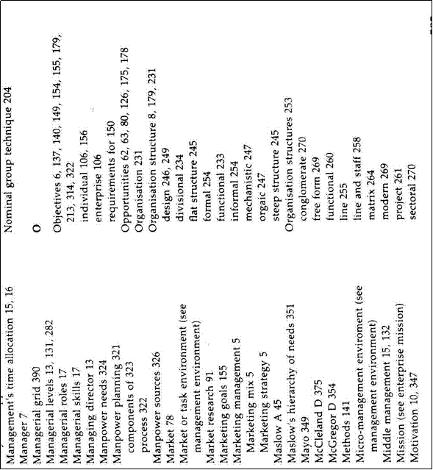

### Internet

You can also search the Internet for information. The Internet is like a very large library. Where a library is filled with books containing information, the Internet is made up of web sites that are filled with information.

Searching the Internet is a lot like using an Index book: you go online to a website such as Mweb or MSN and you will find a Search option somewhere on the first page, that is also called the Home page of the website.

The Search option will give you space in which to enter a keyword or keywords, just like you would look in an Index. You then click on a button and the computer searches for websites that contain information about the word you typed in.

Because the Internet is a worldwide resource of information, there is an awful lot of information to be found out there, so you have to be very specific when you search for information on the Internet.

If you, for example, enter dogs as your keyword, you will end up with a couple of million hits. It is impossible for you to visit all those websites, so you have to narrow down your search, for example by typing in the specific breed of dog you want information on: golden retriever or whatever breed of dog you want information on. This will give you less hits, hopefully only about twenty or thirty websites, which is much more manageable.

Some websites you can use:

[www.howstuffworks.com](http://www.howstuffworks.com/)

[www.answers.com](http://www.answers.com/)

### Magazines and Newspapers

Magazines and newspapers always contain a lot of information. You will find information about developments in the business world such as labour unrest, technology as well as industry specific information.

Most newspapers and magazines have sections about: business, sport, new developments, technology, books, music, art, general news and more.

You will also find industry specific magazines that are about computers and IT, language and culture, transport industry, training and education, mining, marketing and advertising, the HR industry, the retail industry, etc.

Then there are magazines dedicated to geography, aviation, wildlife, animals, the Internet, computer games, sport, fashion, home improvements, gardening – in short for just about any subject you will find a magazine.

Resource centres

#### Libraries

Libraries stock most of the magazines and newspapers read in their areas. There are also encyclopaedias, text books on any subject, biographies and autobiographies and, of course books of fiction available in libraries.

If you are unsure where to find a book about a specific subject, you can ask the librarian to assist you.

Certain books can be taken out of the library, but the so-called reference books may only be used inside the library.

Many bigger organisations have in-house libraries. These libraries typically contain books about the industry in which the organisation operates, as well as operational procedures and training manuals.

#### Archive

An archive is a collection of historical documents or records. In business, documents and records are usually sent to the archives of the business once a year in order to make place for the documents of the new year.

Government departments also have archives where old documents and records are kept, for example birth and death certificates, appications for ID books and passports, etc.

#### Museum

A museum is a building in which objects of importance or interest are stored and displayed. The Transport Museum and Police Museum are examples of this.

### Other People

Friends, family, colleagues at work are all sources of information. Often, if they cannot give you the information or confirm the information, they can tell you who will be able to give you the information. Or, they can tell you where to find the information – in the operations manual, the training manual, the in-house library or which magazines or books contain the information.

Other learners can also help you to do research – they might know where to find information.

Never be afraid to ask someone if you need help to gather information.

Videos

You will find videos a valuable source of information, especially documentary videos. These are available from video stores, some libraries and many organisations and businesses have their own training video library.

Dictionaries

If reading is a form of communication then you, as the reader, have certain responsibilities in order to ensure that the communication process is successful. One of the actions that you will have to take is to ensure that you understand what the writer is trying to say to you.

One of the most common problems in communication is that the recipient of the communication – in this instance you as the reader – does not understand the message. If this is due to words being used that you don’t understand, it is your responsibility to find out what the words mean. There are various resources that you could use to find out what words mean. You could use a dictionary or a thesaurus.

There are various kinds of dictionaries available:

#### Bilingual Dictionary

A bilingual dictionary, e.g. and Afrikaans/English dictionary will give the word, in Afrikaans with the English equivalent, and vice versa. A word like “walk” would, in an English/Afrikaans diary give the following information:

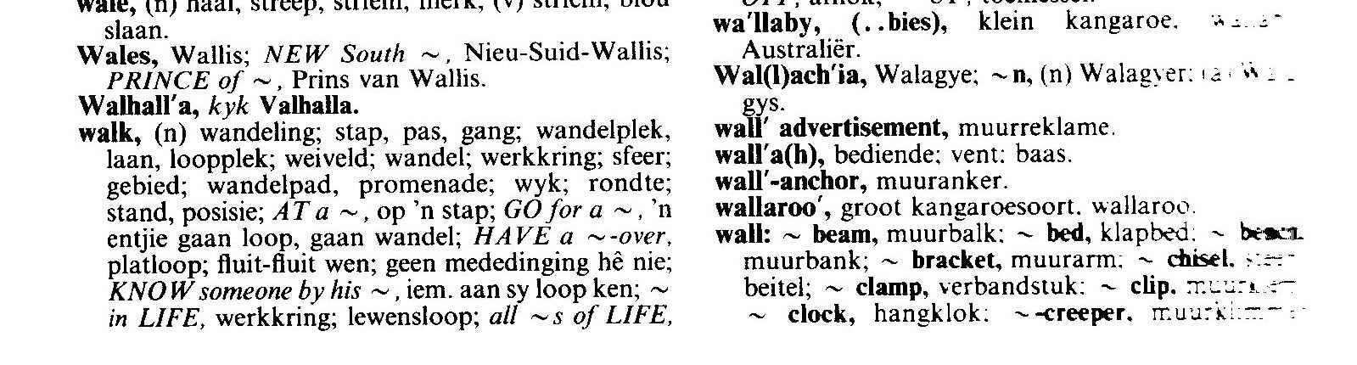

If we now look at the second word quoted, stap, the dictionary would give the following information:

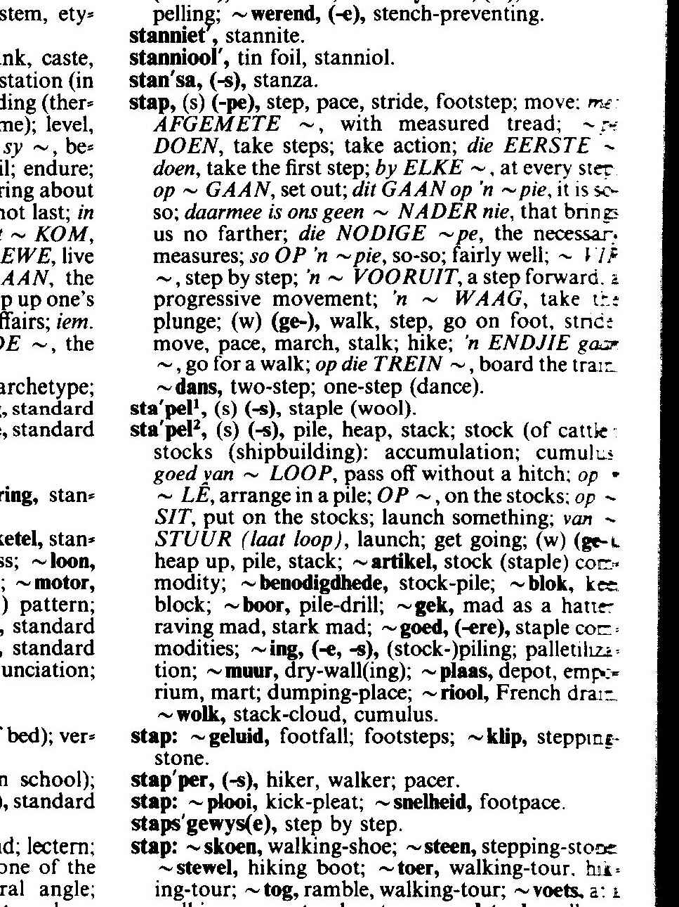

#### Explanatory Dictionary

An explanatory dictionary gives the word, its meaning as well as advice on how to use it in practice. This dictionary would be in one language only, English or Afrikaans or Sotho, etc. There is only one language involved, so there will not be references to the Afrikaans or Sotho equivalent.

If we look up the word walk in an explanatory dictionary, we will get the following information:

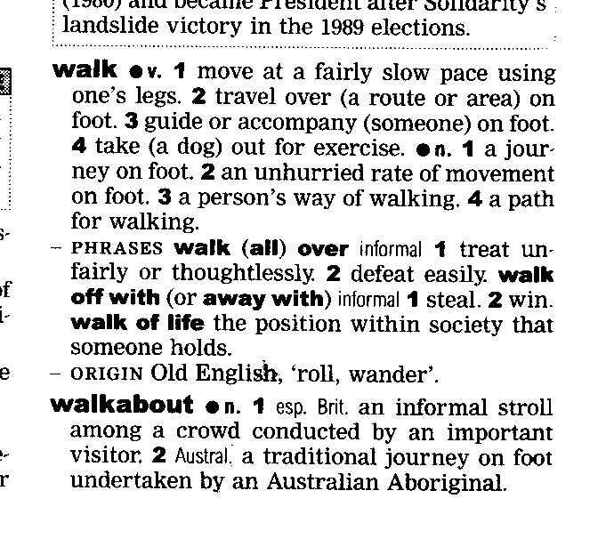

In the front of the dictionary you will find a guide on how to use the dictionary.

Many of these descriptions will sound like gobbledygook to you. What is important for now is that you can refer to the beginning of the dictionary in order to understand what the descriptions in the dictionary mean.

As you can see, the main word is quoted in bold, with variations of the same word quoted afterwards and then follow explanations of what the word means as well as how to use the word in a sentence.

Dictionaries usually also tell you how to pronounce the word correctly.



#### Thesaurus

A thesaurus is a dictionary that contains lists of words that have the same, similar or related meaning. If you look up the word walk in a thesaurus, you will find the following lists, usually with explanations of the words included:

|  |  |
| --- | --- |
| Saunter | Stroll |
| Amble | March |
| Stride | Pace |
| Hike | Toddle |
| Totter |  |

This will enable you to choose the exact word to use, or to determine the exact meaning of the word that was used in the piece of writing.

The sooner you get into the habit of looking up words that you don’t understand, the sooner you will improve your language and communication skills in general. If you don’t own a dictionary, you will probably find one at your place of employment and your local library will also have dictionaries.

## Use learning resources effectively

The purpose of using learning resources is to gather information. This is called research. When doing research, make sure that you focus on collecting information that applies to the topic or subject you want information on.

Once you have gathered information, the material you have collected has to be organised. Follow these steps:

Sorting and categorizing

Arrange or organise the information with common features or characteristics systematically in groups.

All the information with similar content is grouped together. Your classification will depend on the order in which you are going to write the document: you can sort the information **chronologically**, using **contrast** or **cause and effect**.

Sifting for relevance

Once you have classified the information and data, you have to sift through it for relevance.

Keep only the information that is **relevant** to your topic, everything else can be discarded. In other words, if you are writing about plants that flower in summer, any information about plants that flower in autumn is not relevant, you cannot use it to enhance your writing and you should throw it away or put it to one side in case you need it in the future.

Validity and reliability

Now you have to check your information for **validity and reliability**. The obvious way of doing this is to **check your facts with more than one source**:

* check more than one manual,
* talk to more than one expert,
* visit more than one website, to ensure that your facts are correct.

Preferably, you should use more than one manual, more than one website and the knowledge of more than one expert for each aspect that has to be checked. If most of or all your sources state the same basic fact, you can be reasonably sure that the fact is correct.

Acknowledgement Of Resource

You will often find information in a book, magazine article or even a web site that someone else has written. When you use this information, you have to give credit to the person whose written work you are using, even if you get the information from the Internet.

Sometimes you have to get the approval of the author or publisher of the book before you are allowed to use the information. If this is the case, you have to contact them before you can use the information.

Mostly, though, it is sufficient to acknowledge the original author and publisher by quoting their details in your work. This is called a bibliography.

A bibliography is a record of the resources and sources you used during your research. Follow the following format when quoting the sources of your information:

* Author surname and initials
* The year it was published
* The title of the book
* Where it was published
* The name of the publisher

When you quote the author directly, you have to add the following to your text where you use the quote: (Sayles & Chandler, 1971:185)

* Sayles & Chandler are the authors
* 1971 is the year the book was published
* 185 is the page number where the quote appears

Then, of course, you have to add the details of book to the bibliography.

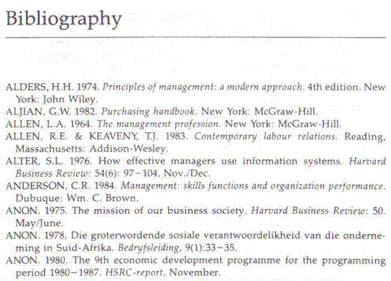

Activity 7 (8967 SO1, AC1-2)

SECTION 7: LEARNING STRATEGIES

#### Outcome

Use learning strategies

#### Assessment criteria

On completion of this section you will be able to ensure that:

* Information is summarized and used for learning purposes
* Specific techniques are selected and applied appropriately: Mind maps, note taking, memorising, key words, underlining, skimming and scanning
* Relevant questions are asked: Checking understanding, clarifying meaning, getting information, asking for help
* Texts are read/viewed for detail: Signed/spoken input is listened to/viewed for detail
* Learning takes place through communicating with others in groups or as individuals: Facilitators, other learners, colleagues

## How You Remember

### Association

PL_MS005In the antique world, Aristotle named four kinds of associations that stimulate the memory :

* Things that are close to each other, such as the sea and the beach
* Things that happen at the same time, such as teenage years and pimples
* Things that are similar, such as ice skates and roller skates
* Things that are different, contrasty such as rural and urban areas

James D Weinland added a couple of items to this list:

* Cause and effect : fire and heat
* Part and whole : nose and face
* Detail and general: bee and insect
* Numbers that lie next to each other: 5 and 6

### The Three Stages Of Memory

All the memory stages have two characteristics : how much information can be stored and the time it can be stored.

* The **immediate memory**: lasts about two seconds and makes it possible for us to undertake continuous activities such as walking. Volume: thousands.
* **Short Term Memory**: volume 7 things and time stored: thirty seconds to two days. When you memorise, you transfer knowledge from your short term memory to your long term memory.
* **Long Term Memory**: Volume unlimited, time stored forever.

### The Three Kinds Of Memory

You need to know how you remember things in order to choose the best memorising technique for you.

#### B0005Verbal

situated in the left half of the brain. People who remember like this, see the words L I O N, spelling lion, when someone says “lion”.

#### Visual

situated mainly in the right half of the brain. This person sees a picture of a lion, teeth, feet, muscles, etc.

Children usually remember visually until they develop language skills and then they change to verbal codes.

#### Kinaesthetic

lion

this is when we remember with our muscles, e.g. when driving a car, playing tennis or tying shoelaces. Blind people use this sort of memory a lot, as does dancers, athletes, musicians, etc. How often have you waved your arms in the air to try and describe something? At that moment, you remembered through your muscles.

Humans tend to remember muscle skills longer and better than visual or verbal skills, just think of riding a bicycle. Humans cannot really function without a measure of kinaesthetic memory.

It would appear that we actually use all three kinds of memory, which can be an indication that we use both sides of the brain, but that we use one more than the other. By fitting your memorising technique to your memory type, you will make the learning process easier for yourself.

Think about this: is it the thought of the taste of strawberries that recall the word or does the word remind us of the taste? Smell, taste and touch are all important tools to store information and recall it at a later stage.

### The Three Stages Of Remembering

When you have stored information in your long term memory, you have to be able to find this information again. It is not good enough just to store information in your long term memory, you have to be able to recall it again. The steps of learning is mentioned below, very shortly:

#### Register

You receive the information. You cannot forget something that you never knew to begin with. Be careful of interruptions when you are busy taking in information

#### Storing

When you store information, you are creating the ability to recall it. You registered something and the information successfully completed the trip from your short term to your long term memory and it has been filed. Now the fun starts.

#### Recall (recall, recognise)

You can find the information later, or it looks familiar when you come across it. There are two ways of finding information again – through recall or recognition.

When you **recall**, the information comes back to your conscious thoughts. You can choose to recall it, or it can happen spontaneously – a friend’s face or the words of a song.

When you **recognise** information, you did not try to bring it back, or you were not successful in bringing it back; but when you encounter it you recognise it. For example, you will recognise the Hillbrow Tower when you see it, but without a picture of it in front of you will find it difficult to draw it.

The biggest part of remembering is recognising and we can also recognise more that we can recall. This means that when we are studying, we do it in such a way that we can find the information again when we need it. This is why we use associations and why it is not necessary to learn your work word for word.

## Memorising Techniques

The reason you study for tests and exams is to transfer the information from your short term memory to your long term memory. As with everything else in life, you need to make the right choices. You can acquire new strategies and structures or you can carry on as you always have. Please bear in mind that, if you don’t change direction, you will surely end up where you are headed! In other words, if your current study method is not helping you get the marks you can get, and you don’t change it, you will never do as well as you can.

There are many techniques to help you to memorise. We will first focus on strategies to remember – plans you make in order to better remember things.

* Be **emotional** about what you are studying. We remember the rugby or soccer score because we get emotional about it!
* Be **logical** and create structures to help you to remember: sequence, categories or whatever.
* **Reward** yourself: when you have done well, finished your studies on time and you know the work, reward yourself. Also reward yourself when you have done well in a test.
* Use as many **senses** as you can: see, hear, feel, smell, taste.

### Structures To Remember

The brain wants structures in order to store information in the long term memory and to be able to recall it later.

#### Sequence

Number the information so that they follow logically; you can number from 1-10, from A to Z, from birth to death or chronologically. Learn events and happenings in the sequence they happen, the brain does not like facts that are mixed up.

Exercise

Write down some examples

|  |
| --- |
|  |
|  |

#### Categorise the information

Group things that are similar together. If you have to remember 25 animals, remember them as follows:: 4 birds, 3 farm animals, 6 reptiles, etc.

Exercise

Write down some examples

|  |
| --- |
|  |
|  |

#### Visualise similar things

Connect things that are visually similar, such as everything that is round or red or even everything that reminds you of Christmas, etc.

Exercise

Write down some examples

|  |
| --- |
|  |
|  |

### Associations

#### Numbers

There are a couple of ways to remember long lists or rows of numbers: One method is associations.

Think of 1 as a pen,

2 as a swan

3 as a double chin

4 as a sailboat

5 as a fish hook

6 as a golf club

7 as a precipice

8 as an hourglass

9 as a pipe

10 as a bat and ball

These are just examples, you can create your own associations. Of course, this method works well for a visual memory.

To use the association technique for a verbal memory:

1 bun

2 shoe

3 knee

4 floor

5 dive

6 sticks

7 heaven

8 gate

9 pine

10 hen

Once again, these are examples, you can create your own associations.

#### Rhythm And Rhyme

We’re not all poets, but those who are should use this technique to their advantage. A rhyme is when you take the first letter of every fact and arrange them in a rhyme that is easier to remember. When you remember the rhyme during the test, you will also remember the facts.

Rhythm is similar but different. The most well-known example is the spelling of the work Mississippi : mr M mr I mr S S I mr S S I mr P P I. If you have the knack of working out a rhythm, use it to your advantage.

Exercise

In a group, write down some examples

|  |
| --- |
|  |
|  |
|  |
|  |

#### Abbreviations

Some of us can make abbreviations of the first letter of the facts that have to be memorised.

If you think about well-known abbreviations that we know, like UNISA or CNA and even AIDS, it is clear that it is a good technique to use. Please ensure that the abbreviations make sense to you, otherwise you are likely to store the information in the wrong place. Once you have stored information in the wrong place, chances are that you will not be able to recall the information when writing the exam.

Exercise

Write down some examples:

|  |
| --- |
|  |
|  |
|  |
|  |

### Do You Know The Following Study Method?

* **Overview** – quickly scan the chapter to give you a general idea of the contents
* **Questions** – ask yourself general questions about the chapter
* **Read** – now read the chapter with the view to summarising it
* **Summary** – make a brief and to the point summary, preferably using mind maps. Your summary should not take longer than 5 to 10 minutes for each hour’s worth of studying. Do not write down whole sentences, use keywords that will help you to remember the facts.
* **Memorise** – memorise the summary
* **Revise** – test your knowledge through revision

If Your Current Study Method Is Not Working For You, Change It!!

* Move your desk or study in another room
* Change the way you are studying.
* Change your attitude toward studying

Note: If it’s not working for you, change it!

## The Process Of Learning

The learning process works as follows:

* Summarise by means of mind maps
* Determine how much time you have to memorise and how much work there is per mind map
* Set a time limit per mind map
* Memorise
* Break
* Revise
* Memorise new work

Skimming

When you read through something very quickly, noting only the main points, or to pick out words in capital letters, bold or underlined, you are skimming. We tend to do this when we are in a hurry, or when we are not interested enough in the writing to read the whole article. We skim, looking only for the main points, and do not take notice of the body of the writing.

As an example let’s take a newspaper article about a crime that took place. Very often, I only read the basic details of the crime: what happened, where and when it happened, were the criminals caught. I do not read what witnesses and bystanders or even the victims of the crime had to say about it. I am only interested in certain aspects of the article and I therefore skim through it.

Skimming allows you to go through a lot of reading material, that might not be relevant to your need for information, in a very short time.

Scanning

Look at quickly in order to find a particular piece of information. This is different from skimming: when you skim, you look for the main points of the reading material, when you scan you look for information that is important to you. This information may not be included in the main points.

For example, this morning I skimmed the newspaper article about the crime, now it’s evening and I want to know what one specific eye witness said. I’m not going to read the entire article, instead I scan only for the witness’s name in order to get to the part that I am interested in.

Summaries

A summary is a brief statement of the main points of something.

The purpose of using reading strategies and then rereading a piece of written word is to separate the main ideas from supporting information and also to identify the author’s purpose.

At the first cracks of gunfire, the villagers of Nyamlell in southern Sudan dropped their hoes and scattered into the bush. Abuk Marou Keer also heard the guns. But the blind Dinka woman could only pull her seven-year-old son and twelve-year-old daughter close. Shaking with fear, they hid in their windowless hut and prayed.

If we take the first paragraph of the article about slavery, we can summarise as follows, using the who what where when how and why questions:

**What** happened? **Where** did it happen? **Who** fled? **Why** did Abuk not flee with her children?

???

During the day, the villagers heard gunfire and fled. A blind Dinka woman could not flee, so she and her children hid in their hut.

I have now summarised a 54-word paragraph into a 24-word paragraph, quoting only the main ideas of the paragraph. Everything else is supporting information: the villagers dropping their hoes indicate that they were working in the fields, so it must be daytime. The blind woman’s name is supporting information, as well as the ages of her children. The last sentence is also supporting information.

The purpose of a summary is to take a big piece of text and break it into smaller parts that are easy to understand and, when you are learning something, memorise it easily, separating main ideas from supporting information.

In everyday life we break big things into smaller parts all the time: when you have a big piece of steak in your plate, you don’t put the whole steak into your mouth, you cut it into smaller pieces so that you can eat it. We also do this with big tasks: doing the weekly washing, we break it into smaller pieces by sorting clothes into colours and materials and then we wash them, using more than one load. When we mow the lawn, we start with one piece, once that is finished we do the next piece, and so on.

It therefore makes sense to do this with reading material as well.

A summary can take many forms:

* As per the example above, which is called paraphrasing. Paraphrasing is when you rewrite something using your own words.
* You can summarise in point form
* When you are summarising a big piece of text, you will make use of headings and sub-headings. This manual is an example of using headings and sub-headings to break a big piece of text into smaller pieces
* Another method of summarising is using a mind-map.

Highlighting And Underlining

While you are reading text you are always looking for the main points. You can make notes of the main points while reading, or you can highlight them. Highlighting can be done by making a note in the margin of the book, by underlining the relevant passages or you can use a highlighting pen.

If the book is your property or belongs to your organisation, feel free to highlight important points. When the book belongs to someone else or a library, please don’t use the highlighting technique – make photo copies of the pages you require and highlight important points on these.

You can also use **various coloured highlighters** to distinguish between different main points or headings and sub headings. How you use the different colours is up to you, as long as there is method and order in the way you use colour.

You can, for example, highlight all the points relating to one topic in blue, all the points relating to another topic in yellow and so on. Or you can highlight all the main points, irrespective of topic, in blue, all the supporting information in yellow.

Feel free to experiment but make sure that you have your system worked out before you start using your highlighter.

Taking Notes

As mentioned, while you are scanning or skimming or reading a piece of text, always look for the main points and key words. Key words are words that you have to remember. When you are summarising, taking notes or drawing a mind map, for the purpose of studying, you do not have to write down full sentences. Writing down the only the main points and key words will help you to recall the entire idea when you have to.

Of course, if you summarise this way, you have to understand what you are reading. If you do not understand, main points and key words will not help you to recall the facts or the main ideas of the text.

Ask And Answer Questions

Using this technique will help you to recognise when you are confused and it encourages active learning.

* Before reading, think about the subject based on the title, chapter heads and visual information. Make notes about anything you are curious about.

???

* While reading, pause and write down any questions. Be sure to write down questions if you are confused.
* Look for the answers while reading. Pause and write down the answers.
* Were all your questions answered? Could the answers come from other sources?
* While you are taking notes, make sure that you understand what is being said.
* If there are words you don’t understand, look up their meaning in a dictionary
* Always make sure that your information is accurate. You will do this by checking more than one source: e.g., not only a website but a text book as well.

Mind-map

A mind-map is a summary that looks like a diagram. When you are learning and trying to memorise facts, a mind-map is your easiest and best method of summarising.

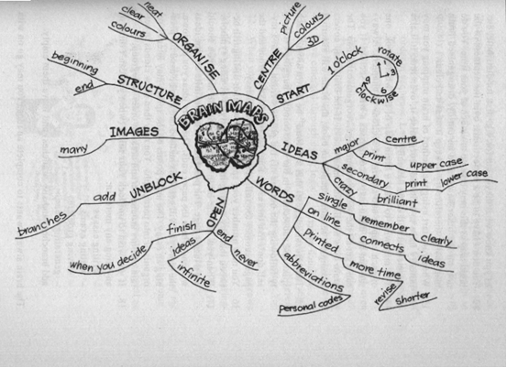

A mind-map is more effective for studying than summarising facts in points, underneath each other, since the human brain is capable of absorbing facts in all directions, not only from top to bottom, but also from left to right.

With a mind-map, you follow the same procedures as for any other summary. You take a big piece of writing, break it into smaller parts by using headings and sub-headings, and then you summarise in point form or paragraph form.

A mind-map looks different, since it resembles a diagram. The one main point of the summary is quoted in the middle. This would be a heading in your summary.

The sub-headings are written on lines that flow out of the main point. Any further points would branch out from the lines that contain sub-headings.

Key words

A key word is an important word in a sentence or paragraph that you can highlight or underline.

To explain this, I will use an example of text with the key words in the text and then show the text without the key words:

*Among the last of its kind, a young gorilla peers from its leafy refuge in Rwanda – a nation bloodied by ethnic slaughter.*

As it stands the paragraph above is clear. If I leave out certain key words, I can change the paragraph so that it does not make any sense:

“A young gorilla peers from its leafy refuge and instability could endanger the gorilla’s survival.” What on earth am I talking about? Where is the gorilla, why would its survival be endangered and what is the instability that I wrote about?

## Ask relevant questions

You can check your understanding of text, clarify the meaning, get information or ask for help by asking questions.

Typical questions to ask are: What, why, where, when, how and which

#### WHAT

1. **What** were your duties?
2. **What** did you do then?
3. **What** subjects did you take?
4. **What** happened then?
5. **What** sort of...?

#### WHEN

1. **When** was that ?
2. **When** did that happen...?
3. **When** did you go...?
4. **When** did you decide...?
5. **When** did the company

#### WHY

1. **Why** was that...?
2. **Why** did you choose...?
3. **Why** do you think that...?
4. **Why** did you do...?
5. **Why** did they...?

#### WHERE

* **Where** was that...?
* **Where** did you go next...?
* **Where** were you when...?
* **Where** did you go...?
* **Where** do you think...?

#### WHICH

* **Which** school was that...?
* **Which** course did you...?
* **Which** were your best...?
* **Which** department was...?
* **Which** was that...?

#### HOW

* **How** did that come about...?
* **How** do you think that...?
* **How** much did that...?
* **How** did you get...?
* **How** was that...?

## What Do We Read?

We read, or look at and interpret a variety of written and visual material during our lives, including:

* Textbooks
* Magazines: a periodical publication containing articles and pictures
* Newspapers: a daily or weekly publication containing news, articles and advertisements
* brochures: a leaflet containing information about a product or service
* policies: a document containing the course of action adopted or proposed by an organisation – how the organisation goes about its business
* questionnaires: a document containing printed questions that have to be completed, usually done to conduct a survey
* notices: announcements or advertisements printed in the media
* memorandum: a note sent from one person to another in an organisation
* agenda: a list of matters that have to be discussed and/or dealt with in a meeting
* application forms: forms similar to questionnaires, that have to be completed when you are applying for something – job applications, credit applications at shops and so on
* documentary: a factual report of real events where use is made of documents, film, photographs and sound recordings in order to convey the message
* novel: a story of book length about imaginary people and events
* photographs: still pictures made with cameras
* diagrams: are discussed fully later on
* blueprints: design plans or other technical drawings
* films: a story or event recorded by a camera and shown in a cinema or on television

We also read the following in order to familiarise ourselves with the instructions and directions given:

* instructions to play games and effect basic repairs to objects
* classroom and workplace procedures
* recipe: a list of ingredients and instructions for preparing a dish
* schedule: a plan for doing something, giving lists of intended events and times
* map: a diagram of an are showing physical features, cities, roads, etc
* warranties: a written guarantee that promises to repair or replace an article if necessary within a certain period, if certain conditions are met.
* Simple instructions and directions are read and interpreted and subsequent explanations are consistent with the intention of the text

Each of the above serves a different purpose, but all of them influence how we read and look at things.

When you read for study purposes, make sure that you read or view the text for detail. It is very important that your notes and summaries contain the correct information. If necessary, check your notes against the source.

## Listen for detail

When you are attending a workshop or a seminar, make sure that you listen actively for detail. make notes and ask questions if necessary.

Refer to the section about active listening and communication skills for hints on improving your listening skills. Start practicing these skills immediately as you will need them.

## Peer And Self-Assessment

It is always a good thing to check your notes, summaries, mind maps and understanding of the work.

You can do a self-assessment by reading through the main text again and comparing your notes to what you understand from the main text.

Then compare your notes and understanding to the notes and understanding of your colleagues and fellow students. When you find points that you do not agree on, you then go through the main text together, ask questions and make notes in order to clarify your understanding.

If you still do not agree, go to the facilitator or another colleague or fellow student. Carry on in this way until you all agree about what the content of the text is. Use all the strategies you have learnt to clarify the meaning of text.

## Communicating With Others

Studying and the learning process do not have to be an individual activity. In fact, if you do it alone, without consulting your facilitator, colleagues and fellow students, you are making it hard on yourself.

There is always a collective knowledge in a group, where the total knowledge in the group is more than the knowledge of individuals: you might know something about computers that the other group members do not know, while some other members of the group may have more knowledge about Labour Law, etc.

Talk to your facilitator, your colleagues and your fellow students if you do not understand a subject.

In the same way, you must be willing to share the knowledge you have with the group. In the end, everyone benefits from working in a group.

Activity 8 (8967 SO2, AC1-6)

SECTION 8: PLAN AND GATHER INFORMATION

#### Outcome

Plan and gather relevant information for a given context and purpose

#### Assessment criteria

On completion of this section you will be able to ensure that:

* Information gathering steps are planned and sequenced appropriately
* Information gathering techniques are applied: Gathering information, reading/viewing, interviewing, observing, using appropriate electronic sources
* Information is sifted for relevance
* Information is classified, categorized and sorted
* Scope of information gathered is appropriate for given context and purpose
* Conclusions are presented in the appropriate format

## Sources of Information

Before you start writing your document, you have to plan what you are going to write. First, you are going to define the topic and then you have to gather information about the topic.

|  |  |
| --- | --- |
| **Information can be gathered from**: | **In the case of business correspondence, you will find information in:** |
| Libraries | Minutes of meetings. |
| Encyclopaedias | Correspondence with clients and suppliers. |
| Manuals | Operations and procedures manuals |
| Magazines | Internal correspondence between departments, branches and regions. |
| Newspapers | Correspondence between management and their departments. |
| Interviews with experts |  |
| Internet |  |

When doing research about a topic it is important that you gather as much information about a subject as possible. The more information you have, the better. Of course, the information and data must be relevant to the topic that you are going to write about.

Interviews (asking people questions)

These may be structured or unstructured. Tools used include:-

* Questionnaires: draw up a form containing questions relevant to the subject
* Discussions: this includes discussions in teams, study groups, etc.

#### Preparing for an interview

The key to a successful interview is good preparation. If you take time to prepare for the interview you will find that you will confidently be able to participate in the interview even if you are nervous. You will instinctively know how to respond to the questions put to you and you will have a good interview.

* Do some research and find out as much as possible about the subject and the person you are interviewing.
* It is a good idea to make a list of all the questions you want to ask.
* Make a list of question you think you may be asked. How would you answer them?

Observation

Observing someone whilst he/she is carrying out the work or doing something – watching what is being done.

Questions to ask include:

* What is being done and how is it done?
* Does it conform to the official policies and procedures?
* What deviations are taking place?

## Organise The Material

Once you have gathered information, the material you have collected has to be organised.

### Sorting and categorizing

Arrange or organise the information with common features or characteristics systematically in groups.

All the information with similar content is grouped together. Your classification will depend on the order in which you are going to write the document: you can sort the information chronologically, using contrast or cause and effect.

You can use cause and effect, and contrast to help you arrange your paragraphs in a logical way.

* **Contrast** is when you contrast one theme, thought, opinion or product with another. Refer back to the introduction of the article about the gorillas: you can contrast the concern of conservationists who were worried about the gorillas, with the views of humanists who were more concerned about the people being killed.
* **Cause and effect**: referring back to the same text, you can progress from the causes of the war to the consequences(effect) of the civil war on ordinary people.

If you are writing about something that happens over a period of time, you can arrange your paragraphs chronologically: start with the earliest date and end with the latest date. When writing about droughts in South Africa you can start with the big drought in the 1930s and end with the current drought.

### Sifting for relevance

Once you have classified the information and data, you have to sift through it for relevance. You should keep only the information that is relevant to your topic, everything else can be discarded. In other words, if you are writing about plants that flower in summer, all information about plants that flower in autumn is not relevant, you cannot use it to enhance your writing and you should discard it.

### Validity and reliability

Now you have to check your information for validity and reliability. The obvious way of doing this is to check your facts with more than one source:

* check more than one manual,
* talk to more than one person,
* visit more than one website,

to ensure that your facts are correct.

Preferably, you should use more than one manual, more than one website and the knowledge of more than one expert for each aspect that has to be checked. If most or all you sources state the same basic fact, you can be reasonably sure that the fact is correct.

### Recording

Once you have sifted and verified your information, record it in the categories you have selected. This recording is in draft form, usually in the form of rough notes.

Any arguments used in your document must be supported by sound reasons and facts. You have to justify your feeling about the matter with facts in order to persuade the reader to your point of view. Something your neighbour said about the matter is not fact – you have to verify the statement your neighbour made.

Now you are ready to draft a copy of the final document.

#### Before you start writing/signing your text you have to plan what you are going to write

* BOOK054Who will you be writing for: your friends and family, the general public, a business document, a newspaper or magazine article, etc.
* In which register will you be writing the text: formal or informal
* Which writing style will you use: narrative, discursive, expository, etc.
* Will you write in the first person or the third person?
* Determine the research you will do
* Organise your writing: make sure ideas and facts flow logically

#### Make your writing/signing interesting

* Use numbers and bullets to separate ideas, facts and paragraphs. You will find examples of bullets and numbers in this learner guide
* Use punctuation correctly: commas, periods, etc.
* Use titles, subtitles, headings, contents and index
* Use an introduction and a conclusion
* Use visual images and captions with these images
* Vary the length of your sentences
* Structure your paragraphs correctly
* If any action is required, make suggestions about the actions
* Put ideas forward
* Use appendices or addenda if required
* Use NMF’s (non manual features) appropriately

#### Diction

* Choose words or signs that are familiar and easy to understand
* Make sure that you are using the correct words or signs
* Do not use technical language, legalisms, etc. when writing/signing for the general public. When it is a business document, use of technical terms and jargon will be acceptable
* Do not use slang or write in dialect unless you are writing to entertain

#### Document

When you are writing a document, it should be about a specific topic or theme. The text you are writing will usually consist **of more than one paragraph**, each with its own topic but relating to the main topic of the document.

Your piece of writing should start with an **introduction** of the theme of the document. Your first paragraph would therefore be the introductory paragraph. Keep your introductory paragraph short, relevant, and introduce the theme of the document. The introductory paragraph must get the **attention of the reader**.

Your paragraphs must follow each other in a logical way, from point A to point B to point C. The last sentence of the previous paragraph should lead to the next paragraph. One thought should be connected to the next thought in a logical way. Do not jump around from one topic to another without giving the reader some clues about your purpose.

#### Arranging The Paragraphs In A Logical Order

You can use cause and effect and contrast to help you arrange your paragraphs in a logical way.

* **Contrast** is when you contrast one theme, thought, opinion or product with another.
* **Cause and effect**: you can, for example, progress from the causes of war to the consequences(effect) of the civil war on ordinary people.

If you are writing about something that happens over a period of time, you can arrange your paragraphs **chronologically**: start with the earliest date and end with the latest date. When writing about droughts in South Africa you can start with the big drought in the 1930s and end with the current drought.

1930 - 2006

Any arguments used in your document must be **supported by sound reasons and facts**. You have to justify your feeling about the matter with facts in order to persuade the reader to your point of view. Something your neighbour said about the matter is not fact – you have to verify the statement your neighbour made.

Ensure that you **state your point of view clearly**. Remember other people also have to understand your point of view.

If you want your writing to be clear, you have to ensure that you give the reader **all the information** he/she requires to understand your reasoning.

“They said it is going to rain today.” This is a terrible sentence. Who are “they”, where did they get their information from, where is it going to rain, where do they live – do they even live in the same area as you and I?

✓

**Always check your facts for correctness** before you commit them to writing. Readers are very critical and will never forgive you if you get your facts wrong. Anything you write in future will be viewed with suspicion

“The Weather Bureau predicts that there is an 80% chance of rain in Gauteng today.” Now you have stated the source of your fact, you have backed your statement with an estimate of the possibility of rain and you have also made it clear where it will rain. If it doesn’t rain, your readers cannot be angry with you, since you only reported what the Weather Bureau predicted.

At the end of your document, you have to come to a **conclusion**, where you connect all the facts that you stated previously. State your conclusion or recommendation clearly and make sure that it is based on the facts you stated. The conclusion can be:

* A short **summary** of the main points of your document.
* A **direct-approach** conclusion where you show the reader how the message relates to him/her.
* **Plan of action** conclusion where you answer the question of what should be done about the matters discussed in the body of your document.

Activity 9 (8967 SO4, AC1-6)

SECTION 9: TEAMWORK

#### Outcome

Function in a team

#### Assessment criteria

On completion of this section you will be able to ensure that:

* Active participation happens in group learning situations: Discussions, activities, workshops
* Responsibilities in the team are taken up and group work conventions are applied in learning situations: Turn taking, rotation of roles: conducting, chairing, recording, and reporting
* Negotiating techniques are practised
* Teamwork results in meaningful products or outcomes: Reaching consensus, completing tasks

## Team Members

When you are working in a team each team member has to commit to the following in order to ensure the team functions effectively:

* Commit to work together in a team, commit to the goals and purposes of a team, find your place in the team so that you can also feel you belong.
* Ensure that all team members are travelling in the same direction – working towards the same goals and purposes.
* Take turns doing the hard jobs, it will benefit the team in the long run and therefore also benefit individual team members.
* Encourage, support and praise each other.
* Stand by each other and help each other in times of need.
* Team members have to take responsibility for their own jobs as well as the achievement of the goal or purpose of the team. Members support each other so that the objectives and goals can be met by the entire team.
* There should also be a culture of respect for each other and this is the responsibility of the entire team.

If team members commit to the above it means that they will actively participate in

* Meetings
* Site visits
* Excursions
* Discussions
* Activities
* workshops

Participating in group activities means that you also take part in discussions by saying your say, agreeing or disagreeing with someone. It also means that at times you keep quiet and listen to what someone else is saying, without interrupting that person. You can have your say when that person has finished talking.

In effective teams, the roles of the team members are also rotated. Of course, specialist roles are not included, but the following roles should be rotated among the team members:

* Chairman of meetings: each member should get an opportunity to preside as chairman of a meeting
* Secretary: each team member should take a turn in arranging the agenda, taking the minutes and circulating the minutes of a meeting
* Mentor: each team member should be a mentor for one other team member. A mentor is a trusted advisor who helps to develop the professional and personal skills of another team member.
* Coach: the job of coaching other team members or newcomers to the team should be shared equally amongst team members
* Team leader: this is not always possible, but if it can be done, each team member should be the team leader of the team for a period of, say, two weeks or a month
* Reporting: each team member should get an opportunity to report to management about the progress of the team

## The Role Of The Team Leader

What can you, as team leader (when your turn comes), do in order to promote the effectiveness of the team?

* Be tolerant towards the team members, and promote and demonstrate this attitude of tolerance
* Acknowledge you own faults and shortcomings. If team members have an insight into the mistakes of the team leader, they will be more inclined to confide their own mistakes to their leader.
* Create a learning culture and not a knowing culture. The result of any exercise or task should be a learning result
* Give credit and show appreciation for all contributions.
* Stop taking decisions on behalf of team members. Involve the team in the decision making process.
* Accept decisions made by team members.
* Encourage differences of opinion.
* Be consistent. Do not say one thing and do something else.
* Trust your team members and encourage them to trust each other. It is important to note that when team members agree that trust is important, they invariably win. Teams that try to ignore the issue of trust rarely work. Trust is like customer relations. It takes a long time to achieve but it can be destroyed in a few seconds. Trust cannot be imposed and it only comes through experience some say. **Definition of Trust**: TRUST IS THE BELIEF THAT WORDS WILL BE TRANSLATED INTO ACTION AND THAT OTHERS WILL TAKE YOUR INTEREST INTO ACCOUNT
* Support your team members and encourage them to support each other. Support and trust go together for without the one the other cannot exist. Both can best be achieved where individual members do not feel they have to protect their territory or function, and feel able to talk straight to other team members. With trust people can talk freely about their fears and problems and receive from others the help which they need to be more effective.
* Do not avoid conflict, address the problem. Conflict and avoidance in the name of support is like building relationships on sand. People working together must sense that their shortcomings or mistakes will be accepted along with their strengths and weaknesses, if a healthy supportive climate is to exist.

## Purpose Of A Team

All teams have a purpose: the purpose of a sport team is to win, the purpose of a team in the workplace could be to finish a product at a certain time or any other work related purpose and the purpose of a study group is to give support to all the members so that all will pas the test or exam.

If all teams have a purpose, it stands to reason that all teams also have goals and objectives that have to be met in a certain way at a certain time.

All the team members have to work together towards achieving the goals and objectives of the team. If one team member is not doing his/her bit, it affects the entire team.

It means, therefore, that all team members have to identify with the goals and objectives of the team, agree with them and work together in order to achieve them.

## Negotiation

Preparation

The first step in the bargaining process is to prepare. Follow these steps:

#### Gathering Information

You have to be clear about ideas and views held by others and you must also identify the position of others before beginning to negotiate. You also have to clarify where a common ground can exist).

Find out what they think and where they stand so that you can find a point where you all agree. Always make sure that you are well prepared so that you are not caught off guard.

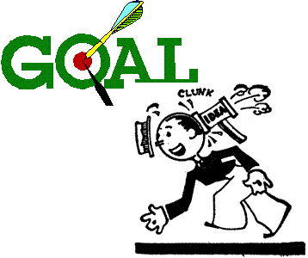

#### Define goals

* What do you want to achieve?
* Which issues are not negotiable?
* Which issues are negotiable

#### Clarify the issues

In most conflict situations realistic negotiators are interested only in the most relevant circumstances. A broad understanding of the background is important, particularly a knowledge of any previous attempts at negotiation.. However, getting bogged down in arguments about history is usually a waste of time. Your main need is to understand the mood and the aspirations of the individuals that you will be talking with so that the common interests and common hopes can be put in the foreground.

As a negotiator one of your prime responsibilities will be to present your group's perception of the conflict. Discussion may occur at formal meetings round a negotiating table or in a street-corner cafe, but whatever the surroundings, your objective is always the same.

You want to put your case across in such a way that your opponents cannot fail to understand more clearly than before the needs and aspirations of your group. Their reactions cannot be predicted but it is your task to give them the clearest possible picture to start with.

#### Compromise/resolution

You have to determine what is vital for the success of the organisation and keep these points in mind when going into negotiation. However you should also remain realistic and think about both the ideal agreement or conclusion and the worst possible settlement which might have to be accepted.

At this stage you should also consider the disadvantages of each party to each bargaining position.

If we use a wage increase example, what happens to the business and the employees if an agreement is not reached and the employees go on strike:

* The business has a shortage of skilled workers and has to employ workers who are not trained in the company’s procedures. The business will lose money while the matter is sent for mediation or arbitration. This is not ideal, if an agreement can be reached with just little effort.
* The employees will not be paid for the entire period they are on strike. Can they really afford to do that for a mere 1% or 2% extra on their wages?

To calculate the impact on the employees, let us take a salary of R5000 per month. The offer on the table has gone up from 6% to 8%. The union, on behalf of employees, is demanding 10%. A 10% increase on R5000 would be R500 per month, or about R22,73 per day. If the union accepts the offer of 8%, the increase would be R400 per month, or about R18,18 per day.

If the employees go on strike for a period of two weeks, they will lose R5400 per month, or R245,45 per day, of which R18,18 per day would be the value of their increase, in order to gain R4,55 per day – the difference between a 10% increase and an 8% increase.

If the strike lasts for fourteen days, the worker will have lost R3436,30. How long must he now work to make up this loss if he gets an increase of 10%? He lost R3436,30 in order to gain R4,55 per day, so R3436,3 divided by R4,55 means that he must now work for 755 days to make up the loss. This is a period of more than two years.

So, the question remains, was it worth it? should the workers not have settled for the 8% increase?

There would also be a cost to the business as production will be lower, there is negative publicity which impacts on the name of the business and there is a loss of faith between management and employees. In the end, taking a hard-line view means that everyone loses.

Always consider the disadvantages of not reaching a compromise as disadvantages impact negatively on both parties.

Building Understanding

Once the negotiation process has started, you have to build understanding between yourself and the other party. You can do the following to ensure that you build understanding:

* Communicate main points effectively by paraphrasing, summarising, etc
* Listening to the other party
* Ask questions
* When the discussion is becoming heated, consider adjourning the discussion for a body break, tea break, etc.
* Testing arguments and positions: you have to test the other side’s arguments and bargaining positions. Remember that negotiation is a process of giving and taking until a mutual agreement is reached.

When preparing your proposal, keep these guidelines in mind:

* Know what you want to say and what you do not want to say
* Use words that tell what is on your mind in such a way that the listener will get the same picture
* Provide actual examples to make your point
* Separate what you think (assumptions and opinions) from what you know (facts)
* Encourage feedback. Check for understanding
* Keep the talk centred on the main problem, not side issues
* Try to make the other person feel good, and important

Bargaining

The bargaining process usually includes:

* Getting and making concessions. Here you will refer back to your bargaining objectives. From these you will know which concessions you can make and which objectives are really not negotiable.
* Breaking deadlock: at times during the negotiation process it could look like agreement cannot be reached. There are strategies for trying to break this deadlock.
* Moving towards agreements: once the concessions have been made and given and deadlocks have been broken, the parties will start moving towards agreements on the issues at hand.

Closing

When closing negotiations, do the following:

* If an agreement has been reached, summarise the agreement points and get commitment from both parties to uphold the agreements. Ideally, these agreements should be put on paper and signed by both parties.
* 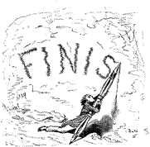If an agreement has been reached but the negotiators have to go back to their organisation or members to confirm, set a follow up date to finalise the proceedings.
* If an agreement has not been reached, both parties have to agree on the next step: set a new meeting to discuss issues that have not been resolved, maybe using a facilitator, mediation or arbitration
* Walking out of the negotiation procedure is also a way of ending negotiations, but this is a very negative step.
* Strikes and legal proceedings should really be a last resort, once all the other options have been tried and no agreement was reached.
* Activity 10 (8967 SO5, AC1-4)

SECTION 10: WORKPLACE CHARACTERISTICS

#### Outcome

Reflect on how characteristics of the workplace and occupational context affect learning

**Outcome Range**

Environmental features, technological resources, communication resources, communication strategies, and multilingual needs in relation to client or colleague interaction.

#### Assessment criteria

On completion of this section you will be able to ensure that:

* Sector and organisation type is identified: Sector/occupational focus: Services, manufacturing, financial, educational etc Organisation type: Government, parastatal, heavy/light industry, large organisation, small business
* Features of the occupational environment are described and discussed
* Ways in which these features affect learning processes and/or application of learning are described and discussed

The characteristics of a workplace varies according to the industry in which the organisation is:

You will find that the workplace of a services organisation, a manufacturing organisation, a financial organisation and an educational organisation will differ in terms of availability of resources and interaction between learners and colleagues or employees and clients:

* Technological resources: such as computers, machinery and equipment
* Communication strategies and resources: how the employees and different departments communicate with each other, as well as how the organisation communicates with the world outside the organisation
* Multilingual needs regarding the interaction between clients and employees as well as between employees in the organisation: how languages differ in the organisation as well as between the organisation and the rest of the world.
* Environmental features: the conditions in which the organisation functions will also influence occupational learning. For instance, a small business in Kathy or some remote place will not have the same facilities that a large organisation in the same location will have. Also, business in urban areas (cities) are closer to resource centres such as libraries, etc.

The workplace of different types of organisation will also differ:

* Government: the workplace of government organisations differ vastly from those in private enterprise.
* Parastatal: a semi-government organisation such as Telkom
* Heavy industry: mining, car manufacturers and so on
* Light industry: providers of packaging materials,
* Large organisation: such as De Beers, Putco bus company, etc
* Small business: such as a hairdresser, taxi service and so on.

Activity 11 (8967 SO6, AC1-3)

SECTION 11: OCCUPATIONAL LEARNING MATERIALS

#### Outcome

Occupational learning materials are organised for efficient use

#### Assessment criteria

On completion of this section you will be able to ensure that:

* Occupational learning materials are organized for efficient use: Videos, texts, handouts, textbooks, charts, maps, plans, and diagrams
* Layout and presentation of learning materials is understood and used effectively: Index, contents page or glossaries are used effectively
* Technical language/ terminology is engaged with, and clarification sought if needed

## Occupational Learning Materials

There are many types of learning materials available:

* Training videos and DVD’s
* Text books
* Charts
* Maps
* Plans
* Diagrams
* Handouts
* Internet

## Layout of learning material

When you start gathering information about subjects for research or for studying purposes, you will find that the layout of learning materials is very similar. You will find an Index, a contents page and a glossary in most learning sources.

The Index and Contents Page were discussed in a previous section. Refer to this section for information on how to used them.

Glossary

A glossary is usually found at the back of a text book. It is a list of words, usually unusual words, that are used in the manual, with an explanation of their meanings.

An example of a glossary can be found on the next page. When you find an unfamiliar word while working through the text book, you can refer to the glossary to find out the meaning of the word, if it is stated there.

| Term | Definition |
| --- | --- |
| Address Book | A list of names and email addresses. |
| Appointment | A reminder to do something on a particular date at a particular time (and optionally in a particular place). |
| Archiving | Removing old items from Outlook folders by either deleting them or storing them in a compressed file. |
| Attachment | A file sent by email. |
| AutoSignature | An Outlook tool for inserting text into a message. An AutoSignature can be a line or block of text and can be added to all new messages by default. |
| Bcc | Blind Carbon Copy - sending a copy of a message to another recipient without other Bcc recipients knowing. |
| Calendar | The diary component of Outlook. |
| Categories | A tool for grouping related items together. |

Technical language and terminology (Jargon)

Words or expressions that are used by a specific trade, business or industry.

* **A paper tiger:** when a committee or other body is established to investigate an occurrence, and nothing much happens, it is called a paper tiger.
* It means that the committee is not doing what it is supposed to do, the members of the committee postpone actions and make up imaginary problems as to why they cannot do the work in time.
* In the training environment in South Africa we find a lot of jargon – words that are used in a context not previously used and existing words put together to mean something that is unique to the education and training environment.

We talk about Unit Standards, which previously was called training courses, we talk about assessments rather than tests and we have standards generating bodies and standards governing bodies, and so on.

* **Electrocardiograph**: monitors the heartbeat
* **Government fiscal matters**: to do with the governments budget and how they spend the money that we pay in taxes.
* The **metallurgist** in charge is Karis Allen, 35, a specialist in fractions and corrosion: a metallurgist is a person who specialises in studying metals, fractions and corrosion in this instance means how metal, such as steel, breaks and corrodes

When you come across technical language and terms in your learning resource, you will have to make an effort to find out what the word means. You can use dictionaries, thesauruses or even the Internet to find out what the word means.

## A Filing System

This material has to be stored in a safe place and a record of everything must be kept, so a filing system for the learning materials is necessary. A good filing system has certain essential features:

|  |  |
| --- | --- |
| 1. Simplicity | 1. Appropriate classification |
| 1. Accessibility | 1. Selection of suitable equipment |
| 1. Safety in terms of minimizing loss | 1. Safety in terms of avoiding damage by fire, water, dust |
| 1. Safety in terms of maintaining confidentiality | 1. Compactness – using space efficiently |
| 1. Elasticity – it must be able to expand if required | 1. Speed of retrieval |
| 1. Trained staff | 1. Economical in terms of time, cost of equipment and accessories |
| 1. Sufficient cross-referencing | 1. An “out” guide or “tracer” system should be incorporated |
| 1. Thinning out should be performed on a regular basis | 1. Daily filing |

## Methods Of Classification

### Alphabetical Order

* items are grouped alphabetically. The file for Mahotsi would be placed before that for Ndengwe, because m comes before n. Baker would be placed before Barker, as bak comes before bark
* Should more than one client have the same name, their files would be arranged in order of initials: Mahotsi, C would be placed before Mahotsi T
* Short before long: if all the other letters in a name are the same, you arrange the shorter name in front of the longer: Cole will be placed before Coleman.
* Prefixes before surnames, such as de der le van von O, etc are considered part of the name: du Plessis will be placed alphabetically with D and not P, so will van der Merwe be placed with V.
* Should more than one client have the same name and initials, a number could be added after the initials: Mahotsi T1 would be followed by Mahotsi T2
* Impersonal names, such as company names are placed in the order they are written: Gilbert Enterprises will be filed with G and Tiger Brands with T.
* Official or descriptive names: the most important word is the first filing unit: The Hotel Shelly will be filed as Hotel (The) Shelly and City of Durban will be filed as Durban City (of).

### Numerical Order

* A number is allocated to each item, regardless of surname and initials. This is how banks file our records.
* Files are then arranged numerically
* As it is not possible to remember each client’s number, a separate card index is kept to record clients’ personal details and file numbers
* New clients receive the very next number after the last allocated number. The new file is placed last in the drawer.

### Alpha-numeric filing

* This consists of a combination of alphabetical and numerical filing systems
* Files are placed alphabetically, but not strictly so
* Each file is labelled with the client’s name and a number, e.g.. J Maxwell could be M5. The next file could be B Mason, with the number M6
* You will find this form of numbering used for example for spare parts of cars or motorbikes
* A separate index system is used to record files and this will be arranged alphabetically.

Then there must be a form of control over the “lending” of the material by individuals, so that the material can be traced if someone else needs it.

### Selecting a classification system

Occupational learning materials will usually be sorted according to subject, with cross-references to the authors, publishers and date of publishing.

If you have access to a computer, draw up a database of learning materials, so that items can be searched for according to subject, author, publisher, etc.

### Lending of Learning Materials

* Ensure that the “out” cards are completed and signed for before handing over the files.
* It will also be your responsibility to ensure that the item is returned. Follow up on outstanding items on a weekly or daily basis, depending on the procedure in your organization.
* When the item is returned, remember to sign it in again.

|  |  |  |  |
| --- | --- | --- | --- |
| **OUT CARD** | | | |
| NAME OR SUBJECT | DATE | TAKEN BY | DATE RETURNED AND INITIALS |
| Smith James | 15/05/05 | NDP | 31/05/05 NDP |
| Tiger Brands | 15/05/05 | BJP | 26/05/05BJP |
| ABC Trading Co | 26/05/05 | ISN |  |

Activity 12 (8967 SO3, AC1-3)